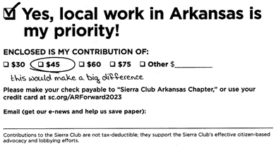 | 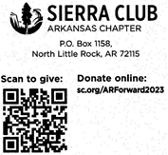
Your Name: | City, State:
Address: | Zip Code:
- - - - - - - - - - - - - - cut here - - - - - - - - - - - - - -
Your Name: | City, State:
Address: | Zip Code:
- - - - - - - - - - - - - - cut here - - - - - - - - - - - - - -

Your Name: | City, State:
Address: | Zip Code:

