States Lead the Way: A safer nation, thanks to state action to address toxic chemicals
http://www.saferstates.com/
Year after year, state decision-makers are finding new ways to protect children and families from toxic chemicals where our federal system has failed. States have made critical progress to:
- define hazardous chemicals of greatest concern to vulnerable populations
- disclose the use of these chemicals in consumer products
- ban the worst-of-the-worst; and
- move the marketplace and the nation towards safer alternatives.
State leaders are learning from one another. They are building on the progress of their neighbors and working in coalition to build progress. States are leading the nation with solutions, and calling on Congress to improve our country’s chemical stewardship and protect human health. More than 150 state policies have been enacted to protect citizens from harmful chemicals, forming the foundation for federal change.
Learn About More Toxics Policies
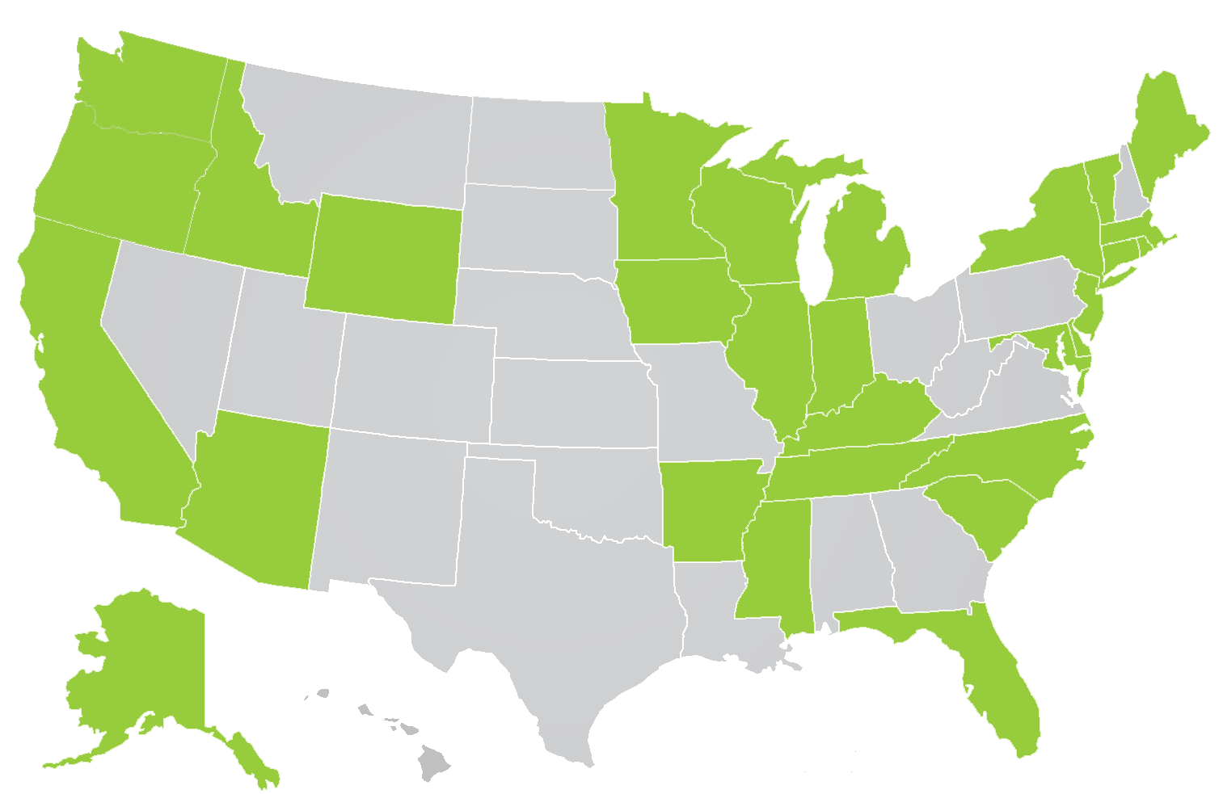
States expected to consider chemical legislation in 2015

Click below to learn about toxics policy in our partner states
- Alaska
- California
- Connecticut
- Florida
- MaineMaryland
- Massachusetts
- Michigan
- Minnesota
- Montana
- New York
- North Carolina
- Ohio
- Oregon
- Rhode Island
- Vermont
- Washington

