Beyond The Headlines…
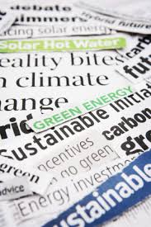
What: Q&A panel with noted environmental journalists

Why: Learn more about the media’s challenges and
successes in covering environmental issues and helping to empower the public. Lean how YOU can influence what and how environmental news is reported.

When: Thursday, October 1st, 6-7 pm social; 7-9pm program
East Cobb Government Center
4400 Lower Roswell Rd., Marietta

Who: Dan Chapman, Atlanta Journal-Constitution
Peter Dykstra, Environmental Health News
Dr. Camille Feanny, CNN International
4th panelist (not yet confirmed)

“Delicious and sustainable” refreshments
Special guest: Linda “GG” Foster of GG’s Fine Foods

Special display: Lexicon of Sustainability

Sponsored by: Sierra Club Centennial Group

All are welcome! For more information:
http://georgia.sierraclub.org/centennial/
https://www.facebook.com/Centennial.Sierra.Club
or call 678-463-7827

