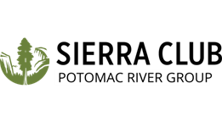
For Immediate Release: March 31, 2026
Contact: John Bloom, Political Chair, johnlbloom@gmail.com

Sierra Club Virginia Chapter Endorses Matt de Ferranti
In Arlington County Board Democratic Primary
Arlington, VA, March 31, 2026 – Sierra Club’s Virginia Chapter announces its endorsement of Democratic candidate Matt de Ferranti in the Democratic Primary election to be held on August 4.
“Matt is a true champion on climate and environmental issues. We need his leadership and expertise in office now more than ever," said Dean Amel, Chair of the Sierra Club’s Potomac River Group.
Matt has been at the forefront of many climate and environmental debates. He provided key support to Arlington’s 2019 Community Energy Plan, including its ambitious goal of 100% renewable electricity county-wide by 2035. He also backed creation of the Climate Policy Office in the County Manager’s Office; stronger green building standards for new and existing buildings; electrification of County fleets, including transit buses; elimination of gas-powered leaf blowers; food-waste recycling for all, and many other policies and programs now in place or being implemented.
More information about Matt can be found at https://mattforarlington.com/.

