PETITION TO - - KANSAS DEPARTMENT OF WILDLIFE AND PARKS
SAVE ORNATE BOX TURTLES - - STOP TURTLE RACES
ORNATE BOX TURTLES, AS KANSAS’ STATE REPTILE, DESERVE MORE PROTECTION. ALL TURTLES DESERVE BETTER PROTECTION. DON’T LET PEOPLE RACE THEM. THEY ARE NOT TOYS!
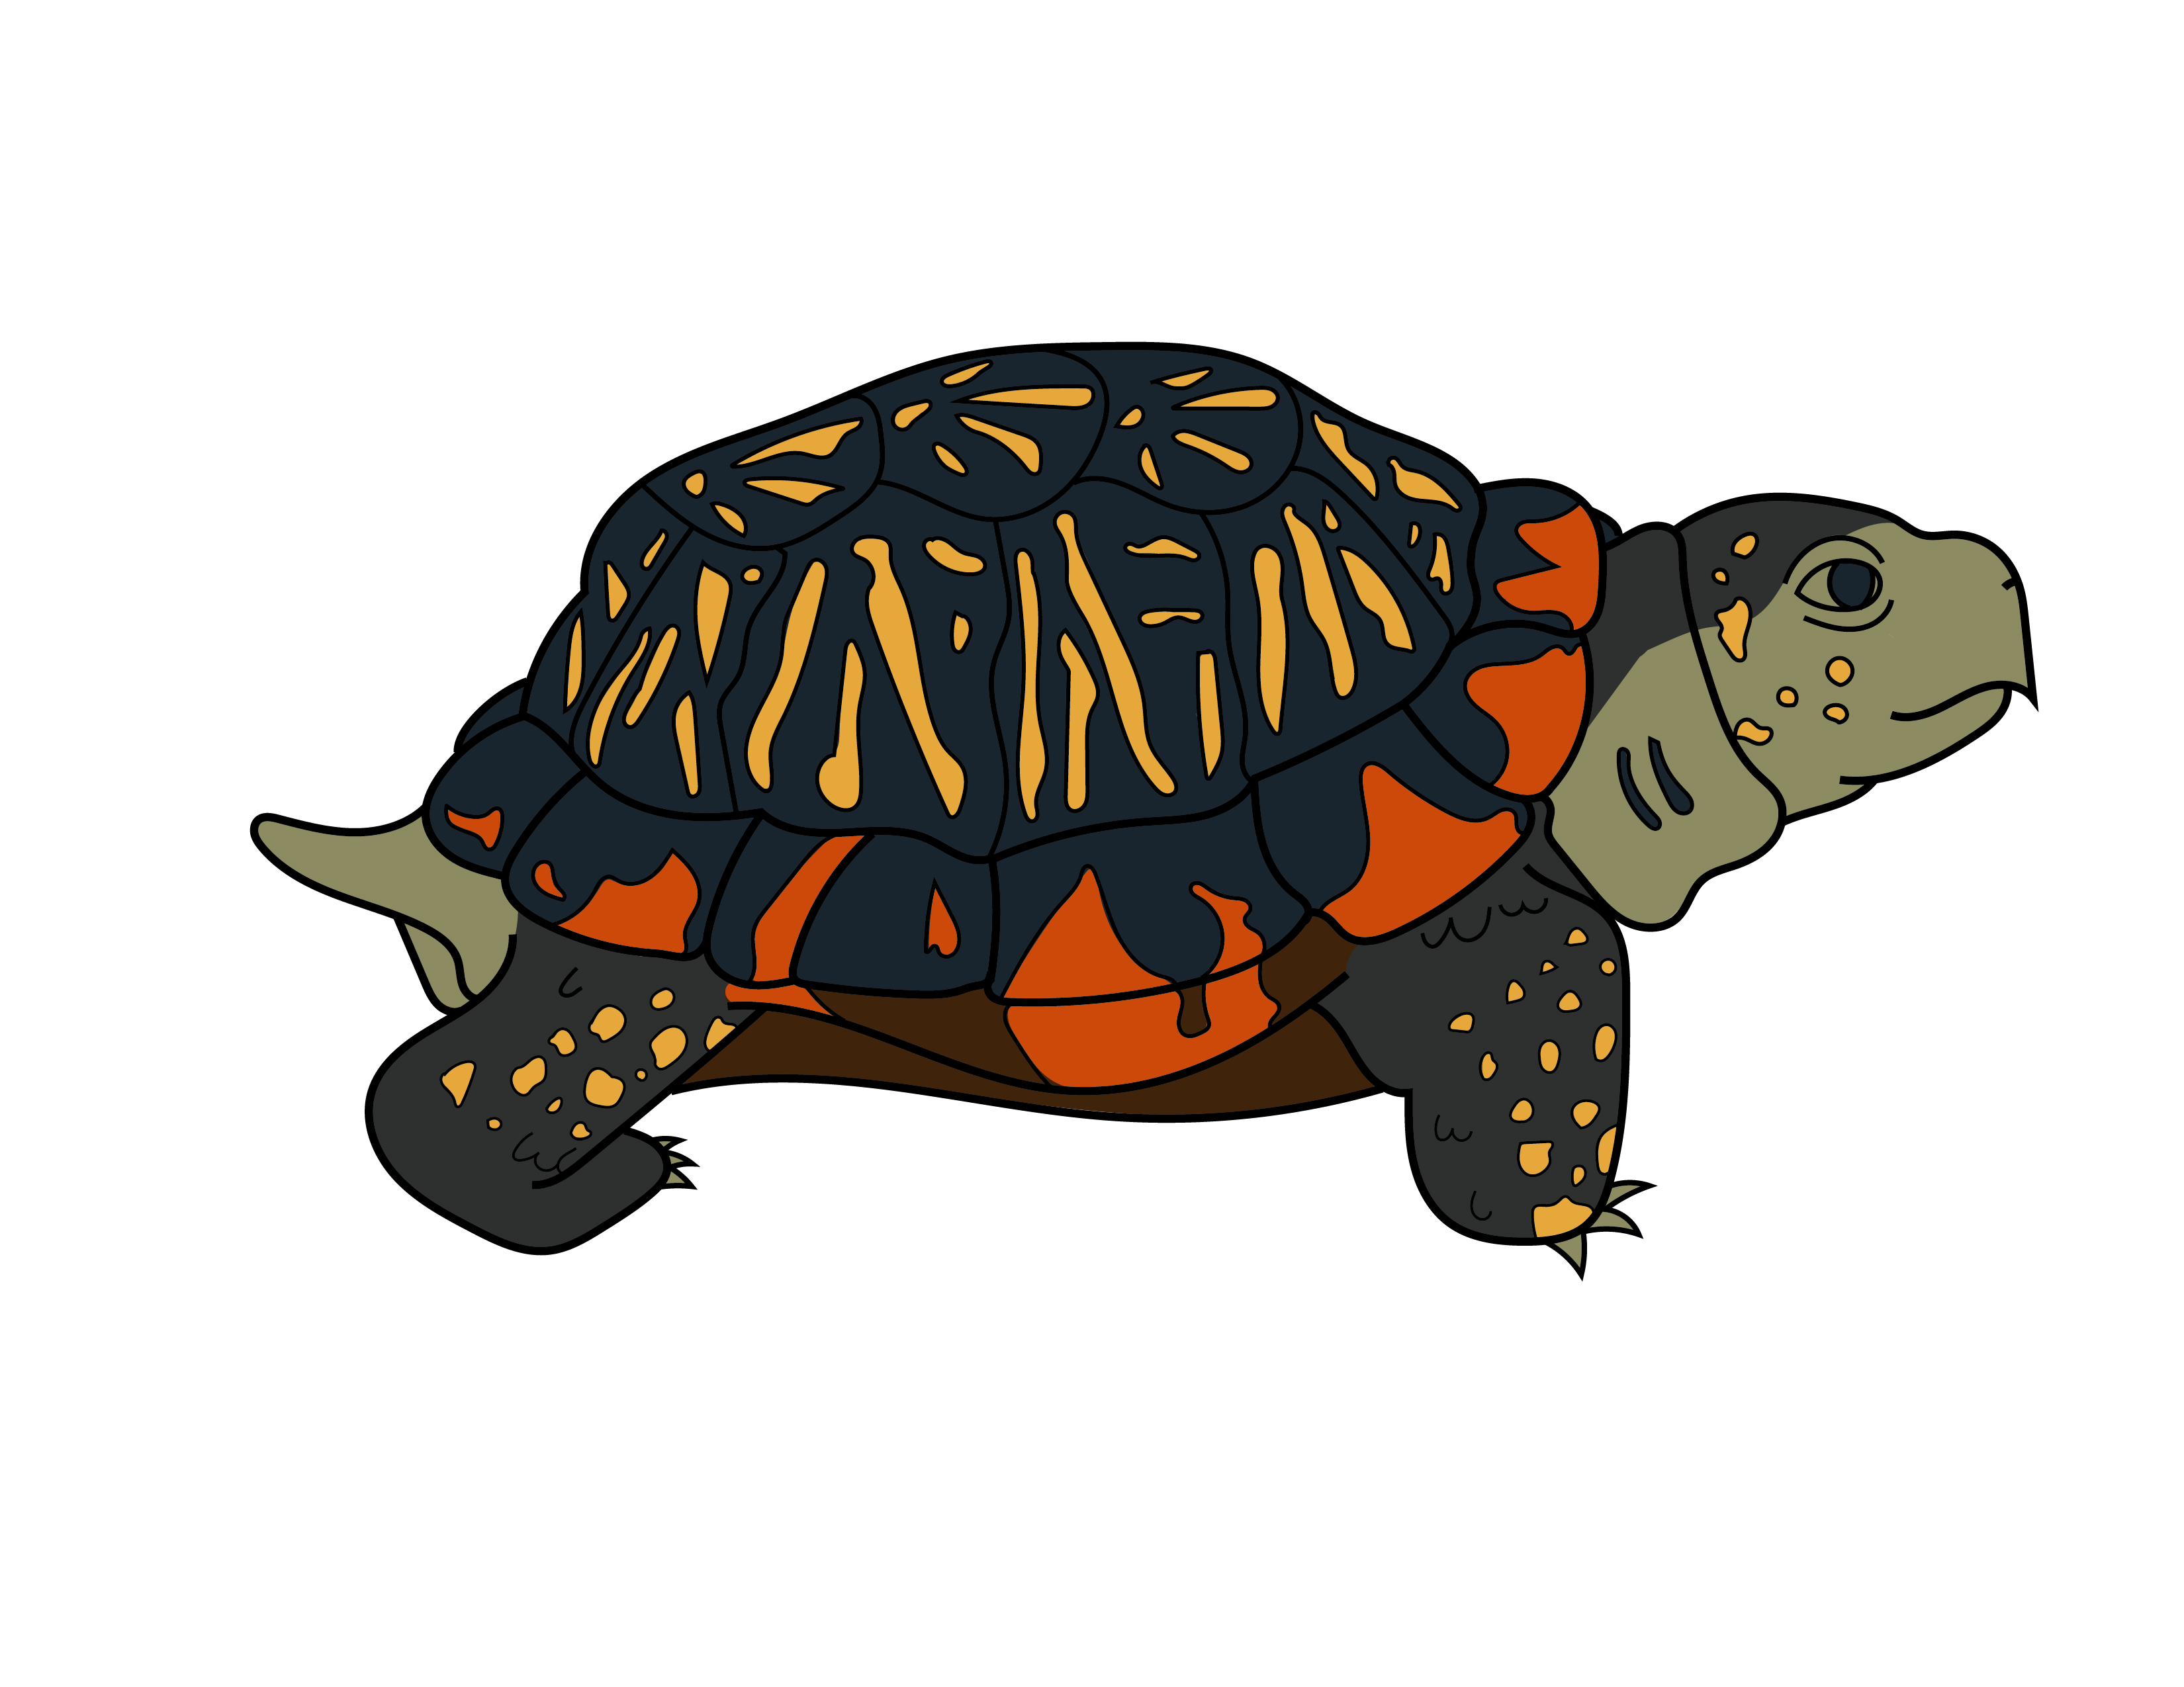
MIXING TURTLES TOGETHER SPREADS DISEASE. ALL IT TAKES IS ONE SICK TURTLE TO MAKE OTHERS SICK. WHEN RETURNED TO NATURE, THEY MAKE MORE TURTLES SICK.
ORNATE BOX TURTLES OFTEN DIE AFTER RACES BECAUSE THEY ARE FREQUENTLY RELOCATED OUTSIDE THEIR HOME RANGE AND SO STRUGGLE TO FIND WATER, FOOD AND SHELTER FOR SURVIVAL.

THEY ARE OFTEN STARVED, DEHYDRATED AND KEPT AT UNSURVIVABLE TEMPERATURES BEFORE AND DURING RACES BY PEOPLE WHO DON’T KNOW HOW TO CARE FOR THEM.
ORNATE BOX TURTLES (OUR STATE REPTILE) ARE THE MOST COMMONLY RACED TURTLES
A RECENT FIELD SURVEY OF ORNATE BOX TURTLES BY 7 ZOOS IN KANSAS FOUND ALARMING POPULATION LOSSES THROUGHOUT OUR STATE

PLEASE STOP ALL TURTLE RACING BECAUSE:
NAME | ADDRESS (City & State) | EMAIL (OPTIONAL)

KANSAS CHAPTER
KANSAS CHAPTER
This petition organized by the Kansas Chapter of the Sierra Club. See us at https://www.sierraclub.org/kansas
Ornate Box Turtles - - Leave ‘em in the Wild!

