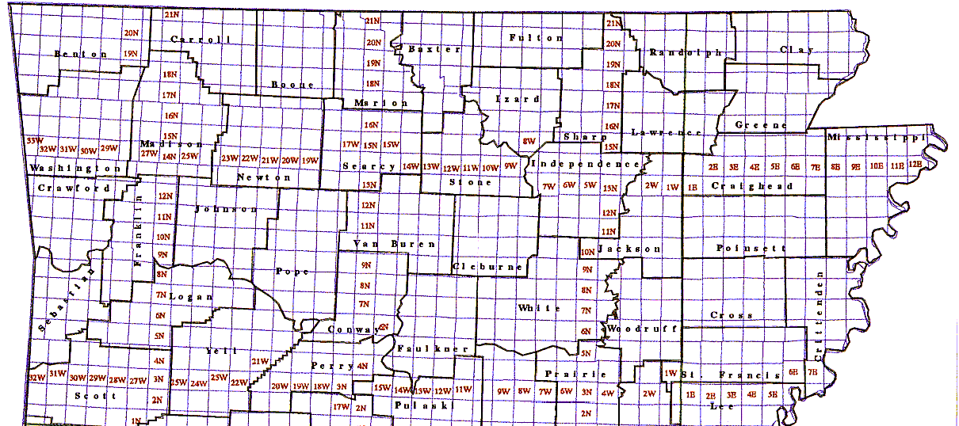
UTM UTM
Zone 15S zone 16S
Chic_7.5Quad_2019
Easternmost point: approx.
UTM:16S/261300/
T15N R13E, 89º 38' W
Half Moon_Quad_2017
UTM zone 15/16 border
15S/770450 (west of 90º) or
16S/229550 (east of 90º)
T16N R10E, 90º
Most of Arkansas lies in UTM Zone 15 between 15S/355100/ and 15S/770450/ (with northing between 3653200 and 4042995 {meters north of Equator})

Eastern Mississippi County lies in UTM Zone 16 between 16S/229550 and 16S/261300
Piggott 7.5Quad_2017
NE corner of state: approx.
UTM 15S/755000/4042995
T21N R8E
90º 9' W, 36º 32' N
Except for the eastern half of Mississippi County, all of Arkansas is in UTM zone 15S. Zone 16S starts (at 90º west longitude) near western edge of Blytheville or Osceola in Mississippi County and continues east to 84º west longitude. The S after the 15 or 16 indicates latitudes between 32º and 40º north. (The southern border of Arkansas is around 33º; the northern border of Arkansas is at 36º 32'. so the entire state is in either zone 15S or 16S.)
Possible examples of UTM designation:
15S/240000/3985000 (area marked 9E) (T14N R9E)
16S/770000/3985000 (area marked 11E) (T14N R11E)
Zone/easting/northing
(Center of a UTM zone has easting of 500000.)
(3985000 is meters north of equator.)
Colcord_NE_7.5Quad_2017
Topo NW corner 94º37'30"_36º30'
NW corner of Arkansas: approx.
UTM 15S/355100/4040560
T21N R34W
94º 37' W, 36º 32' N
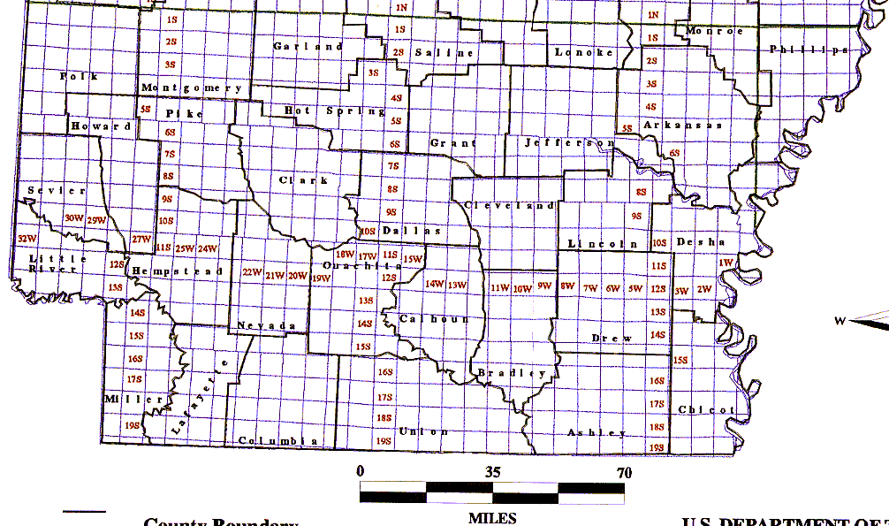This page is 11 x 17 inches (ledger size)
Readland_7.5Quad_2017
Topo SE corner_91º07'30"_33º00'
SE corner of Arkansas: approx.
UTM 15S/671300/3653200
T19S R1E
91º 10' W, 33º 40' N
Disregard blue double line north of Phillips County. Map had to be copied in two parts for legibility. Parts do not fit together perfectly.
Baseline is between Township T1N and T1S (between Lee and Phillips Counties).
Principal Meridian is between Range R1W and R1E (between Monroe and Phillips Counties).

This arrow points to Initial Point used for surveys in Arkansas.
Foreman_7.5Quad_2014
Topo SW corner 94º30' 33º37'30"
WSW corner: approx.
UTM 15S/362200/3723000
T13S R32W
Ravanna_7.5Quad_2017
Topo SW corner 94º07'30" 33º00'
SW corner of Arkansas: approx.
UTM 15S/402600/3653900
T20S R28W
MAP SHOWING ARKANSAS TOWNSHIP BOUNDARIES

