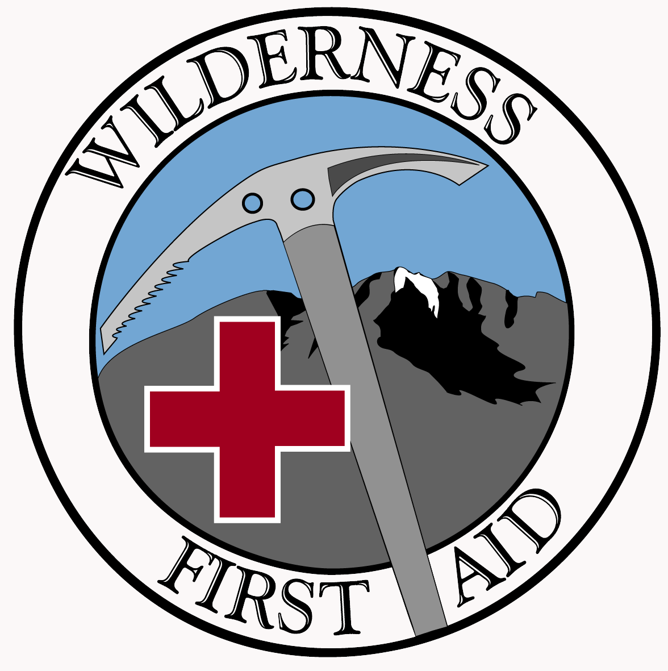
0
Fall 2021

The Wilderness First Aid Course (WFAC) will be taught from Saturday morning through Sunday evening on the weekend of Oct 30,31. The first day of the WFAC will be in a classroom with some outdoor exercises. The second day will be outdoors at a park. Both locations are in Fullerton, CA. Proof of CPR training (including hands-on skills practice) within the past five years is a prerequisite for enrollment.

Course virus safety precautions will include distancing and masks.

The fee for the WFAC is $150. Included are course notes (as a pdf) and two laminated first aid checklists for your backpack. Applicants must submit (at the same time) this application, the course fee, proof of CPR training and a COVID vaccination certificate.

“This 16 hour course rivaled any 24 hour course I have taken.” – Eric G.
“…the most intense, well organized and informative seminar I’ve ever attended (and in my work I attend a lot of seminars!). The WFAC is not a seminar or a workshop; it’s an experience” – Paul M.,
“I’ve taken a lot of classes to become a better leader. WFAC is hands down the best. This class astonishes me every time I take it.”– Ron C.

Name(s) :
Street Address : City:
Zip Code: e-mail address:
Primary Phone: Both e-mail and phone are required

My age category is:
[ ] Adult (21 or older; [ ] Young adult [18 – 20]; [ ] Teen [14 – 17] (registering with adult as trusted partner)
[ ] I am a health care professional - please specify (MD, RN, EMT, etc.) ___________________

Mail all of the following items in the same envelope:
[ ] This application form
[ ] Your signed check for $150 made out to WFAC
[ ] Copy of CPR card
[ ] Copy of COVID vaccination certificate

Please address these to:

Wilderness First Aid Course, P.O. Box 3414, Fullerton, CA 92834

Contact Steve Schuster at 714-315-1886 or steve.n.wfac2@gmail.com
or visit the WFAC website at wildernessfirstaidcourse.org for more info.
Fall 2021

