Chester County
Greenhouse Gas Reduction Report

May 2010

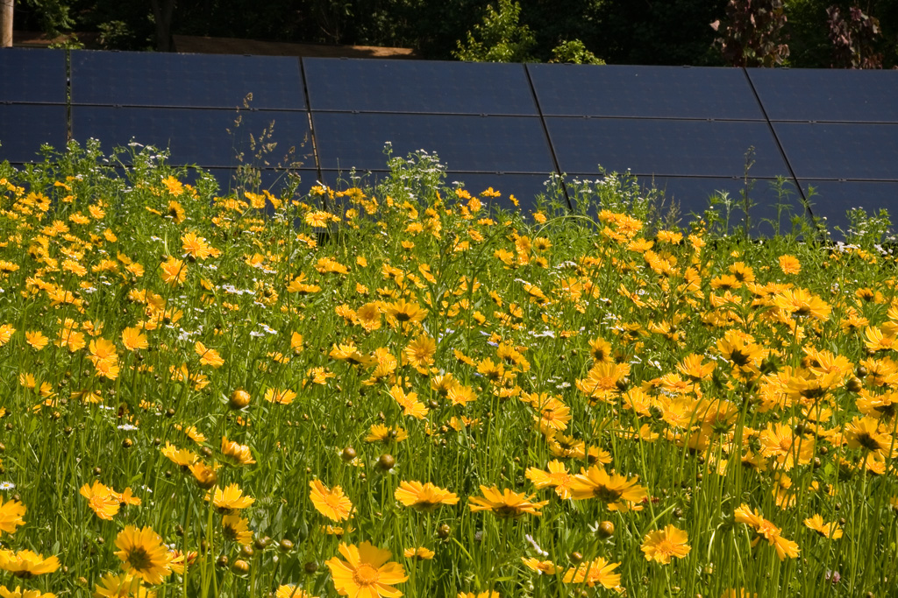

Submitted to the
Chester County Board of Commissioners

Submitted by the
Chester County Greenhouse Gas Reduction Task Force



Chester County Board of Commissioners
Carol Aichele
Kathi Cozzone
Terence Farrell



Table of Contents

Introduction

Forward

Executive Summary for Policymakers

Chapter One: Energy Use in Residential, Commercial, and Industrial Buildings

Chapter Two: Transportation and Land Use

Chapter Three: Outreach and Communications

Chapter Four: Recycling and Waste Management

Chapter Five: Agriculture and Forests

Chapter Six: Summary of Recommendations for Chester County

Appendix - A: Chester County Green House Inventory

Appendix – B: Office of Sustainability

Annex I: Glossary

Annex II: Abbreviations

Annex III: Contributors to the report
Introduction

Chester County is faced with an economic and environmental challenge- how to respond to ever increasing energy consumption and the release of greenhouse gases associated with County operations.

Energy inefficiencies and greenhouse gas emissions have posed a threat to both the budget and air quality in Chester County. Our inefficient use of energy, our dependence on the automobile, and our land development and farm and forest practices all contribute to increasing greenhouse gas emissions and climate change.

Greenhouse gas pollution contributes to global warming. It threatens our health, our economy, and our food supply. Further, the rising cost of fuel, the projected 10-15%+ increase in energy costs when rate caps associated with deregulation expire on January 1, 2011, and increased costs associated with industry and utility compliance with GHG and other environmental regulations warrants serious consideration of how we can conserve our resources and reduce greenhouse gas emissions.

Pennsylvania was ranked the third highest state in the generation of carbon dioxide in 2004, behind California and Texas. Chester County continues to be the fastest growing County in the state with an anticipated increase of over 176,000 people over the next 30 years. This growth has consumed a significant amount of energy and accelerated the generation of greenhouse gases.

Over 40% of our greenhouse emissions are generated from electric power generation and transmission, with and another 25% from transportation. Sustaining the future growth of Chester County requires a strategy for the wise use of energy and a plan for reducing greenhouse gas emissions.


This report serves as a first step in managing energy consumption and reducing greenhouse gas emissions in order to provide a sustainable future to our residents.

This report has been coordinated with the concurrent update to the County’s policy plan, Landscapes2. That plan establishes a long-range strategy for how to manage growth and preservation in Chester County. The updated plan has proposed an element for energy conservation, including policies and a set of recommended actions. These policies and actions have guided the recommendations identified in this report. As a result, this report and its recommendations are consistent with Landscapes2.

The over-riding goal for energy conservation within Landscapes2 is:

Energy Conservation
Through sound planning practices and design, promote the use of green technologies in construction, and encourage the use of energy efficient technology and consumer education to promote sustainable development that minimizes energy consumption and incorporates the use of renewable energy resources.

A. BENEFITS OF A GREENHOUSE GAS REDUCTION STRATEGY
Establishing a County-wide strategy for reducing greenhouse gas emissions and energy efficiency holds several profound benefits:

1. A reduction in energy consumption. Implementing the recommendations of this report can reduce energy consumption and demand associated with County facilities and operations.

2. A reduction in associated energy costs. A reduction in energy demand and consumption will have a direct benefit in reduced energy costs to the County. This is particularly important once utility rate caps are removed in 2011.

3. An improvement in regional air quality. Reduced energy consumption will also limit the amount of carbon dioxide and other greenhouse gases released into the environment. Carbon sequestration recommendations will further improve air quality in the County.

4. A more sustainable land development pattern. Working with municipalities to modify their land use regulations can go a long way to reducing energy demands and result in a pattern of development that uses energy efficiently and reduces the demand for dependence on the automobile. These recommendations will further champion the policies and strategies of Landscapes.

5. Achieve the County Commissioners Strategic Business Plan goals. By implementing the recommendations of this report, the Commissioners can realize one of their guiding goals under the County’s Strategic Business Plan. The goal states that “by 2015, there will be a 9.5% reduction in greenhouse gas emissions” below 2005 levels.

6. Establishes the Strategy for Funding Opportunities. The report establishes the County’s strategy for managing energy conservation and greenhouse gas reduction. As such, it along with Landscapes2 serves as the rationale to secure funding to implement the identified recommendations. Various grant programs as well as stimulus funds that have been awarded to the County through the American Recovery and Reinvestment Act will be used to implement the Report.

Foreword

The Chester County Board of Commissioners, recognizing the importance of the subjects raised in the preceding introduction, chose to address the issues of increasing energy consumption and greenhouse gas emissions through resolution. The resolution (copy on the following page) provided instruction for the formation of a Task Force, later changed to the Greenhouse Gas Reduction Task Force (GHGRTF), to provide written recommendations to the County of Chester to address climate change from an economic, technical and environmental standpoint.

This report is the product of the GHGRTF. It provides recommendations for the reduction of carbon emissions that will require approval by the Chester County Commissioners. Of note is the recommendation for the formation of an “Office of Sustainability” to continue the efforts of the County and the Municipalities, created to oversee an implementation team that will make the recommendations found in this report a reality within Chester County.

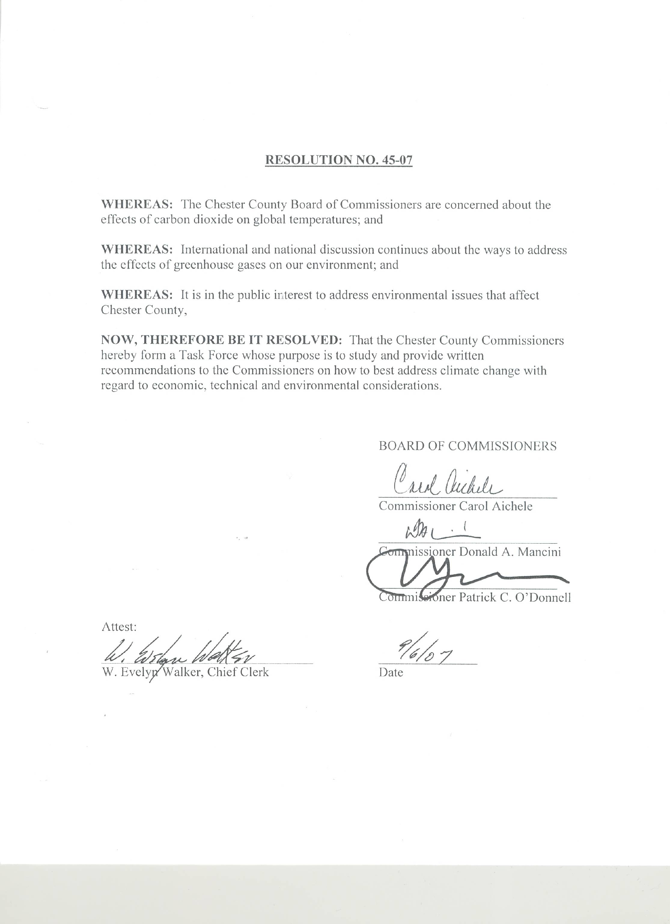
The Commissioner's Resolution 9/6/07
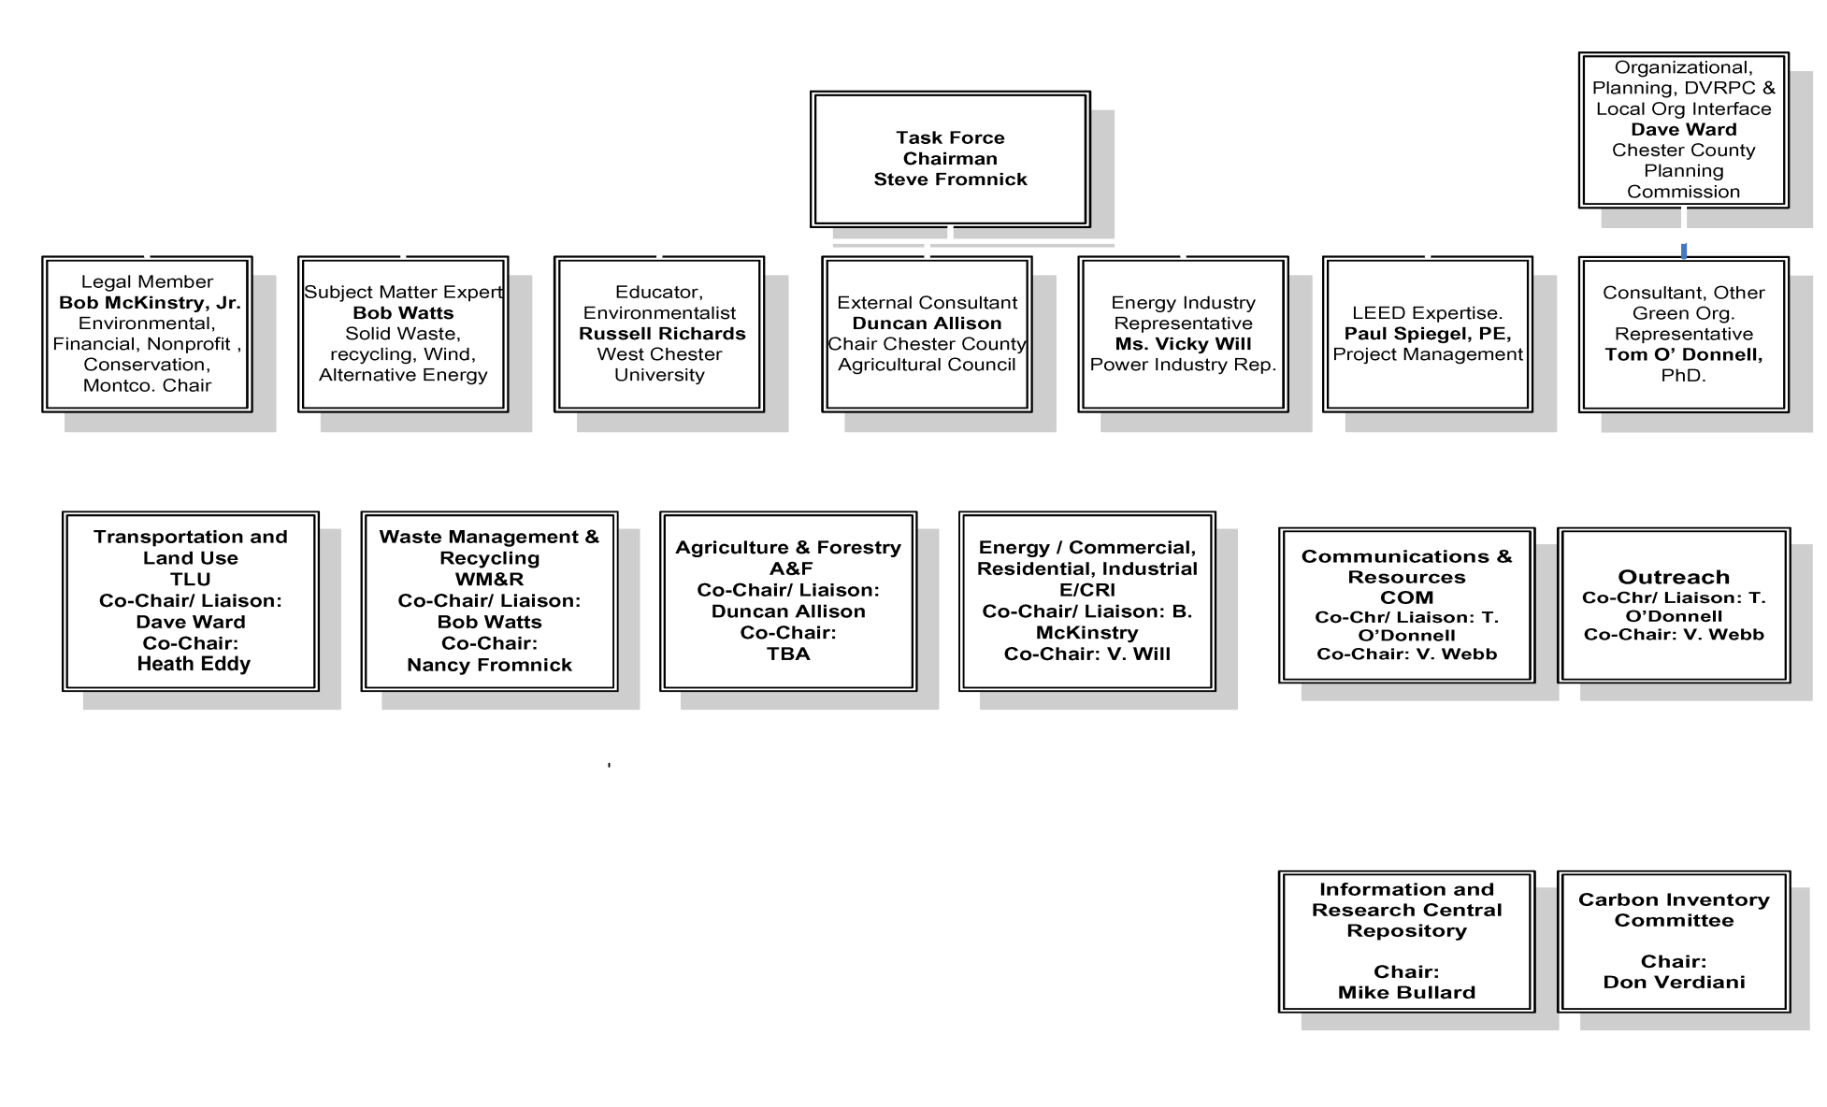

Executive Summary for Policymakers

Policymakers are faced with the challenge of interpreting the myriad of concepts, facts and options embedded in the Climate Change/Greenhouse Gas (GHG) Reduction Paradigm, as well as making policy choices from the options available. This report will focus in on the issues relevant to our County, and offer an ensemble of actions, goals and mile markers tailored to our situation.

The opportunities facing the county today are mirrored by similar opportunities in the past. When one compares agriculture, transportation, communication and the types of energy in use 150 years ago to the shape of these vital elements in our County today, the transitions are striking. Now we face many of those decisions anew. We are living today with the stream of consequences--both good and bad--which flowed from the decisions made many decades ago, and just as surely, future Chester County citizens will live with the consequence flowing from the decisions we make today. This report seeks to look ahead and compare the different opportunities available to us today, to better both the economic and environmental outcomes.
Fossil fuel energy supplies in Chester County:
- Coal
- Oil
- Natural gas
A primary challenge involves our energy supplies. Peak Oil¹ has likely arrived, coal prices² are skyrocketing, cost of heating fuels have doubled in recent years, electric rate caps are coming off³,and the electric grid is near capacity at times⁴. Not only are actual shortages possible for some energy forms, the inflationary drag on our local economy as energy prices climb is real and troubling for our economic outlook. Persons on limited incomes could face troubling choices in the years ahead--or new opportunities. We may adapt to rising energy cost through leaps in energy efficiency--or we may avail ourselves of newer, abundant forms of local energy. Likely, we must do both. This report will lay out the opportunities for both new forms of energy, and for the real economic growth made possible through investment in energy efficient technology that is ready now.

Chapter One: Commercial, Residential, Industrial Building Energy Usage

Executive summary

In 2008, the Delaware Valley Regional Planning Commission (DVRPC) compiled a greenhouse gas emissions inventory for counties and municipalities in the region. The baseline year of the inventory is 2005. Based on the DVRPC inventory, residential, commercial and industrial energy use accounts for the largest amount of greenhouse gases produced in Chester County (63.4% of the total):
- County total – 8.7 million MT CO₂e
- Residential energy use
  - 2.15 million MT CO₂e (24.5%)
- Commercial and industrial energy use
  - 3.42 million MT CO₂e (38.9%)

The County can reduce greenhouse gas emissions by reducing building energy use and procuring energy from lower carbon sources. The Energy Subcommittee identified a number of actions the County can undertake to accomplish this. These are categorized under three broad recommendations:

- Adopt a three-pronged conservation and sustainable energy use strategy
  - Institute conservation and energy efficiency best practices in County building operations.
  - Take a leadership position in removing barriers to energy efficiency and energy independence to assist residents and businesses in reducing their greenhouse gas emissions
  - Educate residents and businesses on methods and resources available to reduce energy usage and become more energy efficient

- Enhance building performance standards.

- Support local municipalities to amend local building codes to increase the minimum requirements for energy efficiency levels.

Additionally, there are two financing mechanisms the County should evaluate to assist in funding many of these recommendations. The financing mechanisms, which can be combined, are:

- Establishment of a County Energy Efficiency and Alternative Energy Utility to facilitate the public and private finance of energy efficiency, energy conservation and alternative energy production facilities
- PA Act 77 – The Guaranteed Energy Savings Act

Conservation and Sustainable Energy Use

Energy decisions made today will severely affect the physical environment, public health and financial health and security of our County for decades to come. These decisions cannot be ignored or postponed because the consequences are rapidly approaching. There are some things that should be considered immediately and acted upon while others that will take a little longer to study and implement. These are discussed separately below.

In addition to reducing energy use, greenhouse gas emissions in the County can also be reduced if the County were to procure electricity from lower carbon, alternative energy sources. The County should develop partnerships to attract the development of alternative energy resources in the County, including biomass, solar, geothermal and low-head hydro. Due to the rural nature of Chester County, opportunities for energy production from biomass should be evaluated, as discussed below.

1.a. Conservation and Energy Efficiency Best Practices in County Building Operations

County Energy Use - Short Term Recommendations

1. Chester County should hire an energy consultant to review the efficiency and sustainability of the County’s use of electricity. Their review and report should cover but not be limited to the following:
- Replacement of all incandescent lights bulbs with new high efficiency bulbs (CFLs).
- Use of the task lighting concept
- Installation of motion detectors to control lighting in areas not used for long periods such at bathrooms, break rooms, conference room storage areas and offices during weekends and the evenings.
- Use of LED lights in Exit signs
- Replacement of florescent T-12 lamps and ballasts with T-8 lamps and ballasts
- Use of solar and wind energy where possible
- Installation of dimmers where appropriate
- Use of natural daylight when sunlight is available
- Cleaning of air filters monthly
- Regularly cleaning all heat exchanger surfaces, water and refrigerant coils, condensers and evaporators.

2. Chester County should adopt the following guidelines on outdoor lighting under its jurisdiction, taking into consideration security concerns. All new and replacement outdoor lighting should have the following characteristics and existing lighting should be reviewed to determine the economic feasibility of updating to these standards.
- All area lighting should be LED type lights
- Where possible the lighting should be solar
- With the exception of security concerns, outdoor lighting for buildings should be automatically shut off one hour after the business closes until the building is reopened. Similar automatic shut off should be installed for parks and parking lots under the County control

Short Term Recommendations Discussion

Motion sensors have been used to reduce electricity usage by Tufts University at campus vending machines and by Harvard in their classrooms (Reference 1)

Researchers from the California Energy Commission’s Public Interest Energy Research Program (PIER) experimented with occupancy sensors and LED night lights at the Double Tree Hotel in Sacramento, California. The results showed a 50% energy savings, 33% reduction in operations and a 2.5 year payback for new construction and 5.5 for retrofits. The payback is based on energy use reduction alone (Reference 2).

The city of Portland Oregon obtained a 40% energy savings by switching to T-8 from T-12. This resulted in a payback of 5 years. This is per discussion with Dave Tooze (503-833-7582) of Sustainable Portland in August 2006.

The combination of LED lights and solar power provide a powerful combination of energy savers and alterative energy. The International Dark-Sky Association is calling for regulations on LED street lights design to reduce light pollution and unnecessary glare (1). The Energy Star program appears ready to adopt them in their 2009 standards. Several states are considering enactment or have actually enacted light pollution laws including Massachusetts (2), Maine, Arizona, Connecticut, New Mexico and Iowa(3). Any purchases should conform to these new 2009 Energy Star recommendations which mainly deal with shielding.

Short Term Recommendations References

(1) Sierra magazine, November/December issue, “Go Big Green”, pg 33-35
(2)http://www.energy.ca.gov/2005publications/CEC-500-2005-141/CEC-500-2005-141-A26.PDF
(3) http://starrynightlights.com/blog/category/led-light-bulbs/
(4) http://www.cfa.harvard.edu/nelpag/BILL.html
(5) http://www.legis.state.ia.us/GA/78GA/Legislation/HF/00200/HF00265/Current.html

County Energy Use - Long Term Recommendations

Chester County should hire an energy consultant to help the County develop an energy use sustainability plan that will allow the County to (1) minimize the cost of energy; (2) cost effectively use alternative energy resources; and (3) position the County to take advantage of technological developments in the energy sector that promote sustainability. The review should cover but not be limited to the following:

1) Operational improvement and investment measures to improve the economic and environmental efficiency of the County’s lighting, heating, cooling systems, and motors in administrative and non-administrative facilities;

2) The installation and development of distributed energy and storage resources, such as solar, ice-making and combined heat and power plants;

3) Evaluation of alternative energy generation sources feasible within the County, such as low-head hydro, solar, geothermal, biomass. See next section for a recommendation

4) Installation of centralized automation equipment and other software devices that will allow the County to optimize the benefits of controlled power use and distributed energy resources.

5) The execution of an energy supply plan that will allow the County to develop a sustainable electric power supply portfolio.

6) County participation in programs administered by PJM Interconnection and/or PECO that will allow the County to use its ability to control energy use to reduce power expense and its carbon footprint.

Long Term Recommendations Discussion

The county should take a leadership role in showing how active energy and power management through the deployment of energy efficiency measures, control of unnecessary usage of electric power and use of distributed resources can reduce the cost of energy and yield environmental benefits. Numerous studies conducted by the Department of Energy and independent researchers have demonstrated the personal and societal benefits of these types of measures.

The Alliance to Save Energy notes that the cost of energy efficient measures is .2-.4 cents a kWh. See the Alliance to Save Energy web site at www.ase.org.

Recommendation for Study on Energy Production from Biomass

The potential for waste-wood biomass to energy opportunities are discussed in Chapter 5: Agriculture and Forests, Section H: woody Biomass in greater detail.

The Energy Committee recommends that Chester County should retain a consulting firm to accumulate reliable data on the magnitude of economically combustible organic waste material available in the County. It is recommended that the Commissioners use the findings of such a study to encourage its use by a commercial electric energy producer.

Biomass Discussion

The study should identify the potential to capture as much as possible of the woody waste and other suitable organic waste material created in Chester County annually.
- This should at minimum include material generated by landscapers, tree care specialists, homeowners, home builders, and Asplundh (in behalf of PECO from waste generated in the clearing of power lines by them).
- It should also include all clean lumber residuals from home construction.

The study should also identify locations to which this material can be accumulated and converted to chip form and other forms suitable for feed to a boiler or combined heat and power plant for combustion to generate electricity.

There are about 140 firms operating in Chester County that collect waste woody materials. From very preliminary data from a few of those firms and extrapolation to the total number of firms, along with a rough estimate of the amount collected by Asplundh in behalf of PECO, there may be as much as 35,000 tons of this material collected in Chester County annually. In very rough terms, that amount of mixed waste wood materials could generate about 40 billion BTUs per year when co-fired with coal.

Further sources of material that can be considered include:
- Well dewatered sludge from the wastewater treatment plants in the County.
- Corn stover (stalks) and cobs from agricultural crop residues. Here, it would be necessary to ensure that sufficient residual material was left on the ground to replace necessary nutrients back to the soil, but as much as 50% of the residues could likely be collected for use as fuel.
- Woody residual materials from other agricultural crops.
- Mushroom house waste bedding material, if its combustion would make technical and economic sense.
- Clean combustible wood fiber-based waste paper. In a full life cycle analysis, it may be that burning waste paper instead of recycling it may be the most environmentally appropriate way to dispose of the material. If that were proved to be attractive and a convenient technology exists to feed the waste paper to a boiler for co-firing, it could be an interesting additional option. However, even if environmentally and economically attractive, it is likely that there would be pushback from folks that are devoted to the idea of recycling.

The Energy Committee explored a “Fuels for Schools and Beyond” project that would garner subsidies from the Commonwealth and the Federal Government to offset some of the initial capital cost for installation. There is a concern that this would place a heavy operating and maintenance burden on a school to ensure that the delivered chips were clean and would work in the system. As an alternate, schools could consider geothermal systems for renewable energy resources to replace the use of fossil fuels for their heating. Geothermal systems should be virtually maintenance free once installed.

Biomass References
- Survey sheets returned to the Energy Committee by landscapers and tree specialists that list their woody waste material collection practices.
- Data on the heating value of common wood species is widely available from a number of sites on the Internet. One such source is found at http://hearth.com.
- Bruce Arnold, a member of the Committee, is a retiree of Scott Paper Company, where he was involved with Scott’s eleven pulp mills throughout the world. In that service, he became well aware of the types and operation of wood handling and processing equipment, as well as of the design and operation of very large biomass boilers that were used to produce heat and electricity for use in the pulp mills. This is a very well developed technology and one that could be readily adapted to a coal boiler system, such as the one operated by Exelon at the Cromby Generating Station in Phoenixville or a newly constructed facility

1. b. Remove Barriers to Energy Efficiency and Energy Independence

The County can take a leadership position to remove barriers it residents and businesses face in reducing their greenhouse gas emissions. This can be done through model ordinances for adoption by townships and boroughs in the following areas:
- Limit Homeowner Associations in their ability to restrict installation of alternative energy and conservation equipment unless there is a safety concern
- Require outdoor lighting to be LED lights which meet Dark Sky recommendations

The cost and energy savings and rates of returns on recommendations adopted by the County should be shared with townships and boroughs to assist in their evaluation and decision making processes.

Homeowner Association Recommendation

The County should approve and recommend the following model ordinance for townships to adopt:

The township and all homeowners associations (HOAs) and condominium associations located therein shall not place restrictions, either directly or in effect, on the installation or use of a solar energy system, wind energy system or energy conservation equipment unless the restriction satisfies one of the following conditions:
- Serves to preserve or protect the public health or safety.
- Does not significantly increase the cost of the system or significantly decreases its efficiency.
- Allows for an alternative system of comparable cost and efficiency.

This model ordinance applies to, but is not limited to, the following:
- Roof and ground mount solar energy devices (Photovoltaic and thermal hot water)
- Wind energy generators
- Awnings, shutters, and other shade structures marketed for the purpose of reducing energy consumption
- Garage and attic fans
- Vents
- Evaporative coolers
- Energy-efficient outdoor lighting devices
- Retractable outdoor clotheslines

Discussion

This proposed statute is an amalgamation of laws based on enacted and proposed state statutes in Colorado, Wisconsin, Nevada and Arizona:
(1) Colorado’s law was signed on April 24th, 2008. See www.cohoalaw.com.
(2) Wisconsin’s statute 66.0401 was passed in 1993 and Nevada is currently considering Bill AB236. See the National Renewable Energy Laboratory Conference Paper NREL/CP-500-38167 issued May 2005 titled Zoning for Distributed Wind Power-Breaking Down Barriers by Jim Green and Mick Sagrillo. http://www.renewwisconsin.org/wind/toolbox
(3) Press Release - Arizona Solar Energy Industries Association - 25 February 2003
“Arizona Court Again Strikes Down HOA Restrictions on Private Property Rights to use Solar Energy”
The Arizona Court of Appeals issued a published opinion in a case that will lead to greater use of solar energy in Arizona. In Garden Lakes Community Association v. Madigan/Speak, the HOA was seeking to force the homeowners to take down solar panels installed on the roof. The Appeals Court found that the HOA's deed restriction and architectural guidelines, combined with the HOA's conduct, violated the public policy of Arizona as expressed in Arizona Revised Statute Section 33-439.
The Appeals Court, in upholding the lower courts decision in favor of the homeowners, concluded the HOA's restriction on solar panels "effectively prohibited the installation and use of SED's (solar energy devices)." The Association attempted to place restrictive guidelines on the residents that were contrary to the provisions of A.R.S.-33-439 (A). The Arizona Legislature passed ARS-33-439 in 1979 in order to protect individual homeowner's private property rights to use solar energy.
(4) The use of outdoor retractable clotheslines is a growing demand of the “Right To Dry” movement originating in Vermont and the Project Laundry List in New Hampshire. North Carolina recently passed a law invalidating limitations on energy devices based on the use of renewable resources. See http://www.EROEI.com/articles/2007-articles/the-clothesline-makes-a-comeback. According to the Association of Home Appliance Manufacturers in 2005, there were 88 million dryers in the country. Annually these dryers consume 1,079 kilowatt hours of energy per household creating 2,224 pounds of carbon-dioxide emissions.

Cost: Homeowners associations are under the jurisdiction of the townships in Pennsylvania. A model statute like this would give the townships guidance in adopting responsible laws in this area without costing the county (or township) any money.

Carbon Savings: Calculation of estimated carbon savings for this proposal could only be accomplished with specific assumptions (how many homeowners would install alternative energy devices, when, what type of device, how many associations currently restrict the installation) specific to each locality adopting the statute.

Outdoor Lighting Model Ordinance Recommendation

Chester County should adopt the following model ordinance for government and business outdoor lighting. It would serve as a guide to the local jurisdictions in development of their policies on the subject.

All new and replacement outdoor lighting should have the following characteristics and existing lighting should be reviewed to determine the economic feasibility of updating to these standards.
- All area lighting should be the LED type
- Where possible the lighting should be solar
- With the exception of security and safety concerns, outdoor lighting for commercial and government buildings should be automatically shut off one hour after the business closes until the building is reopened. Similar automatic shut off should be installed for parks and parking lots.

Discussion

The combination of LED lights and solar power provide a powerful combination of energy savers and alterative energy. The International Dark-Sky Association is calling for regulations on LED Street lights design to reduce light pollution and unnecessary glare (1). The Energy Star program appears ready to adopt them in their 2009 standards. Several states are considering enactment or have actually enacted light pollution laws including Massachusetts (2), Maine, Arizona, Connecticut, New Mexico and Iowa (3). Any purchases should conform to these new 2009 Energy Star recommendations which mainly deal with shielding.

References
(1) http://starrynightlights.com/blog/category/led-light-bulbs/
(2) http://www.cfa.harvard.edu/nelpag/BILL.html
(3) http://www.legis.state.ia.us/GA/78GA/Legislation/HF/00200/HF00265/Current.html
(4) See Appendix – Ordinances 95 and 95A from London Grove Township on outdoor lighting standards as model ordinances

1. c. Educate Residents and Businesses on Methods and Resources to Reduce Energy Usage

The County can help residents and businesses reduce greenhouse gas emissions associated with energy usage by providing education on tools and resources available, as well as funding mechanisms to assist in their projects. The County website provides a great tool to facilitate this and recommendations to improve the website to do this are discussed below.

Education and Outreach Recommendations:

The County should incorporate the following into its existing training programs and resources.

Commercial/ Industrial

The County should sponsor and coordinate workshops and training:

- for architects, designers, and operators of buildings so that they are knowledgeable about LEED & Energy Star practices and can successfully use resources. Successfully done by BLUER for Energy Star (http://www.energystar.gov/)
- for business owners so that they are aware of grant programs, renewable energy credits, and other programs to support energy efficiency; e.g., Industrial Assessment Centers, US DOE Industrial Technologies Program (http://www1.eere.energy.gov/industry/).
- by utilizing the resources of the Chester County Economic Development Council (http://www.cceconomicdevelopment.com/service_edutraining.html), and West Chester University and the Business Technology Center (http://www.btcwcu.org/index.htm).

Residential

- Connect with citizens groups and municipal teams (e.g., 4CP, BLUER) within the County to sense educational needs and to share strategies and information.
- Provide event-oriented educational opportunities through a Speakers Bureau drawn from County Departments (e.g., Health, Planning, Water Resources, Agricultural Development Council), colleges and universities, and citizens groups (e.g., 4CP) with specialized knowledge or interests in energy issues and climate change.
- Use the Chester County Library system (central library + 17 member libraries) to provide programs and specialized information resources.

[“The Chester County Library System provides materials and information for life, work and pleasure.” “The libraries… contribute to the quality of life by helping residents become thoughtful, educated and involved members of their communities.”]

- Use the Chester County Parks & Recreation Department to provide programs to inform park visitors about the effects of climate change parks and the role of energy conservation to limit climate change.
[The Department works “to enhance the quality of life through educational programs, recreational opportunities, and partnerships. The Department serves the community by protecting and managing open space while interpreting natural, cultural and historical resources.”]

- Use the Chester County Office of Public Information to advertise the County’s GHG reduction initiatives and programs to the public.
[Mission Statement
To manage the overall communications program for Chester County government, both internally for employees and externally for the citizens of the community.

As a member of the Commissioner’s staff, the Public Information Officer (PIO) is responsible for the release of accurate and timely information to insure the public is well-informed on the services, accomplishments and initiatives of Chester County government.

The Public Information Office is committed to educating the public on the responsibilities, functions, and services of their county government organizations. It is the goal of the PIO to foster a positive image and comprehensive understanding of the organization, and to promote its initiatives and achievements.]

County Website Enhancements

Chester County should establish a Green Corner on its website and encourage Townships to do the same. The County can provide links to each Township’s website from the County home page and vice versa. The web sites should be designed to do the following:
- Lists the County’s goals and mission regarding conservation and clean renewable energy
- Provides an updated list of Green Events in the County and neighboring jurisdictions with their website addresses
- Lists helpful Green practices and products
- Lists the adopted recommendations of the Chester County GHG RTF and progress on implementation of those recommendations
- Lists businesses in Chester County that provide green products and services with a web site address if possible. These products and services should at least cover the following areas:
  - Geothermal heat pump installers and service providers.
  - Solar energy installers and providers
  - Wind turbine installers and providers
  - Energy star equipment providers
  - Water conservation equipment provider
  - Job opportunities in the various green industries
  - Training courses currently being offered in the alternative energy field by various organizations
  - Local farm markets with dates and hours of operation and locations
  - Home and business energy efficiency service providers

Discussion

The County would be demonstrating strong leadership in this area by setting up and maintaining a helpful website. This will not only provide a service to the residents of this county who are part of the growing grass roots movement to live cleaner and healthier and improve environmental quality. It will also benefit the growing green business in the county.

Cost
The cost would be the salary of a part time webmaster. A recent college graduate or a student at a local university with web experience and interest in the environmental area could complete this.

References
Refer to the London Grove web site at http://www.londongrove.org/ and click on the Green Corner section to the left of the screen as a best practice.
2. Building Performance Standards

In order to curb direct and indirect emissions of greenhouse gases (GHGs) from the building sector, the County should incentivize the construction and operation of buildings that adhere to LEED or Energy Star standards. To serve as a role model for all residents, institutions, and businesses, the County should require certification of its own existing and new buildings. The County should incentivize the use of LEED/Energy Star products in the private sector via building permit fee reductions, expedited permitting reviews, or property tax credits or abatements, whichever is most appropriate to the situation. To maximize the energy efficiency and resultant GHG reduction benefits of this recommendation, the LEED/Energy Star building projects for the County and the private sector should be required to earn a specified number of points under the “Optimize Energy Performance” credit of the “Energy and Atmosphere” category. Other green building rating systems could be eligible for the private sector incentives as well.

Discussion

There are benefits and limitations to both LEED and Energy Star that are discussed in more detail herein.

The LEED (Leadership in Energy and Environmental Design) Green Building Rating System™ was created by the US Green Building Council (USGBC). LEED is a widely recognized and accepted green building rating system in the country, one of the reasons for which is because it has produced market transformation. As of September 1, 2008, various LEED initiatives have been established across the US in the form of legislation, executive orders, resolutions, ordinances, policies, and incentives in 105 cities, 29 counties, 25 towns, 31 state governments, 12 federal agencies or departments, 15 public schools, and 38 institutions of higher education¹ (please examine this reference to read all the details of these initiatives).

Why promote green buildings as a strategy for combating global climate change? The answer is not only do green buildings directly reduce GHG emissions via energy efficient features; they also provide numerous indirect benefits which help to combat climate change. The LEED credit checklist² offers a glimpse of what those indirect benefits include. For instance, LEED issues up to two points for the use of locally harvested and manufactured materials in a building project and thus reduces the GHG emissions generated by vehicles used to transport those goods. LEED also provides up to four points for encouraging the use of alternative transportation (i.e. biking, use of mass transit). By providing points for the use of recycled content materials and reusing portions of existing buildings, energy is saved because raw materials do not have to be used. Other indirect GHG-reducing features for which LEED issues points include site location considerations (i.e. urban infill projects), the purchase of electricity from green sources (green power), and the use of wood products from sustainably-managed forests. LEED also provides two points for landscape and exterior design features (green roofs, high-reflectivity surfaces) that reduce the urban heat island effect, which increases the cooling load of our buildings and thereby increases emissions from power plants. The water-efficient features of green buildings produce energy savings due to less need to pump and treat water. In addition, as we begin to feel the effects of global climate change, such as increased flooding and drought, the water efficiency and storm water management features of green buildings will help us to cope.

Numerous organizations and governments have recognized how green buildings complement their climate change initiatives and have thus incorporated green buildings as part of their climate change action plans. For instance, Philadelphia, as part of its Local Action Plan for Climate Change, passed an executive order in 2007 requiring all new municipal construction and major renovation projects over 10,000 square feet attain LEED Silver³. In 2008, the 21 localities that surround the nation’s capital and comprise the Metropolitan Washington Council of Governments published a best practices guide of programs and policies that are working to reduce GHG emissions in the region⁴. Green buildings are one of the best practices which are highlighted, and the guidelines state that LEED is the green building rating system of choice.

Energy Star is an excellent program as well. It focuses on energy efficiency and does not contain the indirect GHG emissions benefits that LEED does. A benefit of Energy Star is that it requires a building to attain a certain level of energy efficiency. For instance, Energy Star-labeled buildings use on average 35% less energy than typical buildings and must obtain a score of 75 or more to be eligible for the label. A common complaint with the LEED rating system is that it doesn’t require enough energy efficiency, as LEED for New Construction (LEED-NC) only requires two points (energy cost savings of 14% for new buildings and 7% for existing building renovations) be obtained in the Optimize Energy Performance credit. The County should thus make a requirement that a specified level of points be attained under this credit for each LEED product used in buildings in the County. According to the Government Resources section of the USGBC website¹, several cities and one county have added this requirement to their LEED initiatives. In regard to the residential sector, it is important to note that the LEED for Homes (LEED-H) rating system uses Energy Star criteria as the baseline. Thus, a home cannot attain LEED certification without at least meeting Energy Star criteria.

Another common complaint regarding LEED is that importance is placed on energy design and not energy performance. However, one of the best aspects of the USGBC and its LEED rating system is that they are continually trying to improve it. For instance, USGBC is currently working on their most recent version, LEED 2009, which is to focus more on the actual energy performance of buildings. In addition, the USGBC newly-released 2009-2013 strategic plan⁵ states that two key strategic issues they will address in the coming years are the lack of performance data for LEED buildings and finding more ways for LEED to combat climate change.

Since the majority of buildings are already built, the LEED for Existing Buildings (LEED-EB) rating system holds much promise. The USGBC just released a new version of this rating system called LEED-EB: Operations & Maintenance (O&M). There is an emphasis on energy performance in LEED-EB: O&M due to the fact that you must recertify all projects attaining this designation at least once every five years. LEED-EB: O&M also requires a minimum Energy Star score of 67 to qualify for the designation. An interesting point to note here is that major corporations, such as Exelon are renovating existing buildings to LEED-EB standards when undertaking modifications.

Multiple case studies have shown that LEED buildings can be constructed for the same initial capital costs as traditional buildings. This requires a project team (general contractor, architect, engineers) whose members have green building experience and set green goals from the onset of the project. A 2007 Davis Langdon (consulting firm focused on managing construction costs for architects & owners) report⁶ shows there is no significant difference in average costs for green buildings as compared to non-green buildings. For LEED-EB: O&M, a number of the credits can be achieved by writing and implementing policies, thereby costing only staff time.

Penn State's green building policy requires that new construction meet LEED certification standards. Three campus buildings are LEED-certified, two buildings are awaiting certification, and one building has been LEED-EB-certified. The university has installed low-flow faucets, showerheads, toilets, and urinals, as well as higher efficiency washing machines.

References
http://www.usgbc.org/DisplayPage.aspx?CMSPageID=1852
http://www.usgbc.org/ShowFile.aspx?DocumentID=3998
http://www.phila.gov/green/LocalAction/pdf/PhiladelphiaClimateChangeLocalActionPlan2007.pdf
http://www.mwcog.org/store/item.asp?PUBLICATION_ID=321
http://www.usgbc.org/ShowFile.aspx?DocumentID=4708
http://www.dvgbc.org/green_resources/research/Cost_of_Green_Revisited.pdf
http://www.greenreportcard.org/report-card-2010/schools/pennsylvania-state-university

3. Building Energy Codes

Building energy codes specify minimum energy efficiency requirements for new buildings or for existing buildings undergoing a major renovation. Amending local building codes to increase the minimum requirements for energy efficiency levels will have an immediate and ongoing impact in reducing building-sector greenhouse gas emissions.

Improvements for Evaluation

- The greatest results for energy reduction would come from the implementation of building testing for energy consumption rather than leaving the present (and/or) choice for energy compliance to the 2009 energy code adapted by Pennsylvania from federal levels. The (and/or) is a choice given to building professionals to meet code or estimate building performance with REScheck or COMCheck Code Compliance Software or similar and not have to measure actual performance of building. Measuring actual performance of buildings reflects the workmanship and guarantees the performance of the building in real world conditions leading to baseline for additional improvements of energy efficiency.

- Provide Building Inspectors with equipment to perform blower door test with calculations to measure actual air tightness of building package (or qualified testing companies certification). Requiring 2009 IECC (International Energy Conservation Codes) testing option of building envelope tightness and insulation installation shall be acceptable when tested air leakage is less than 7 ACH when tested with a blower door at a pressure of 50 Pascals.
- Continue to inspect for minimal R-value of building thermal package. Inspect to insure proper ventilation for roofing and indoor air quality is present and operating properly.

- Increase 2009 IECC R-values for buildings’ thermal packages by 50% more to greatly reduce the energy needed for heating and cooling.

- Require actual building performance results to determine if all criteria are met per adopted present building energy codes or exceed minimum.

- Prior to building settlement transfer, require disclosure of annual energy cost or energy usage for heating and cooling.

- Partner with the Weatherization Training Center of the Pennsylvania College of Technology branch of Penn State to put a satellite program in Southeastern Pennsylvania for low income families and all sectors of the economy. The partnership could include local economic development organizations. This could be located at the Great Valley Campus in Chester County.

The Weatherization Assistance Program enables low-income families to permanently reduce their energy bills by making their homes more energy efficient. During the last 30 years, the U.S. Department of Energy's (DOE) Weatherization Assistance Program has provided weatherization services to more than 5.6 million low-income families.

By reducing the energy bills of low-income families instead of offering aid, weatherization reduces dependency and liberates these funds for spending on more pressing family issues. On average, weatherization reduces heating bills by 32% and overall energy bills by $358 per year at current prices. This spending, in turn, spurs low-income communities toward job growth and economic development. In some cases some cases the expenditures averaging around $2500 produced results ranging from 20% to 50% energy reduction for heating cooling and hot water.

References
http://www.energycodes.gov/implement/state_codes/state_status.php?state_AB=PA
http://apps1.eere.energy.gov/weatherization/
http://apps1.eere.energy.gov/weatherization/improving.cfm
http://apps1.eere.energy.gov/weatherization/wxtech_neat.cfm
http://www.pct.edu/wdce/wtc/

Sample Model Ordinance

To promote incorporation of building performance standards in new developments, the County should adopt a model ordinance for Townships to use to promote sustainable development. Language provided by London Grove Township is provided herein.

§__.___ Green Design

Applicants for Subdivision and Land development who earn Neighborhood development credits in accordance with Section ___.__ of the Subdivision and Land Development Ordinance may receive and increase in the Density and/or Floor area Ratio as follows, provided all other requirements of this Ordinance and the Subdivision and Land Development Ordinance are met;
30-50 credits 10% increase
50-79 credits 15% increase
80 or more credits 20% increase

1. All applicants for subdivision and Land development shall submit a “Neighborhood Design Plan”, which shall include documentation as identified in the June 2007 Pilot version of LEED for Neighborhood Development Rating System for all prerequisites required by section ___.___.02 of this Ordinance, and for all Credits which they are seeking in accordance with section ___.___.03 of this Ordinance.

Exceptions:
- Lot Line Changes, which do not create any new lots.
- Residential subdivisions creating less then 5 lots, and not involving the construction of a new roadway.

2. All Subdivision and Land development plans shall meet the prerequisites identified in the June 2007 Pilot version of LEED for Neighborhood Development Rating System as published by the U.S. Green Building Council, with the exception of “Smart Location and Linkage, Prereq 1, Smart Location”, and “Neighborhood Pattern & Design, Prereq 2, Compact Development”.

2. Subdivision and Land development applicants are encouraged to, and may gain additional density and/or floor area in accordance with the zoning ordinance for obtaining credits in accordance with the June 2007 Pilot version of LEED for Neighborhood Development Rating System as published by the U.S. Green Building Council. Credits are available for all sections with the exception of “Neighborhood Pattern & Design, Credit 1, and Compact Development”.

3. Final determination for prerequisites met, and credits received, for the purpose of this ordinance, shall be made by London Grove Township.

4. Nothing in this ordinance shall require applicants for Subdivision and Land Development to obtain LEED Certification, however such certification is encouraged.
Financing Mechanisms

Establishment of a County Energy Efficiency and Alternative Energy Utility

The County should establish an “Energy Efficiency and Alternative Energy Utility” as a municipal authority which will facilitate the financing of both public and private projects that will conserve energy, increase energy efficiency and produce alternative low or no carbon energy. The authority would coordinate information about financing mechanisms and accumulate capital from various sources to create revolving funds for loans that would be repaid out of energy savings from the projects, revenues from alternative energy production, and revenues from sources such as the sale of alternative or renewable energy credits (“RECs”) and verified emissions reductions (“VERS”) of both carbon dioxide and other tradable pollutants such as NOx. The authority would issue bonds for projects that can be financed through tax exempt bond financing and identify other sources of revenue (e.g. grants or other funding) to create funds for projects that would not qualify for bond financing. The US Department of Energy (DOE) Energy Efficiency and Conservation Block Grants (EECBG) Program grants might be used to provide seed funding. The authority would facilitate joint public private financing mechanisms to allow use of federal and state tax credits. The Authority could establish a Preferred Assessment for Clean Energy (PACE) Program, using existing legal authority.

Discussion

Implementation of cost effective projects to reduce carbon dioxide emissions through energy conservation and efficiency or alternative energy generation facilities is often limited by (1) the availability of mechanisms to provide readily available capital and (2) lack of knowledge regarding these opportunities and the many tax incentives, grants and mixed funding solutions that are available. A number of states and localities are examining ways to increase the funding and knowledge available for implementation of these projects and sometimes providing public funding to act as seed money. One of the mechanisms that has been used in a number of states, including Delaware, Vermont and California, is an energy efficiency utility. Although Pennsylvania does not have such a utility, counties and other municipalities could create an equivalent institution by creating a municipal authority.
The authority could perform four functions: (1) It would raise capital for qualifying projects through its power to issue bonds, from state and federal grant programs and foundation sources. (2) It would use the capital to create revolving low interest loan funds that would loan money to qualifying projects and be repaid (and have its costs of operation covered) by payments equal to the cost savings from the projects and revenues from the projects (i.e. sales of energy and attributes such as renewable energy credits or emissions reduction credits) or voluntary assessments on real property installing the project. (3) It would provide information regarding projects and financing opportunities. (4) It would facilitate contacts between those wishing to implement projects, potential outside investors, and vendors of equipment and services necessary to implement these projects.
The Authority would provide a mechanism to fund county projects without implicating the County’s bond caps, to create incentives for municipalities to implement similar projects without implicating their bond caps, and to create incentives for individuals and companies to develop projects.
Types of Projects that Might be Funded

There are a wide variety of projects that can reduce greenhouse gases and potentially be funded through the Authority or through projects where the Authority assists in identifying sources of private capital.
- Renewable energy technologies include wind, solar, geothermal, biomass and waste fuels in both stand alone configurations and co-firing in traditional boilers.
- New and retrofitted buildings can achieve high energy efficiency and LEED certification. Weatherization, alone can produce significant GHG emissions reduction
- Water and wastewater treatment options help conserve water (and thereby reduce GHG emissions associated with treatment and pumping) and take advantage of biological processes. Solid waste can yield new materials and energy while reducing net GHG emissions.
- Biofuel can be manufactured from a variety of feedstocks or purchased for fleet use or energy generation. Biofuel production can be integrated into sustainable systems for forestry and agriculture, which will both reduce GHG emissions and promote carbon sequestration.
- Many innovative strategies involve integrated solutions such as district heating and cooling, campus or community smart electrical grids, and purchasing aggregation. An institution or community can manage its total energy demand as an asset, arbitraging both time of use and type of fuel.
- Management of transportation systems and facilities planning can result in a more livable community while reducing fuel use in an era of rapidly escalating prices.
Available Incentives

Numerous incentives can assist in pursuing these strategies:
- Federal tax incentives include investment tax credits for solar electric and hot water, production tax credits for most other forms of renewable electric energy and certain biofuels, and tax credits for achieving energy efficiency in new buildings and retrofits. These facilities can also generally take advantage of accelerated depreciation.
- Other federal tax credits such as new market tax credits, historic preservation tax credits and housing tax credits can potentially be applied to construction projects as well.
- Pennsylvania recently created a state tax credit for renewable energy projects. States often grant tax credits for favored forms of commercial development.
- Over 30 states, including Pennsylvania, have adopted legislation requiring electricity retailers to sell a certain percentage of renewable electricity. Utilities and other electric retailers can meet their requirements by buying renewable energy credits from renewable energy generators, including those in other states.
- Federal grants administered by the US DOE, including Energy Efficiency and Conservation Block grants are available to provide seed funds
- Pennsylvania has grants and loans available for alternative energy facilities, energy efficiency programs and energy conservation programs.
- Though the United States is not a signatory to the Kyoto Treaty, carbon credits generated by greenhouse gas emissions reductions can currently be purchased and sold in the voluntary market and qualifying credits will be able to be sold in the Regional Greenhouse Gas Initiative Market following the first auction in late September 2008.
- Municipalities, hospitals, schools, universities, colleges, and other charitable institutions are generally able to finance campus and building improvements through tax-exempt bonds (but would not, as an example, be able to finance electric generating equipment if the institution generates electricity in excess of its own demand) and an authority can also issue bonds to finance these projects. Certain facilities can be financed with tax-exempt bonds even though owned by or managed by private parties, including electric generating facilities using waste fuels, district heating and cooling systems, and water and wastewater treatment systems. Tax exempt finance can substantially lower borrowing costs. However, certain federal tax credits can be reduced or eliminated when used in conjunction with tax-exempt bonds.
Implementation

Implementing many of the strategies outlined above will involve construction and in some cases operation by private parties who bring specialized experience or proprietary technology. Private ownership or operation of facilities eligible for tax credits may substantially reduce all-in costs. By facilitating partnering arrangements with private companies, the Authority will allow tax exempt institutions to take advantage of third party expertise and technology while at the same time reducing cost. It is important to structure the arrangements to assure appropriate performance guarantees and consistency with the values of the university community. Care must be taken to deal with technical structure around unrelated business income, but 501(c)(3) organizations can, if they choose, invest in their own energy future at rates that compare favorably to their endowment return.

A Sustainable Energy Utility (SEU) can implement other recommendations of this plan. For example, an SEU can utilize energy performance contracting. An SEU can also establish a Preferred Assessment for Clean Energy (PACE) Program.
In addition to private partners, hospitals, schools, colleges, universities and other charitable organizations (for example conservation organizations and museums) that rely on contributions may wish to involve their donors in financing sustainability improvement. Donors can be given the opportunity to be tax investors in projects eligible for tax credits. Donors can be offered to purchase bonds designed to meet estate planning objectives by eventual recontribution of the principal to the institution. Interests in real property such as buildings can be contributed to a charitable remainder trust. This can create the opportunity to establish relationships that will continue for the economic life of projects that will extend into times when estate planning is important.
Cost and Carbon Reduction

Initial legal fees would be required to establish the authority, but the authority should be able to repay costs through its programs and bond issues. All costs would be recovered through revenues from project loans.

This is a mechanism to finance both public and private financing of many projects. The projects will achieve very significant carbon reductions.

PA–Act 77/The Guaranteed Energy Savings Act

Chester County should explore implementation of a Performance Contract (aka Guaranteed Energy Savings Agreement) for the benefit of reducing utility usage & costs with respect to all County buildings. The typical program can yield up to 25% of total annual energy savings (electric, water, natural gas, and oil).

The reduction in energy usage will result in significant emission reductions. As an example, a project for a near-by county resulted in savings of 2,000,000 kWh’s and 275,900 therms of natural gas through the implementation of a performance contract. This resulting in the following of reduction in emissions:

Table 1-1

Type of Pollution | Amount of Reduction /Year
Greenhouse Gases (CO2) | 7,438,237 lbs
Nitrogen Oxides (NOx) | 10337 lbs
Sulfur Dioxide (SO2) | 31225 lbs
Toxic Metals Pollution | Amount of Reduction /Year
Mercury (Hg) | 55432 lbs

Other PA County’s who have used Act 77/GESA are Delaware County, Lehigh County, Blair County, Beaver County, Cambria County, Armstrong County, Indiana County, Lackawanna County, Luzerne County, Allegheny County, Berks County, & Dauphin County.

Background on Act 77

The Pennsylvania Legislature enacted authorizing legislation in 1998, amended in 2003, that enables the Commonwealth’s state agencies, universities, local governments and school districts to use energy performance contracting to implement large capital-improvement energy projects and reap the associated long-term energy-saving benefits (see 73 P. S. §§ 1646.1–1646.7). Act 77 uses energy savings as a means to offset the capital costs for improvements, which is financed either as a lease or bond.

Guaranteed energy savings agreements (GESAs) are offered by Energy Service Companies (ESCOs) as a practical way for public sector entities to obtain and finance energy-saving projects for their facilities.

- GESAs can provide the resources to finance and acquire needed capital equipment and improve energy efficiency and comfort in public buildings.

- GESAs are use by agencies because they offer a means for overcoming constrained capital budgets, aging and inefficient buildings and equipment, and limited maintenance staff resources. In Pennsylvania, one of the most attractive and distinguishing features of GESAs is the guaranteed energy cost savings that pays for all associated project costs over the life of the contract. This provides an opportunity for agencies1 to free up scarce budget resources for other needed services and activities.

- By allowing the energy cost savings to cover all projects and financing costs, GESAs provide agencies with the ability to purchase these comprehensive energy improvements (e.g., lighting, heating, air conditioning, and system controls, etc.) and services from qualified ESCOs.

- Agencies in Pennsylvania are authorized to use GESAs as provided for in 73 P. S. §§ 1646.1 – 1646.7 of the Pennsylvania Statutes, as amended. For all agencies in Pennsylvania, the length of the contract term for guaranteed energy savings projects cannot exceed 15 years.

Rationale:

Ultimately, the county will need to begin evaluating various methods to reduce energy consumption to curtail the expected increases in fuel costs. This can only be achieved through understanding how your buildings operate and the efficiency of the systems that operate them. The program addresses these needs through an energy audit that is performed by the ESCO, with no cost to the county.

Benefits of a Performance Contract

In addition to the savings guarantee, there are a number of other benefits for public agencies to use GESAs to implement capital energy projects:

- Preserves limited budget dollars for other county services, programs and activities
- Allows counties to implement comprehensive capital energy projects and avoid a “piecemeal” approach to bidding on and managing separate project components- refer to table 16.2.
- Finances capital energy improvements from utility savings
- Reduces frequency of repairs and maintenance costs for inadequate, aging or obsolete equipment
- Provides operating personnel with technical training
- Decreases indoor air quality (IAQ) problems
- Creates a more comfortable work environment and increases employee productivity
- Enhances the local economy with the ESCOs’ use of local subcontractors
- Creates an incentive for ESCOs to develop efficient projects since compensation is linked to project savings
- Improves the environment and conserves scarce energy resources

Table 1-2

Conventional Bid and Spec |  | DGS Process
Requires several years to secure funds to implement energy projects | VS | All funds needed for comprehensive energy project are readily available
Piecemeal approach to bidding and managing separate project components = high staff costs | VS | Lower staff costs and quicker completion of a comprehensive project
Multiple contracts with multiple vendors can result in conflicting project requirements | VS | Single contract with single point accountability for project performance
No guaranteed energy savings | VS | ESCO Guarantee long-term energy savings
Comfort and operating standards usually are not offered by equipment vendors | VS | Energy Performance contracts typically contain explicit comfort and operating standards
Incremental project implementation misses savings design opportunities | VS | Comprehensive project implementation maximizes savings design opportunities
Energy projects must complete for limited budget resources with other improvement projects | VS | Energy projects are funded with utility bill savings
No direct incentive for building staff to reduce energy costs | VS | ESCO payments are tied to achieving energy cost savings over the contract
Limited staff expertise and resources may put project performance at risk | VS | ESCO provides ongoing technical expertise to insure project performance
Under-funded operations and maintenance typically result in wasted energy | VS | GESA projects generate energy cost savings to finance the operation and maintenance required to sustain long-term project performance

(1) PA DGS Website: http://www.portal.state.pa.us/portal/server.pt?open=512&objID=1300&&SortOrder=100&level=3&parentid=1298&css=L3&mode=2&in_hi_userid=2&cached=true

Chapter Two: Transportation and Land Use

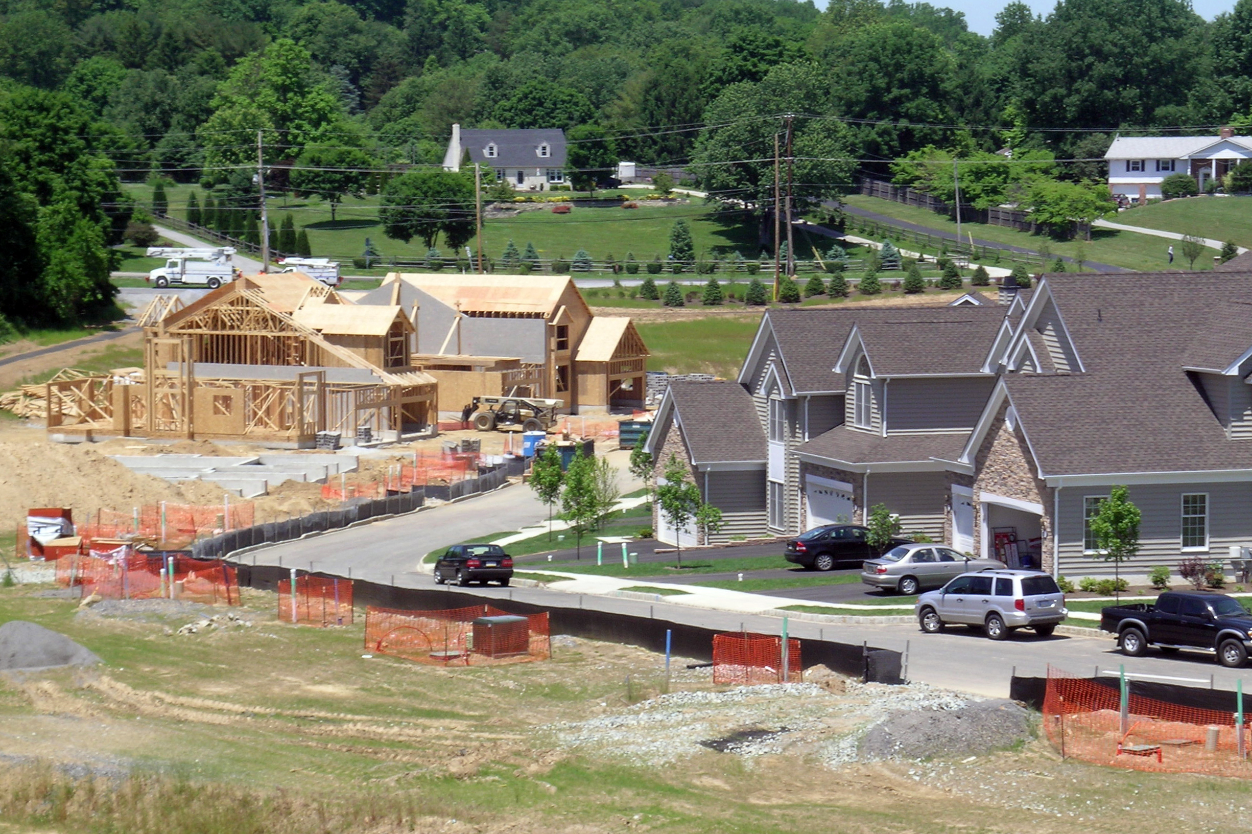
The pattern in which development takes place goes a long way to contributing to the amount of energy consumed and greenhouse gases created. A compact, mixed-use pattern served by public transportation such as found in the boroughs and the city of Coatesville, consumes far less energy and generates far less greenhouse gases than does a suburban sprawl pattern, consisting of low density residential areas that are isolated from shopping and employment opportunities. Much of the rural and suburban portions of Chester County have experienced a sprawl development pattern.

This sprawl development pattern has resulted in:

- A continued dependency on the automobile for access to anything and anywhere;
- A significant demand for resources to address growing highway capacity improvements; and
- An ever increasing amount of time Chester County residents spend in their cars, needlessly consuming energy and generating excess greenhouse gases.

According to the Delaware Valley Regional Planning Commission report, Greenhouse Gas Emissions Inventory (2009), Chester County ranks in fourth place for the total amount of greenhouse gasses generated, behind Philadelphia, Montgomery and Bucks Counties. However, the County’s sprawl development pattern generates the largest amount of greenhouse gases per capita of any county within the greater Philadelphia area. The report documented that Chester County generated 17.6 metric tons of carbon dioxide equivalent (MTCO2E) per capita in 2005, as compared to 16.5 MTCO2E for the region.

Figure 2-1
Chester County Greenhouse Gas Emissions by Sector (2005)
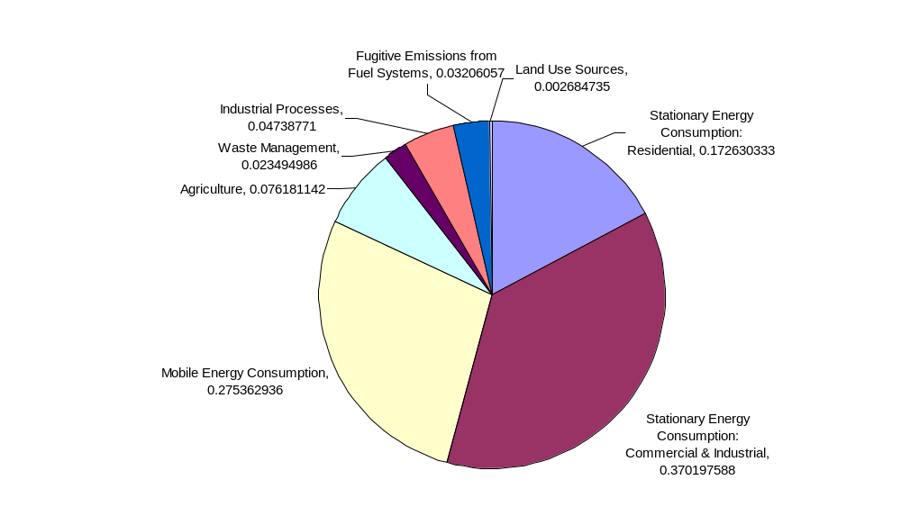
Delaware Valley Regional Planning Commission (2009)
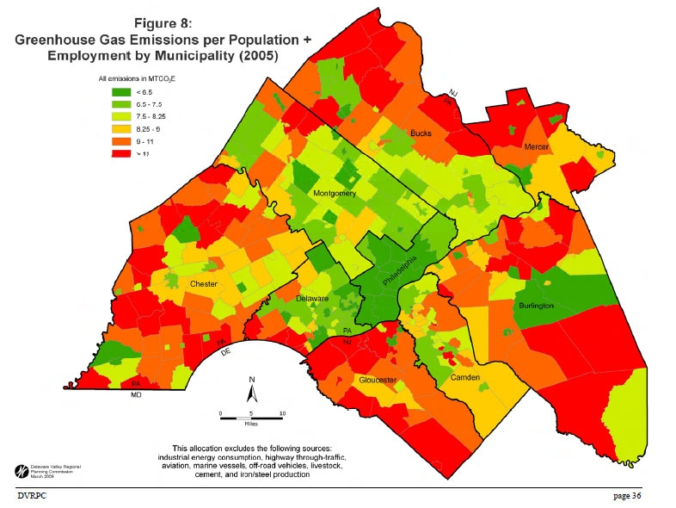
Figure 2-2
The climate-warming impacts
Of transportation choices (2002)
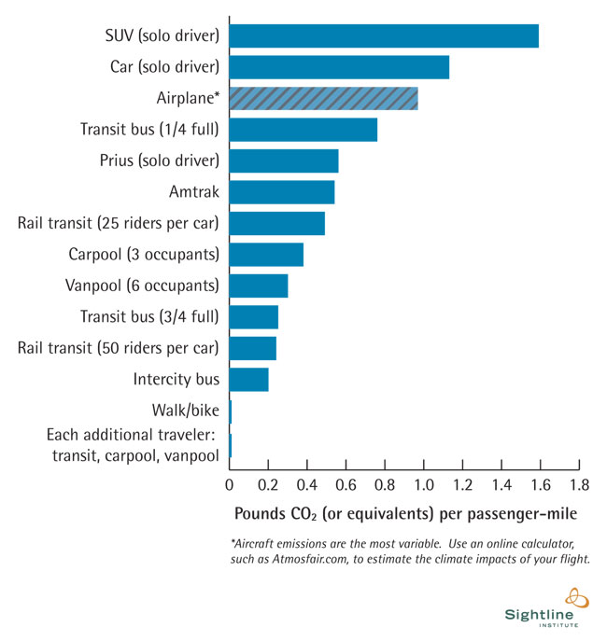
The means by which we choose to travel poses a significant impact on the amount of greenhouse gas emitted. Single occupancy vehicles, the primary means of travel in Chester County, generate the most greenhouse gases. Conversely, carpooling and using mass transit can reduce carbon dioxide emissions by as much as 60% (see table to the right).

A report by the Urban Land Institute entitled, Growing Cooler: The Evidence on Urban Development and Climate Change indicates that there is a clear relationship between of CO2 reduction to Vehicle Miles Traveled reduction (a ratio of 0.9). This is influenced by the relative compactness of existing and future urban developments. Compact development, displaying higher density and transit service such as found in the boroughs and city of the County has the potential to reduce transportation CO2 emissions by 3.5-5% compared to urban sprawl models when carried out to 2050. This study suggests that increasing residential density in designated growth areas may comprise a significant component of broader energy conservation and greenhouse gas reduction policies.

Another report, entitled Comparing High and Low Residential Density: Life-Cycle Analysis of Energy Use and Greenhouse Gas Emissions, provides an analysis of costs involving high-density and suburban development. The results also show that low-density suburban development is more energy and greenhouse gas intensive (by a factor of 2.0–2.5) than high-density urban development on a per capita basis.

When compared with the State, DVRPC has identified Chester County as generating significantly more greenhouse gas emissions from our land use pattern:

County State

Total Land Use Pattern 54.3% 32.0%

Residential Use 17.3% 9.0%

Commercial/Industrial Use 37% 23.0%

GUIDING GOALS

To reduce energy consumption and greenhouse gas emissions associated with our sprawl pattern of development, the Land Use & Transportation sub-committee established a series of goals to guide the development of a list of actions available to the County and its municipalities:

- Reduce energy demand and greenhouse gas emissions through sound land use practices;
- Reduce vehicle miles traveled;
- Reduce traffic congestion; and
- Improve vehicle fossil fuel efficiency.

RECOMMENDATIONS

The following is a listing of recommended actions to achieve these guiding goals that both the County and municipalities working with the county can take.

Reduce energy demand and greenhouse gas emissions through sound land use practices

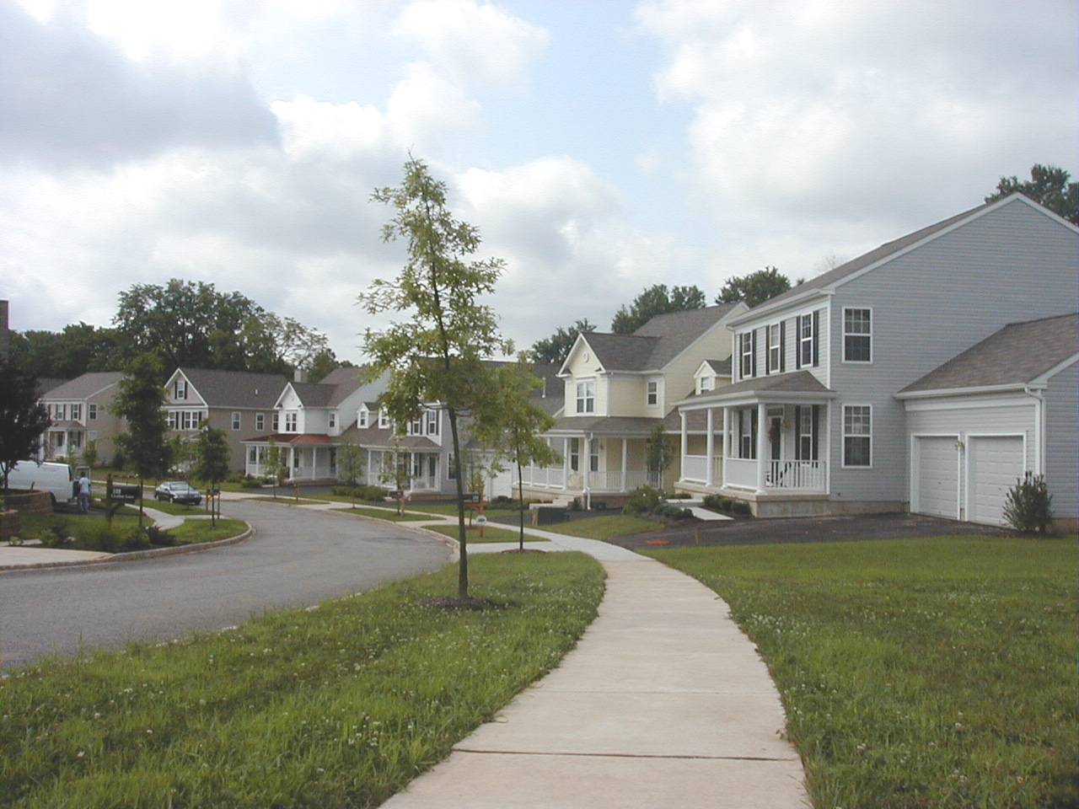
Recommended County Actions

County Operations
- Locate future County facilities in close proximity to transit services
- Locate like kind County services in close proximity to reduce travel demand.

County Policy
- Expand the Urban Center Revitalization grant program to include a “green” building component.
- Promote reforestation of lands preserved under County grant agreements.
- Establish an awards program for projects that qualify under the LEED-Neighborhood program.
- Provide funding to assist municipalities to amend zoning ordinances to establish mixed use, walkable communities using Smart growth principles.
- Assist municipalities establish greenhouse gas offsets for new development.
- Continue to support the Open Space and Farmland Preservation grant programs to reduce the demand for energy.

Recommended Municipal Actions

Municipal Ordinance Revisions
- Revise zoning ordinances to establish mixed use, diverse communities.
- Revise zoning ordinances to increase density in designated growth areas.
- Reduce parking standards where uses are in close proximity to alternative modes of transportation.
- Enable taller buildings in designated urban areas of the county to accommodate urban densities.
- Enable transit-oriented development along transit stops.
- Encourage the redevelopment of Brownfield sites by providing incentives within zoning.
- Adopt effective agricultural zoning in rural landscape municipalities.

Municipal Policy
- Remove energy barriers from local ordinances and homeowner associations.
- Promote reforestation in the common open space of developments.
- Establish adaptive reuse standards to promote the recycling of buildings.

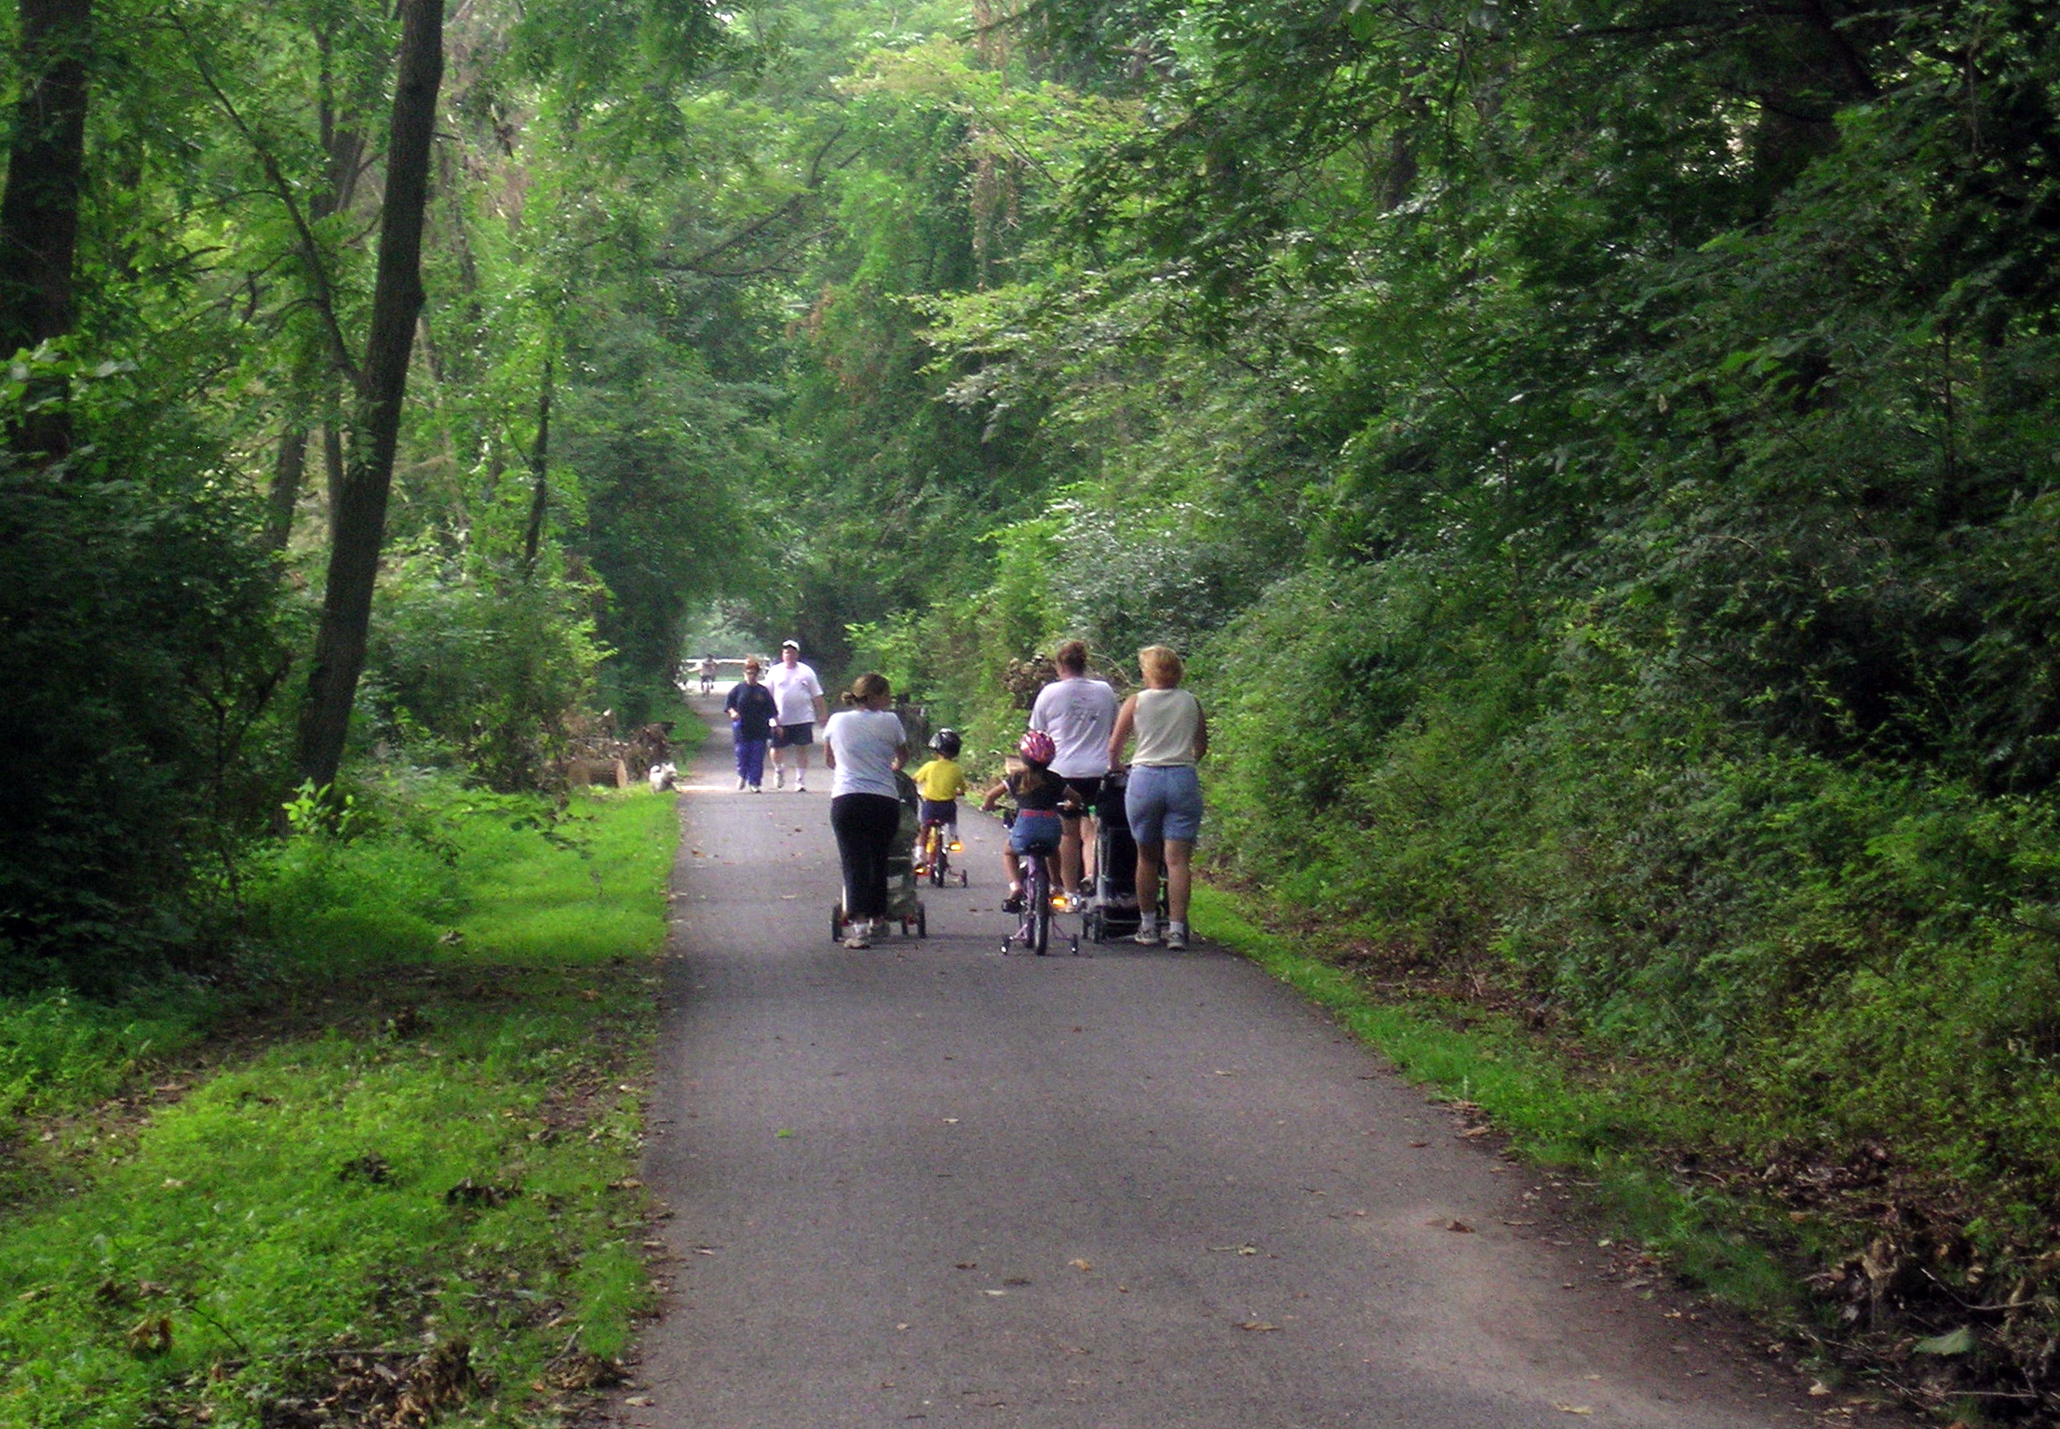
Reduce vehicle miles traveled

Recommended County Actions

County Policy
- Locate County facilities in close proximity to transit service.
- Shift to a 4-day work week, where applicable.
- Promote teleconferencing for County sponsored meetings (Web-NR’s).

County Programs
- Work with DVRPC on the Transportation Improvement Plan to increase funding for transit-related projects.
- Establish a ride-share program for county employees, including carpooling and parking incentives.

Recommended Municipal Actions
- Improve and complete pedestrian facilities.
- Establish addition transit stops.
- Locate higher density zoning districts near transit facilities.
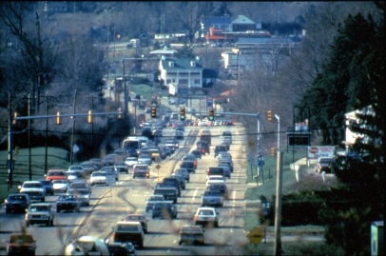
Reduce traffic congestion

Recommended County Actions

- Reduce employee commuting during peak periods through such programs as flex-time and telecommuting
- Support increased funding for public transit services within designated growth areas in the County.
- Accommodate bicycling to work.
- Establish a car share program in West Chester.
- Establish an on-site day care facility for employees to reduce work-day care trips.

Recommended Municipal Actions

- Install additional park-and-ride lots along arterial roads.
- Complete the pedestrian/sidewalk system in designated growth areas to provide an alternative to the automobile.
- Establish bike lanes on municipal roads.
- Coordinate and maintain signal timing to reduce idling time at intersections.
- Install closed-loop signal systems in designated growth areas, where applicable.
- Participate in multi-municipal traffic control plans and congestion management programs on a corridor-wide basis
- Work with school districts to establish a student parking pass fee schedule that off-sets the cost and greenhouse gas emissions associated with busing students.

Improve vehicle fossil fuel efficiency

Recommended County Actions
- Promote aggressive fleet maintenance.
- Establish a minimum, average fuel efficiency standard for County vehicle procurement.
- Schedule current fleet replacement with fuel efficient and compact cars.
- Adopt an anti-idling ordinance for loading docks and delivery areas at County facilities.
- Reserve prime parking spaces for employees participating in car and van pools.
- Use bio-fuels, provided such usage is within 15% of conventional fuel pricing.

Recommended Municipal Actions

- Establish a minimum, average fuel efficiency standard for municipal vehicle procurement.
- Encourage school districts to place a minimum, average fuel efficiency standard on district vehicles.
- Phase in alternative fuels/fuel-efficient vehicles for police and public works departments.
- Promote aggressive fleet maintenance.
- Adopt an anti-idling ordinance for loading docks and delivery areas at municipal facilities.

Create a Chester County Sustainability Office

In order for this plan to be properly implemented and the benefits realized, there is a need to assign the management of the plan to an individual within the County organization. The creation of a Sustainability Office would enable the County to institutionalize its energy and climate work and sustain it over the longer-term. Implementing a successful and self-financing energy program is the single best way for a local government to reduce greenhouse gas emissions and has proven to reduce energy costs. There are funding opportunities to cover the initial cost of creating this service within county government.

The role of the Sustainability Office is to, among other duties:

- Disseminate information to all sectors of the community that will help everyone understand the importance of reducing energy use;
- Provide the financing, secure grants, and other tools needed to achieve energy reductions; and
- Track the benefits received by the County through energy conservation and greenhouse gas reduction measures towards achieving the County’s reduction goal;
- Oversight of grant programs focused on CO2 reduction, Coordination with municipalities to partner with the County and other governmental entities in mutually beneficial programs (ESCOs, Cooperatives, etc.); and
- Serve as a liaison with community groups, local officials and staff regarding activities related to environmental sustainability.

With passage of the recent federal Stimulus Package, there is unprecedented opportunity for the County to create this position. The Sustainability Office could be initially created with grant funds, if they can be obtained.

BENEFITS AND COSTS

By accomplishing this series of actions, the County can realize significant benefits including operational cost savings, energy demand reduction and the reduction in greenhouse gas emissions. Benefits are typically measured on a per-capita, per-unit basis for land use and per-passenger-mile basis for transportation. Recent studies have shown that growth management practices that promote a compact, mixed use development pattern can accomplish the following:

- Adoption of a compact development strategy can reduce carbon dioxide emissions by up to 27% over the current low-density model of development utilized in the County, on a per-unit basis. On a per-capita basis, the reduction is over 60%.

- In terms of transportation choices, the impacts vary depending on transportation type. Changing from a single-occupant SUV or standard auto to a hybrid car, such as a Prius, reduces emissions by 50-62% per passenger-mile, and the percentages go up for rail transit, bus transit, and carpooling.

- The costs depend on the willingness of local officials to engage in planning and development policies that encourage greater density, and in locations that foster multiple transportation options.

  - Passage of this report can serve as the County’s Energy Efficiency and Conservation strategy (EECS) as required by the Department of Energy for grants under the Energy Efficiency and Conservation Block Grant program of 2009.

Chapter Three: Outreach and Communications

Communications and Outreach
Functionally, Chester County's government includes both a County Government, and local governments provided by Townships, Boroughs, and Cities. The County Government is uniquely positioned to provide leadership; however, effectively delivering that leadership out into the local municipalities is an essential step.

An issue which must be resolved early on is the information gap between what economists and scientists know about how to respond to the GHG issue, and what most people in the County know. Therefore, the County must undertake to educate through effective and organized actions. Equally as essential will be the vital flow of information from the municipalities back to the County. Other important shareholders that must be engaged include school districts, businesses, and non governmental organizations

Recommendations

It is important that the public be able to identify the county’s efforts with an easily remembered name, so we suggest defining a tagline or slogan and developing a consistent identity across multiple media.

- Branding/slogan for an identity campaign – along the lines of Smokey the Bear – "Only you can prevent forest fires"…...ONLY YOU CAN REDUCE CO2.

- Promotional and online elements:
  - Outreach designed a logo, posters, tri-fold brochures and various flyers to distribute at events and throughout the county. We recommend a broader campaign that brands further efforts of the implementation team.

  - Outreach produced two video messages for streaming online, podcasting and broadcast; the first in July was emailed to all township officials, commissioners, environmental orgs, school board officials and the press. A temporary website was designed to hold the streaming video.

    - Second video promotes local farmers markets and farms, a brief documentary type promo that will be email-blasted, streamed and broadcast after commissioner’s approval.

  - We advise adding more social networking tools; links, buttons and a possible Facebook segment for public interactivity.

- Continued public meetings –these could be designed as report back meetings featuring speakers and stakeholders from the community and other non-profits and environmental organizations. We suggest that city staff can work with the implementation team on facilitated charities for these meetings.

- Partner with volunteer and non-profit organizations for speakers to provide instruction, education and a Q & A forum for Chester County residents on all aspects of CO2 reduction.

There are many eco and environmental events planned in the county during spring/summer/fall. These are ideal outreach venues in which to distribute flyers and promotional materials for increasing public awareness of the issues.

- Outreach coordinated a large public meeting in early December 2008, co-sponsored by West Chester University’s Environmental Council. We advise that more public meetings can be highly beneficial for ‘visioning’ the county’s future and to engage and involve the public at large in implementation of the task force’s recommendations.

- Our other public events included:
    - Kennett Mushroom Festival September ’08
    - East Bradford Day late September ‘08
    - Exton Mall Environmental Fest October ‘08

- Continued email blasts to the press, various stakeholders, etc.: Outreach coordinated mass email blasts to city officials, non-profits and schools to promote the efforts of the task force and alert the public. This should continue with the implementation team.

- Targeted mailings to retailers who could provide recycling information for CFL's, household batteries, etc.

- Public access TV, blogs, websites: Outreach has created and is managing a website along with streaming and broadcast video messages for online and broadcast on public access TV.

- Education is an integral part of public awareness. We recommend involving local schools and West Chester University in research projects for both determining emission data and on ideas for reduction. A local home schooling project on climate issues was passed along to several committees for further efforts and collaboration.

- Assemblies at schools to instruct what each student/classroom/household/family can do to reduce CO2 in their daily lives. Take home "Pledge Sheet" for family to work toward.

- “NO CO2 Day” Challenge: Countywide campaign on the first Sunday of each month from 12 noon until 6:00 PM - no driving, mowing, laundry, vacuuming, TV, computers, etc.
- Unplug and reduce your carbon footprint for 6 hours. Read, play board games, take a walk, plant a tree, etc. instead.

- “Why Drive” campaign that encouraging people to use public transportation.

- Provide information on how homeowners and small business people can develop a carbon footprint on-line and manage their carbon footprint as they accomplish energy conservation and emission reductions at home and at their business.
- Inform homeowners and small businesses, churches and community groups how they can earn carbon credits for their energy reduction efforts and how they can aggregate these offsets into a bundle of offsets to support community programs.

- Review other task force subcommittee recommendations and extract those parts that need an outreach and communication component. Prepare a specific implementation plan for those activities.

- Recommendation: Hire a dedicated county staff Communications and Outreach Coordinator, develop an interactive website (chescogreen.org or discrete from the township) to receive and direct input and questions from Chester County residents. Coordinator works through a spoke of networks, including all subcommittees, local planning and county officials. Reports to Office of the Commissioners.

Chapter Four: Recycling and Waste Management

Executive Summary

This chapter describes the present waste/recycling program, the issues resulting from excessive transportation of waste/recycling and addresses the problems of non-compliance of recycling ordinances, open burning, illegal dumping and limitless trash disposal still practiced by many in Chester County. These and the issue of unnecessary transportation is what contribute to excessive green house gas production. The County can significantly reduce green house gases by conserving energy and reducing the amount and toxicity of waste by modifying collection, processing and management practices.

The County is already engaged in strategies to reduce greenhouse gas formation. Furthering those efforts, in collaboration with DEP requirements involving waste minimization, recycling and composting will reduce potential green house gas emissions. Over the years our County has made great progress in improving the recycling rate and in the other areas waste management. The recommendations in this report will reduce the number of excessive collection vehicles on the road and at the same time create more manageable, efficient and cost effective waste/recycling collection and processing systems.

Background

Waste Disposal
In 1969 there were 5 sanitary landfills, 15 open dumps and 11 pig farms in Chester County. The County generated 607 Tons of waste per day. In 2008, Chester County residents and businesses disposed of 543,758 tons of waste at Pennsylvania Facilities. This is equal to almost 1,900 tons per day with 73% of the waste disposed of in municipally owned landfills in Chester County.

Chester County developed its first Solid Waste Plan in 1972 as a result of the Pennsylvania Solid Waste Management Act (Act 97). The plan was updated and approved in March 1988. The Pennsylvania Municipal Waste Planning, Recycling and Waste Reduction Act became law in July 1988 (Act 101) and the Chester County Plan was updated again in 1990. Law required another update which was finalized in 2007 and the plan will be updated again in 2009.

The “Solid Waste Crisis” of the early 80’s led many counties to secure disposal capacity. Chester and Lancaster Counties worked together to out bid Philadelphia County for the purchase of the Lanchester Landfill. Lancaster County formed its own Authority in the mid 1980’s to handle the waste generated in their county. Chester County formed the Chester County Solid Waste Authority (CCSWA) in 1984 and purchased the Lanchester Landfill. The County Commissioners appoint six of the seven Chester County Solid Waste Authority Board Members. The seventh is appointed by Caernarvon Township, Lancaster County (a Host Township).

The Lanchester Landfill serves 49 municipalities in the northern two-thirds of the County with a population over 375,000. The Lanchester Landfill is projected to fill the currently permitted capacity in early 2014. The Chester County Solid Waste Authority has submitted an application for a 10 year expansion to the Department of Environmental Protection.

The Southeastern Chester County Refuse Authority (SECCRA) was established in 1971. The first landfill, located in Kennett Square, is now the Anson B. Nixon Park. The “new” landfill located in London Grove is now 20 years old. SECCRA was formed by 10 municipalities in southern Chester County. Each of the founding municipalities appoints a member of the SECCRA Board of Directors. SECCRA now has 24 member municipalities and serves the southern third of the County. The current SECCRA Landfill disposal area is projected to be filled in 2012. SECCRA plans to submit a Department of Environmental Protection 10 year expansion application by the end of the year.

Both Landfills have incorporated landfill gas-to-energy systems. The amount of energy from the Lanchester Landfill alone, on an annual basis, is equivalent to the amount of energy used by 32,400 homes.

Recycling
The Pennsylvania Municipal Waste Planning, Recycling and Waste Reduction Act of July 1988 (Act 101) mandates municipalities with populations of 5,000 and 300 people per square mile implement curbside recycling collection of at least 3 items of the following materials: clear glass, colored glass, plastics, aluminum, steel and bi-metallic cans, high grade office paper, corrugated cardboard and newsprint. All residents, businesses, institutions and special events must have recycling collection service. Commercial, municipal and institutional establishments with a mandated municipality are required to recycle aluminum, high grade office paper and corrugated cardboard in addition to other materials chosen by the municipality. Mandated municipalities are also required to separate leaf waste from other municipal wastes. Mandated municipalities are responsible for the education, promotion, development, reporting and compliance of recycling requirements within their borders.

The Chester County recycling program provides technical assistance to businesses and municipalities and is totally supported by the Chester County Solid Waste Authority. Municipalities are kept abreast of grant opportunities and developments in recycling markets and encouraged to improve efficiency and cost effectiveness. Educational programs, displays, brochures, flyers and promotional items are provided to expand source reduction and recycling practices. The certified master composting training program provides and promotes residential source reduction through backyard composting. The County recycling program promotes commercial and institutional recycling through Chamber initiatives, and prevents the irresponsible dumping of toxic material through the Regional Household Hazardous Waste Collection Program. A required annual County recycling report is also submitted to the Department of Environmental Protection.

Recommendations
The following cost effective and more efficient collection, processing and management practices will reduce the greenhouse gas emissions in the County:

Collection
Promote source reduction and waste reduction to prevent waste in the first place.
Dispose of waste locally to prevent unnecessary transportation.
Limit trash collection to once per week.
Enforce ordinances already in place.
Require recycling service for all residents, businesses, institutions, parks, entertainment and community events according to Act 101 and municipal ordinances.
Promote a policy of requiring trash collection service for all residents, businesses and institutions to prevent illegal dumping.
Promote residential municipal “single hauler” contracting to reduce truck miles.
Incorporate thoughtful incentives to encourage waste reduction and limit collection at the curb.

Processing
Adopt a County “no burn” policy by banning the burning of waste.
Promote County-wide yard waste collection.

Management
Promote www.chestercountyswa.org as the official County waste/recycling information site.
Identify steps to improve the data collection system and encourage reporting.
Advocate the recycling of additional items as markets become available. Develop construction and demolition recycling programs and the use of mixed cullet in civil engineering projects.
Adopt a “buy recycled” policy and encourage the purchase of products made from recycled materials.
Encourage all municipalities to participate in the Regional Household Hazardous Waste Collection Program, reducing the cost for all and ensuring the safe handling of toxic waste.
Calculate how our changes will translate into units of carbon dioxide emissions saved or avoided.
Educate municipal officials.
Instruct and train to change behaviors.
Conduct a feasibility study on waste to energy as a long term solution for waste disposal.

Reasons for Implementation

Chester County is expecting an increased population of 250,000 by 2030 resulting in almost three-quarters (3/4) of a million people. At the present time 31 of the 73 municipalities are required to have curbside recycling programs. An additional 14 municipalities responsibly created their own recycling ordinances. Eight-two percent (82%) of Chester County currently has curbside recycling collection.

However, many municipalities permit several trash/recycling companies to operate within their borders, often traveling the same streets and roads on different days of the week. Many homes have collection more than once per week. Too many inefficient trash trucks travel identical routes daily. These trucks only get 4 miles per gallon. Each gallon of gas consumed by those trucks produces more than 19.4 lbs. of CO2. This type of program is proven to be more expensive for the resident, results in excessive wear and tear on County and township roads and duplicates unnecessary creation of green house gas emissions by excessive transportation of waste/recycling service vehicles. Residents who have “homeowner” subscription contracts for trash/recycling service often pay up to twice as much a year as residents whose municipalities have a contract with a single hauler, often with less service.

All residents may not be in favor of a single hauler contract. Some residents chose to have no trash service and may prefer to burn their trash or dispose of by “illegal dumping”. According to the EPA, the use of a single “personal incineration device” or P.I.D. is more polluting than a waste-to-energy plant. Illegal dumping is another issue that causes concern and cost for cleanup.

When recycling is not required and/or enforced, there is no incentive to limit the amount of trash produced. In 2007, Chester County recycling prevented 1,196,849,203 pounds of CO2 from being emitted into the atmosphere. Limitless trash disposal results in another example of excessive transportation leading to increased green house gas emissions.

They are many ways to implement a single hauler contract while attending to the specific needs and services enjoyed by some residents, such as “back door service”. Technical assistance is available to overcome such hurdles.

Waste reduction by composting also limits greenhouse gas emissions that would be derived from land filling. When land filling organic waste, anaerobic digestion occurs, producing methane and carbon dioxide (CO2). When composted, methane production is avoided and greenhouse gases are negligible. GHG emissions result only from the machinery used. The County recycling program continues to develop residential backyard composting, encourage the development of municipal composting sites and is working to advance the development of food waste composting facilities for grocery stores, restaurants and other large scale food service organizations.

Chester County Costs and Obligations

Municipal governments have the authority and opportunity to make the changes to the waste/recycling collection, processing and management practices that will reduce our carbon footprint. The County is encouraged, however, to implement the following initiatives:
1. The County would encourage the development of a conversion technology as the long term solution for waste disposal, energy production and greenhouse gas reduction. The cost of the project study may be funded by Federal “stimulus” funds received by the County.

2. The Chester County Health Department would develop and add an education program to their existing Personal Health Education Department regarding the health issues associated with backyard “burning” of trash and yard waste. The Chester County Solid Waste Authority would continue to promote cost effective and environmentally correct processing solutions through their education programs already in place.

3. The County would expand and encourage the use of cooperative purchasing power for services and goods by the County and its municipalities and require, with a 5% preference, recycled content option when purchasing office products. The County would host and attend a workshop on how to “Buy Recycled”.

Several collection, processing and management recommendations mentioned are Pennsylvania Department of Environmental Protection requirements already in place or endorsed by the DEP but not enforced in all municipalities. They not only reduce potential green house gas emissions but have proven to be cost effective and efficient. Several recommendations listed have also been suggested to personnel compiling the County’s Planning Commission Landscapes2 Design.

Chapter Five: Agriculture and Forests

Executive summary

Agriculture and forestry contribute a relatively small percentage of total greenhouse gas emissions in the county but have the potential to reduce the current amount and to sequester significant quantities of carbon in soil and tree vegetation in a cost effective manner. The County’s woodlands in particular have the potential to reduce greenhouse gases, especially if supplemented by new plantings. The Committee recommends exploration of vigorous reforestation efforts. But under current conditions existing woodlands are continually reduced at the rate of approximately 1% (1,200 acres) per year. The technology is already well established to reduce energy use in arable cropping and mushroom production. Progress is already being made but significant further progress can be made by implementing the recommendations summarized below for the key segments. A sound infrastructure already exists to advise, implement and offer funding opportunities to achieve most of the goals set but commissions/authorities need to be set up to coordinate tree planting and local food production.

- A. Woodlands: The most cost-effective tool we have at present to increase carbon sequestration is to conserve existing woodlands. The 115,000 acres of Chester County’s woodland are being reduced at an estimated rate of 1,200 acres per year. This represents an alarming loss of carbon sequestration potential along with numerous collateral environmental benefits. Planting additional trees and restoring native woodlands will enhance carbon dioxide removal, increase carbon sequestration and gain the many environmental and recreational benefits of woodland. Reducing woodland loss and planting trees could eventually sequester 498,391mt CO_{2e} and 135,925 mt carbon annually. New reforestation projects will be eligible for carbon credits and additional revenue for those planting the trees under a cap & trade system.
- B. Local Food Production: Decrease the energy required to distribute food by increasing local food production and so provide local communities with access to fresher food and increase local farm revenue. Increasing local food production utilizes the excellent soils and growing conditions in Chester County and reduces the cost and energy required to transport food (typically 1,500 miles).
- C. Mushrooms: Increasing energy efficiency in mushroom production can reduce energy inputs by up to 25% by using available technology. This would reduce greenhouse gas emissions by an estimated 15,000 mt per year. Since energy is second only to labor in the cost of mushroom production, this will also improve the profitability of mushroom producers and their ability to complete with imports. Establishing the technical and economic feasibility of converting spent mushroom compost (SMC) to energy would provide a year-round outlet for large volumes of SMC and a useful revenue stream or hedge against increases in energy costs. Promotion of the wider use of SMC for application to local fields and yards will increase soil carbon, fertility and health.
- D. Arable Crops: Gaining further use of no-till planting of arable crops will both increase soil carbon and reduce energy use by requiring less tractor passes. By achieving no-till on 90% of arable acreage (currently 50%), 18,240 tons soil carbon would be added and 3,016 mt of CO_{2e} removed. Carbon credits should also be available for farmers practicing no-till. Adoption of protected nitrogen fertilizer could reduce nitrous oxide emissions so that 9,115 mt tons/year CO_{2e} would be avoided.
- E. Dairy and Livestock: Reducing enteric CH₄ (methane) emissions from dairy cattle will reduce CO_{2e} by 0.14 MMT/year. Research has shown that enteric methane can be reduced in dairy cattle by up to 50% through improved feed utilization efficiency. The reduction of CH₄ and NO₂ (nitrogen dioxide) emissions from dairy manure can be achieved by demonstrating the technical and economic feasibility of installing small scale anaerobic digesters to generate energy from the methane produced.
- F. Green Industry: Promoting wider use of trees in landscaping houses and commercial developments reduces heating and air conditioning costs and the need for mowing of lawns and open space. Landscape designers play a major role in planning residential and commercial developments. The significant plant nursery industry in Chester County can provide the appropriate planting material to satisfy expanded local needs. There has been no attempt to quantify reduced greenhouse gas emissions from these savings and the additional carbon sequestered by the trees and shrubs. Collateral benefits include more diverse wildlife and higher property values from tree planting.
- G. Carbon Credits: Participation in a county-wide program to aggregate carbon credits for purchase by local emitters for use by Chester County farmers and land users will encourage wider and faster adoption of energy saving practices. The evolving and growing market for carbon credits places monetary value on greenhouse gas emissions which can be matched by verifiable farming, forestry and land use practices that lower emissions either directly or indirectly.
- H. Woody Biomass: Making use of all waste woody material generated in the County to replace coal at the Cromby Station of Exelon through co-firing, or to create new electric power generation facilities that will use the waste fiber material will replace fossil fuel carbon emissions. Planting of short rotation tree or woody grass crops for energy production purposes should be considered on soils not suitable for food production or to provide hay for mushroom producers and the equine segment.

Background

Agriculture has played an important role in the basic economy of Chester County since colonial times and in providing for our rural landscape of farm fields and woodland. The county is blessed with some of the best soils in the United States and abundant rainfall that is well distributed throughout the year. This prime farmland produces the highest yields with minimal inputs of energy and economic resources and farming results in the least damage to the environment when carried out sustainably.

Chester County ranks second in terms of revenue from farming for an individual county in Pennsylvania with mushroom production now playing the major role, whereas historically, grain crops and livestock had been dominant.

There were 1,918 farms in 2002 with 168,234 acres representing 39% of the total land use. Chester County had an estimated 100,000 acres of preserved land of which 22,000 acres of farmland are preserved throughout the county and a further estimated 8,000 acres through other NGO programs.

Farming provides the primary occupation of 57% of the farming population, 50% worked with no days away from the farm and 32% worked 200 or more days off the farm. Average age of Chester County farmers is 53 years old.

Woodlands originally constituted 90-95% of the vegetation at the time of arrival of William Penn in the 1600s, and are integral to our largely rural landscape. They provide the essential framework for our diverse ecosystems and protect the quality and quantity of our wildlife and water supplies as well as contributing significantly to carbon sequestration. However clearing for farmland, housing and commercial development has reduced this to an estimated 24%. Tree cover varies greatly from municipality to municipality but is highest in the northern and eastern municipalities and least in the southern and western farming areas.

Greenhouse Gas Status

The EPA estimates that agriculture contributes an estimated 7.4% of the total greenhouse gas emissions in the country.

In Pennsylvania, the Center for Climate Strategies (for the Pennsylvania Environmental Council) estimated that agriculture contributed 2% of total GHG emissions (2000). These emissions were 8% lower in 2000 than in 1990 due to decreased dairy and beef livestock.

Of agricultural greenhouse gas emissions in Chester County, methane from enteric fermentation within cattle and from animal manure represented 38% and 14% respectively of the total and nitrous oxide emitted from agricultural soils, the remaining 48%. Nitrous oxide emissions were 11% lower in 2004 than in 1990 due to changes in land, fertilizer and manure use. The reduced number of livestock was responsible for the 12% reduction in nitrous oxide emissions from enteric fermentation. Emissions from manure remained the same; since the reduction in manure from fewer cattle was countered by increases in litter from the larger number of poultry operations. A continuing increase in dairy cattle is projected to provide the reason for increasing total emissions from agriculture, with emissions from soils decreasing slightly.

Forests account for 60% of Pennsylvania’s land area and so make a considerable contribution to the greenhouse gas equation by sequestering an estimated 14.4 MMTCO_{2e} each year, with live and dead-standing trees and understory making the largest contribution (12.1 MMTCO_{2e} /year).

In the absence of specific data from Chester County, it is considered that greenhouse gas emissions from agriculture represent 2% of the total. Montgomery County has a smaller agriculture segment and estimated that only 0.9% of total GHG emissions were caused by agricultural activity.

Climate Change and Agriculture

Since crops and livestock were developed through human activity from wild species, there has been deliberate selection to ensure the highest level of survival and crop yields under local climatic conditions. Recent periods of drought in many parts of the world have caused plant breeders to select varieties that manage to yield well under such conditions. Such a history and greater sophistication in plant and livestock breeding technology should give confidence that varieties of crops and breeds of cattle can be developed which deal with higher temperatures. However the projections of climate change during the rest of this century give serious cause for concern.

In the short term the effect of higher carbon dioxide levels, milder winters and longer growing seasons may be beneficial to many crops, particularly in our region. However agriculture is particularly vulnerable to higher temperatures and more frequent periods of extended drought and high intensity storms that global warming brings. Concerted action will have to be taken to reduce the possibility of carbon dioxide levels rising to the higher global levels (1000 ppm) projected under a business as usual scenario. Such levels and the consequent rises in temperature would be seriously damaging to crops and livestock and so seriously reduce agriculture’s ability to supply all the food needs of future generations.

Extended periods of temperatures above 90°F reduce corn yields, mild winters may not provide sufficient winter chill for optimal apple production. The optimal temperature for milk production ranges from 40°F to 75°F depending on humidity so that periods of higher temperatures could seriously depress milk yields (up to 20%).

Milder winters are projected to increase the number of life cycles of many disease pathogens and insects. Many serious weed species have been shown to grow more vigorously with higher carbon dioxide levels and also reduce the effectiveness of herbicides. Milder winters and higher temperatures may allow an even wider range of invasive weed species to become prevalent.

Scenarios

Climate Change epitomizes thinking globally, but acting locally. While we must do our part to solve this global problem, in the end, the future climate and living conditions of Chester County will be the result of thousand of actions taken (or not taken) around the world. Given that, it may be worthwhile to look at some alternate futures, based on analyses undertaken by the Intergovernmental Panel on Climate Change. The table below summarizes three possibilities.

The “Collapse” scenario assumes an utter failure by the international community to address or restrain greenhouse gas emissions, possibly combined with the crossing of climatic thresholds (like release of permafrost and oceanic methane deposits) that cause rapid and irretrievable climatic change. In either case, the type of response required by this scenario at the local level is probably outside the scope of the current Chester County GHG effort and would likely fall into the realm of emergency preparedness.

“Stabilization at a Higher Level,” on the other hand, requires a response that acknowledges that Chester County forests and agriculture will markedly change. Our forests will be characterized by more southern species, particularly southern oaks (based on projections made Dr. James Thorne at Natural Lands Trust), with many more invasive species, different management requirements, and habitat for a new suite of plants and fauna than have existed here historically. The ways in which agriculture can be practiced here will also change with, for example, the dairy cattle being more likely to suffer from heat stress and new threats from pests.

“Stabilization and Restoration” is the most desired outcome and an interesting case because the environmental effects will include similar changes to that described in Stabilization at a Higher Level, but only temporarily. For after a period during which we will experience higher temperature and CO2 levels, we will thereafter slowly return to historical levels. This will introduce a host of land management challenges that are hard to predict, but that deserve serious attention as we go forward. As an example, how we manage forests as southern species move in, then retreat, see the following table and chart.

Table 5-1

No. | Name | Description | Global Temp. Rise (per IPCC) | IPCC impacts
1 | Collapse | Relentless increases in atmospheric GHGs due to lack of policy action and/or crossing of climatic thresholds; CO2e hits ~1000 ppm by 2100 | ~ 5.5 °C | See chart below
2 | Stabilization at Higher Level | International efforts take hold slowly and GHGs level out at ~ 500 ppm of CO2e | ~ 2.5 °C | See chart below
3 | Stabilization and Restoration | Aggressive mitigation and international cooperation succeeds in halting growth and eventually reducing GHG to ~350 ppm of CO2e | ~ 1.0 °C | See chart below
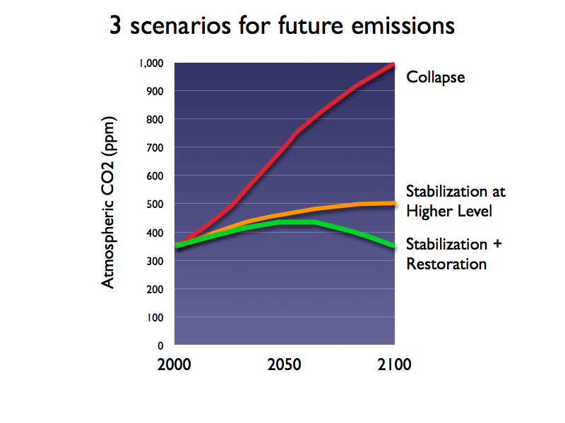

Recommendations

The Pew Center for on Global Climate Change has determined that changes in agricultural practices and the afforestation of marginal agricultural lands could offset up to one fifth of current U.S. greenhouse gas (GHG) emissions. The committee reviewed the potential for reducing GHG emissions directly and indirectly by reducing energy consumption or by changing to renewable sources and through carbon sequestration. It was concluded that agriculture can reduce GHG emissions, reduce energy use and contribute to increased carbon sequestration through the use of existing technology and by following Best Management Practices now being recommended. In forestry, the protection of existing woodlands and the planting of trees in riparian areas, vulnerable ecological areas, unplanted open space etc., will make a valuable contribution to carbon sequestration. Opportunities may be very limited in Chester County for agriculture and forestry to contribute significantly to the production of biofuels to replace fossil fuels, but possibilities need to be constantly explored.

Committee members took leadership for the different segments of this report that were identified as having potential for their contribution.

- Bruce Arnold: 25x’25: America’s Energy Future, Retired (Scott Paper Co.)
- Thomas Bott: Stroud Water Research Center
- Michael Bullard
- Joy Fritschle: West Chester University
- Hillary Krummrich: Chester County Agricultural Development Council,
- Victoria Laubach: Green Valleys Association
- Robert Lonsdorf: Brandywine Conservancy
- Thomas O’Donnell: The Global Emissions Exchange
- Andrew Pitz: Natural Lands Trust
- Victoria Webb
- Gene Wilson: 4CP, League of Women Voters
- Duncan Allison: Chair

A. Segment: Woodlands

Principle: The County’s woodlands offer the greatest local potential to not only reduce but offset greenhouse gases and to help reach the “Stabilization and Restoration” scenario described above, especially if supplemented by new plantings. Therefore, the Committee urges strong efforts to minimize future losses of woodlands and vigorous exploration of reforestation means, with a long-term goal (past the planning scope of this document) of reaching 40% tree cover County-wide. But under current conditions, existing woodlands are continually reduced at the rate of approximately 1% (1,200 acres) per year, making even a simple net gain in tree cover problematic.

Objective: Increase carbon sequestration by planting native trees and conserving and restoring woodlands so as to reduce carbon dioxide levels and gain the many environmental and recreational benefits of woodlands.

Situation: The Chester County Planning Commission estimates that there are 115,415 acres of woodland remaining in the county as of 2005. However, estimates from other sources vary from a low of 102,000 to a high of 136,000 acres. Since 1990 an estimated 31,000 acres of woodland (average of 1,200 acres per year) have been lost to residential and commercial development. In the pre-settlement era, 90-95% of our region was primarily deciduous woodland. Continued loss of woodland will have serious consequences for our watersheds and water supply, wildlife and carbon sequestration potential.

The Committee as a whole wishes to emphasize its alarm at the rate of forest loss in Chester County. The rate of deforestation and degradation can be significantly reduced through a combination of increased woodland conservation and regulation. Unless and until that happens, however, it will be extremely difficult to make gains in carbon sequestration and storage in the woodland sector.

Forested land is capable of storing close to 0.78 mt of carbon per acre per year, so that Chester County woodland removes slightly over 330,000 mt of CO_{2e} annually. This acreage has sequestered the equivalent of 27.5 million metric tons of CO_{2e} over an assumed 55-year average lifetime for these trees. The constant removal of trees reduces this vital sequestration potential still further. Trees planted in urban and suburban settings are also effective in CO_{2e} removal and could be removing an additional 20% of this value. Conservation and tree planting are not a panacea and will not offset all CO_{2e} emissions, but they are two of the most cost-effective and readily available options for addressing this problem at the moment. In addition they offer numerous collateral benefits including flooding reduction and water quality improvements.

Basic recommendation: Conserve existing woodlands to the maximum extent possible. Reduce existing losses to approximately one-tenth (10%) of the current rate as quickly as possible. Plant native trees and conserve and restore existing woodlands wherever possible in riparian areas, steep slopes and watershed headwaters, public and privately owned open space, greenways, setback areas and other under-used areas, marginal farm land, and all areas that are environmentally vulnerable and economically marginal. The recommended long-term goal is for woodland to represent an optimal 40% of the land area of the county, up from 24% at present. For this to happen, there needs to be a broad-based public-private partnership underpinned by an understanding of the value of trees and acceptance of the need to plant them. This in turn will call for education at all levels and special programs within the county (see recommendations below).

Targets: There has been a loss of woodland of around 1,200 acres per year or 3.3 acres per day during the last 15 years. Our estimates for the future use this number as the annual loss figure until the time when losses will be curtailed further. Replanting can occur both in the form of ‘natural landscaping’ (see Green Industry section below) and in the form of ‘ecological restoration.’ A rate of tree planting of 335 acres /year is included in estimates of carbon sequestration in the table below. This would amount to the planting of 134,000 trees per year if a density of 400 trees/acre was used. Since trees take many years to reach the stage when they are absorbing the maximum rate of carbon dioxide, they will be contributing less than the 0.7 mt/acre/year accepted for mature trees. The ultimate row in the table below indicates the accumulated total of CO_{2e} removed and carbon sequestered by having 40% of the land area under woodland. This is a goal that will only be reached at some point after 2025. See addendum Tables A and B for more detailed statistics on acreages, CO_{2e} removal and carbon sequestration (addendum C). What is clear from the table below is that the ultimate goal for CO_{2e} removal will never be achieved without action on two fronts: drastically reducing the loss of wooded acreage and increasing the rate of new tree planting.

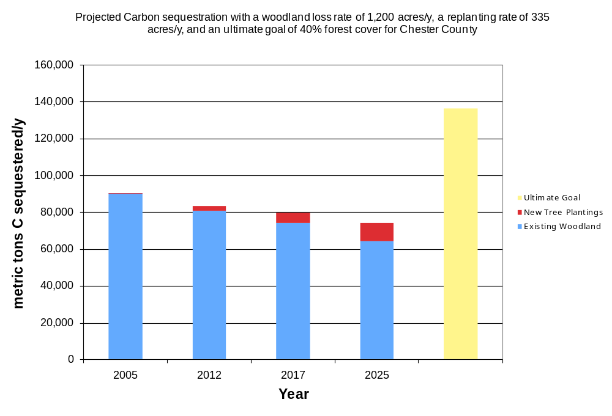

Table 5-2 Carbon dioxide removal, carbon sequestration for 2005 baseline and estimates for 2012. 2017, 2025 and ultimate aim of woodland on 40% of land area.

Years | Base acres with loss at 1,200 acres per year | Base acres with loss at 1,200 acres per year | New tree plantings | New Tree plantings | Total base acres + new plantings | Total base + new plantings
 | CO_{2e} removed MT/year | Carbon sequestered MT/Year | CO_{2e} removed MT/year | Carbon sequestered MT/year | CO_{2e} removed MT/year | Carbon sequestered MT/year
Base 2005 | 330,087 | 90,024 | 934 | 255 | 331,021 | 90,278
2012 | 295,076 | 80,475 | 9,951 | 2,714 | 305,027 | 83,189
2017 | 271,124 | 73,943 | 20,822 | 5,679 | 291,946 | 79,622
2025 | 234,632 | 63,991 | 35,883 | 9,786 | 270,515 | 73,777
Ultimate – tot./yr by 40% at maturity |  |  |  |  | 498,391 | 135,925

Collateral benefits

Multiple significant watershed, wildlife and cultural benefits including:
- Protection of riparian areas, reduction of stream pollution and improved habitat for invertebrates, fish and wildlife. Trees planted in riparian zones lower water temperatures, provide energy for the stream web, and alter stream geomorphology.
- Trees and woodland areas intercept rainfall and produce more porous soils with greater infiltration benefiting groundwater recharge, reducing surface runoff and decreasing the potential for flooding.
- Trees filter out pollutants such as ozone, carbon monoxide and sulfur dioxide and thus improve air quality.
- Trees planted near houses reduce air-conditioning costs, lower heating costs and have been shown to increase property values.

Recommendations for implementation

- Agree on best available GIS system to determine the most precise acreage of woodland for planning and on-going monitoring purposes.
- Direct the Department of Parks and Recreation to immediately investigate opportunities for reforestation of County parklands and other County owned lands.
- Establish a County-wide goal to reduce existing annual forest losses to approximately 10% of the 1990-2005 average of 1,200 acres per year. Direct the County Planning Commission to develop and disseminate new model municipal ordinance language that conserves more woodland and requires tree replacement/ reforestation for lost woodlands.
- Direct the County Planning Commission to investigate feasible amendments to the County’s Vision Partnership Program (VPP) that will enable municipalities to develop their own forest inventory and reforestation plans.
- Direct the Department of Open Space to investigate the feasibility of amending the County’s agricultural preservation grant programs to incorporate criteria to foster the reforestation of riparian buffers and other marginal agricultural lands on potentially preserved farmlands.
- Direct the Department of Open Space to investigate the feasibility of and make a recommendation to the County Commissioners concerning the reallocation of a portion of the County’s open space funds to favor the strategic conservation of woodlands within the County. Consider establishing and building a County Forest Reserve system; explore use of an Official Map as a tool for such establishment.
- Establish a Woodland Conservation and Restoration Committee (WCRC) for Chester County consisting of representatives of a broad spectrum of organizations (see addendum for details).
- The Committee would be charged to:
- Develop a County-wide forest conservation and restoration plan emphasizing the conservation of existing woodlands and a broad-based tree-planting program on both public and private lands.
- Identify priority areas for tree planting such as riparian areas, marginal farmland, and public and privately owned open space.
- Promote tree planting in suburban and urban areas to reduce carbon dioxide emissions and pollutants and produce oxygen.
- Identify funding sources to promote tree planting, such as USDA’s CREP program, TreeVitalize and additional public and private sources.
- Coordinate tree planting needs with local nurseries and other local sources to ensure sufficient trees of most appropriate species and quality to satisfy annual planting needs.
- Initiate education and outreach programs to gain understanding at all levels of local government, within commercial entities, homeowners associations, scout groups and in schools, churches etc. of the value of trees and woodland.
- Assist local groups in identifying areas for planting, possible sources of funding and technical advice, and supplies of trees. Cultivate volunteer groups to assist with tree planting, monitoring and maintenance.
- Facilitate the development and dissemination of management plans for the control of invasive vegetation and deer herds, necessary for successful replanting efforts.
- Facilitate the effort by municipalities to plan for woodland conservation and restoration and urge them to adopt and encourage the development of a certification for financial institutions that incorporate conservation of woodlands into their lending practices to individuals and developers. Institute ordinances which reduce the loss of existing woodlands.

B. Segment: Local Food Production/Local Sustainable Farms

Objectives

Launch Branding and Marketing campaign to enhance consumer awareness, educate the public about local farm products and increase purchasing power. Implementation Committee or Food Coordinator would be charged with developing marketing plan to develop public awareness, monitoring success over a 5-10 yr range.

- ‘Chester County Fresh’ is one branding idea based on ‘Jersey Fresh’.
Projected economic impact of a local 'food pledge':
Housing Units/Chester Co from 2000 census w/ buying $10/week locally - 157,905 households @ $10/week, = $1,579,050.00 per week or $82.1 million/year + new jobs created
- Increase current level of local food production through various measures. 25% of current PASA members live in Chester County, so we can lead the way in developing a sustainable food culture.
- With some of the best silt loam soils in the world, Chester County has the opportunity to support sustainable farming systems.
- We should preserve Class I-III soils for present & future farms. Possible ‘urban growth boundary’, using the Lancaster County model’s comprehensive plan of sustainability. (Lancaster Co. Planning Commission)
- The future of local food production is in smaller farms closer to urban areas and cities. Analyze current Commonwealth rulings and grant programs. Future expansion and protection of best soils/farmland in the county may require revised requirements and reverse rulings for smaller farms. Re-evaluate size of farms; 25 Acres for a Challenge Grant is too large and expensive for the majority of farmers. 50 Acres within an agricultural security area of 500 Acres is no longer viable to entice younger farmers into the field and aggregates of these smaller parcels could increase the farming population. Consider the role of emerging smaller farms in the county, closer to urban areas to reduce the use of energy incurred in transporting food by increasing production of food that can be produced locally. Food typically travels 1,300 to 2,000 miles or more from farm of origin to the final consumer.
Situation
The average WASD (Weighted Average Source Distance) for locally grown produce to reach institutional markets is 56 miles, while the conventional source WASD for the produce to reach those same institutional points of sale is 1,494 miles, nearly 27 times further. (July ‘03 Leopold study)
Using 56miles as an average for Chester County local produce ranges, greenhouse emissions reduced by local food purchases would be (rough estimate):
Locally produced: 2.5 gallons or 48.5 lbs. C0_{2e} emissions (per 56miles) Conventional sources: 66.70gallons or 1,293.98 C0_{2e} emissions (per 1,494 miles)
Note: CO_{2e} emissions (pounds) for each category were calculated using the assumption that 19.4 pounds of CO_{2e} are emitted for each gallon of gasoline burned. Average US fuel economy is 22.4mi/gallon.
Gauging the environmental impacts of the entire food supply chain must also include the effects of production, harvest, processing, storage, preparation (cooking), and waste disposal. We have no data as of yet.
It is estimated that the average world diet uses 1,600 liters of fossil fuels per year (U.S. Organic Consumers Association) and that 256 liters (67 gallons) come from transporting the food. Based on estimated emissions of 19.4 lbs CO_{2e}/gallon of gas and 22.2 lbs CO_{2e}/gallon of diesel, this amounts to 1,300 lbs CO_{2e} for gas and 1,487 lbs CO_{2e} for diesel.

- The population of Chester County is currently using an estimated 9.4 million gallons of gas to transport their food, incurring the production of 182.4 million lbs CO_{2e} or more likely 208.7 million lbs CO₂ when using diesel.
- An increase in local food production of 10% in Chester County could decrease carbon dioxide emissions resulting from transportation by 18-20 million lbs CO_{2e} per year.

Basic recommendation

Decrease CO_{2e} in Chester County by 18-20million lbs by increasing local food production 10%.

Promote agricultural practices that increase carbon sequestration in soils. (No till, cover cropping, open space tree planting, woody grasses, etc) Potential 20 MMMtCO_{2e} from adoption of maximum sequestration practices on all PA farmland so realistically 11 MMMtCO_{2e} for all the state - so potential is 110,880 acres in Chester County (66% of 168,000 acres of farmland).

Targets
Table 5-3 Estimated reduction in Carbon Dioxide emissions resulting from increased local food production using 2006 population estimates 482,112.

Year | Total gallons diesel, million gallons | Total CO_{2e} emissions,  million lbs | Reduced emissions by increasing local food, million lbs
2006 | 32.5 | 721.5 | -
2012 | 31.7 | 703.7 | 17.8
2017
2025

- Provide incentives to local schools, hospitals, institutions and communities to purchase locally produced food in season.
- Bring weekly markets to the same entities identified above. Model: Kaiser-Permanente’s ‘Friday Fresh Farmers’ Markets’ at their hospital centers in CA. Providing healthy food to patients and increased support for local farms.
- Encourage local grocers to purchase local product.
- Presentation of BFBL study/slides for economic impact to county officials and business community, including new jobs projection. (Requires marketing campaign modeled after the BFBL version)
- Public education. Build awareness of where farms and markets are located, illuminate ‘hidden’ costs of shipping and resulting CO_{2e} emissions.
- Penn State Ag Extension should be more directly involved with the new paradigm shift across the country to more local, smaller urban farms.
- Recruitment and retention; research other models like Maine and their success in public schools. Princeton, NJ area schools have garden programs to teach children about farming from grades K through High School. SAITA (Maysie’s Farm) is a 5 month training program that has been successful in our immediate area.
- Existing training programs (United Way, etc) targeted at Hispanic community and other immigrants could be enhanced to include internships for sustainable agriculture.
- Benefits; health insurance, retirement is an ongoing issue.
- Comprehensive Food Guide. BFBL is working on this but there is a cost to join. The current map and index should include all farms, markets and CSA’s in Chester County.
- Creative repositioning - farmers could grow ginseng, goldenseal, woody grasses on riparian buffer zones to avoid losing revenue in protecting stream areas.

Collateral benefits
Social & collective benefits for urban gardens and local food production:
- Builds sense of community
- Creates social diversity while bridging social gaps
- Increases self-sufficiency, income supplements, environmental education.
- Can help municipal governments save money by utilizing & recycling organic wastes that would otherwise occupy landfills.
- Therapeutic value includes faster recovery from illness and depression.
- Dietary enhancements for gardeners and local community residents.
- Low cost recreational activity.
- Community greening helps to moderate temperature, noise and pollution, creating a more pleasant physical environment. For many, community gardening is their first experience with civic participation. The skills they learn can provide job training, particularly in inner-city areas where jobs are scarce and skills hard to acquire.
- Community greening projects provide neighborhoods with opportunities to develop and control their own space, an advantage not afforded by traditional parks.
- Increase in urban food production can result in increased business at local greenhouses, nurseries, and garden supply outlets.

Recommendations for implementation

- Branding and marketing campaign to increase public awareness.
- Encourage direct consumer marketing – from farmers markets, CSA’s. Reduce miles for food travel. Typically, 15% of total energy consumed from food transportation.
- Advocate for farmers through Food Coordinator/Food Council. A county appointed Food Coordinator could act as a mediator and liaison to analyze and achieve the goal of emissions reduction in the local agricultural community. The Food Coordinator would seek to facilitate industry transformation to new market opportunities through investment in innovation, promotion and market development.
- Review and revise agriculture rulings to offer grants/easements for 5-25 Acres.
- Encourage Land Trusts, Community Gardens, Co-Operative Farms, providing funding through a smaller model. Greenhouse gas registry could be associated with the Land Trust. Support a standard to validate and quantify greenhouse gas reductions.
- Build a greater understanding of agriculture and aquaculture’s contribution to the community through youth programs (e.g., 4-H, fairs, “Agriculture in the Classroom”) and other proactive communication strategies.
- Establish a program for micro-loans to farmers, based on the Kiva.org model that allows individuals to make loans as small as $25 increments to third world farmers. The program combines social networking with microfinance. (Since its founding in 2005, Kiva's 270,000 lenders have assisted about 40,000 borrowers in 40 countries and provided a total of about $27 million in funding.)
- Produce biofuels and biomass feedstocks for electricity. An increased reliance on alternative fuels for tractors, farm equipment will reduce carbon dioxide emissions.
- Hire Consultant Ken Meter, President of Minneapolis Crossroads Resource Center, to generate estimated data for Chester County local food projection. Will generate data on history of farming from 1969-2006 + current amount of food Chester county consumers eat in one year to compare numbers. ($2000 fee)

C. Segment: Mushrooms

Objectives: Reduce greenhouse gas emissions by increasing energy efficiency in mushroom production, establish spent mushroom compost as an economic source of energy and gain the wider use of spent mushroom compost on farms, municipal, residential and commercial sites.

Situation: There are an estimated 60 producers of mushrooms in Chester County, utilizing over 11.3 million sq ft in of production area in 1,500 mushroom houses to produce 340 million lbs of Agaricus mushrooms and a further small volume of specialty mushrooms. Value to producers was estimated to be $306 million and a total of $1.4 billion to the local community.
A mushroom production house typically uses an estimated 70,550 kWh of electricity for the average number of 4.7 cycles per year and a further 2,300 gallons of Number 2 fuel oil for heating and pasteurization. Based on 1500 mushroom houses this gives a total of 47 million kWh and 3.45 million gallons of fuel oil. If coal is the primary energy source for the electrical power, this would result in emissions of 28.6 million kg CO_{2e} and 36.2 million kg CO_{2e} from the fuel oil (diesel) – total 64,800 mt CO_{2e}.

Basic recommendations

- Encourage the adoption of energy efficient heating and air conditioning equipment and lighting, more efficient, higher r value insulation and other appropriate measures. This should not only result in lower GHG emissions from the lower electricity and fuel oil use but also reduce cost and improve the ability of Chester County’s mushroom producers to compete with Chinese and other producers.
- Support research efforts to determine the technical and economic feasibility of using spent mushroom compost (SMC) to generate electricity.

Targets

The adoption of energy efficient equipment and procedures in established mushroom production should allow an accumulated total of 25% reduction in energy use which in turn would translate in to a 25% reduction in GHG emissions. Since rate caps on electricity in SE Pennsylvania will be removed at the end of 2010 and fuel costs are likely to remain high, mushroom producers have every incentive to invest in technology that is already available to achieve higher efficiency and cost savings. 90% adoption is forecast by 2017.

Table 5-4
Reduction in greenhouse gas emissions from reduced energy use in mushroom houses for the base year 2007 and target years of 2012, 2017 and 2025.

 | 2007 | 2012 | 2017 | 2025
Total CO_{2e} mt | 64,800 | 58,300 | 50,220 | 49,800
Reduction in CO_{2e} mt | - | 6,500 | 8,080 | 420

No attempt has been made to estimate the increase of soil carbon that could result from the increased use of spent mushroom compost applied to agricultural, residential and public land. Typically SMC contains 25.5% organic matter and 14.1% carbon.

Collateral benefits

- Reduced ongoing cost as a result of the implementation of energy efficient measures.
- Increased ability to compete particularly as the cost of both electricity and fuel oil rise.
- Possible potential for gaining carbon credit payments
- Increased soil organic matter with consequent improvement in soil fertility, carbon and health and ability of crops to withstand drought from the application of compost to fields, yards and public areas.
- Year round outlet for spent mushroom compost with likely reduced transportation by being able to supply all or the bulk of SMC for energy generation.

Recommendations

- Promote measures that can be readily implemented to increase energy efficiency. See mushrooms addendum 1 for list of recommendations prepared by Dr. Dennis Buffington, Penn State.
- Publicize possible funding sources for increasing energy efficiency, such as the specialized energy programs - Energy Harvest and PA Energy Development Authority. There are also grant and low interest loan programs. The Pollution Prevention Assistance Account has a particularly low rate and is readily available. See mushrooms addendum 2 prepared by Suzanne Milshaw, Chester County Economic Development Council for full listing of funding options.
- Facilitate funding of two final studies to determine the technical and economic feasibility of using spent mushroom compost as an energy source for electricity generation. See mushrooms addendum 3 for background, technology status and recommended path forward by Dr. Thomas O’Donnell.
- Promote use of SMC particularly in county and municipal landscaping maintenance projects but also for agricultural and residential use. Good literature is already available from American Mushroom Institute.

Energy Strategies to Optimize Energy Consumption in Mushroom Production to Increase Profitability and Net Cash Flow

With the high prices for energy today and the possibility of even higher prices on the horizon, it is essential for mushroom producers to establish strategies to use energy in an optimal manner to increase profitability and net cash flow. Appropriate strategies include:

Increase energy efficiency – All aspects of mushroom production involve the use of energy in various forms. It is absolutely essential to increase energy efficiency through measures such as:

- increasing amount and quality of insulation in the building envelopes;
- decreasing air infiltration through doors and other openings;
- insisting on high efficiency (or better yet, premium efficiency) whenever purchasing air conditioning compressors, boilers, pumps, fans, and lights; and
- Optimizing the flow of materials through the entire chain of mushroom production, processing, and marketing systems.

Manage energy demand: The peak demand for electricity and natural gas in a billing period will have a tremendous impact on the amount that will be charged for the commodity during that billing period. Therefore, it is very important to manage the demand by spreading out the big users rather than having one big user consuming electricity or gas at the same time as other big users.

Choose the “right” energy source: Consumers of energy have the opportunity to purchase the energy source that provides the most BTU per dollar. Numerous decision aides are available on-line to assist with evaluating cost per million BTU. But since costs change rather dramatically, then costs per million BTU change in a corresponding manner. Therefore, the best strategy is to establish multi-fuel flexibility to be able to cope with varying prices of the different forms of energy.

Watch for new technologies on the horizon: There are bound to be numerous changes within the next 2-3 years as technological capabilities increase. Other factors that will favor the adoption of new technologies include environmental and political considerations especially as our society begins to grapple with carbon tax/credit programs. Our nation’s desire to decrease dependency on foreign energy sources will also speed the availability of new technologies. Therefore we all need to be sufficiently flexible to evaluate new technologies for all aspects of mushroom production and processing.

Table 5-5 Potential Funding Sources for Installation of Energy Efficient Technology for Mushroom Farm

Source Program Name Description Reference
Federal | Emergency Economic Stabilization Act of 2008 | Tax credit for commercial energy conservation and efficiency through 2013. Pertains to energy-efficient property installed in commercial buildings. The amount of the deductible is up to $1.80 per square foot of building floor area for buildings achieving a 50% energy savings target. | http://www.energy.gov/additionaltaxbreaks.htm
Pennsylvania Department of Environmental Protection | Energy Harvest Grant Program | Annual grant program that funds deployment of alternative energy technologies. Previous projects have been funded within the agricultural sector. Annual program guidelines are released in spring each year with funding applications due in late spring/early summer. | http://www.depweb.state.pa.us/  Enter keyword: Energy Harvest  A brief description of previously funded projects and grant awards are available at the website above. Additionally, interested parties can sign up to be notified electronically when the 2009 program opens.
Pennsylvania Department of Environmental Protection | Pennsylvania Energy Development Authority (PEDA) Grant Program | Grant funding program for clean, alternative energy projects and investment in PA’s energy sector, including research. | http://www.depweb.state.pa.us  Enter keyword: PEDA  Interested parties can sign up to be notified electronically when the 2009 program opens.
Pennsylvania Departments of Environmental Protection and Community and Economic Development | Pollution Prevention Assistance Account (PPAA) Loan Program | Assistance for small businesses to implement pollution prevention and energy-efficiency projects, enabling these businesses to adopt or install equipment or processes that reduce pollution, energy use or raw materials.  Provides financing of up to 75% of project costs, with a maximum loan amount of $100,000, for machinery and equipment acquisition and installation with a current interest rate of 2% and maximum term of 10 years. | http://www.newpa.com/find-and-apply-for-funding/funding-and-program-finder/funding-detail/index.aspx?progId=31

Note: In addition to the above-named resources, the Alternative Energy Investment Act passed by the Pennsylvania Legislature and signed by Governor Rendell in July 2008 includes provisions for tax credits, rebates, and loans for alternative energy investments for consumers and businesses. The guidelines for the programs to be developed from this $650 million bill are currently in development and expected to be released in spring 2009. At present it is not known what specific programs would be suitable for the mushroom industry, but this source should certainly be followed for future potential use by this industry.

D. Segment: Carbon Credits

Principle: The carbon credit market will provide a tremendous incentive to fundamentally alter the way agriculture and forestry practices are conducted in Chester County. Industry, commercial, utility, residential, and transportation sector greenhouse gas emitters will provide a source of revenue that will reintroduce sustainable forestry and agriculture practices that have not been possible for many decades. The new revenue balance will tip the scale toward a truly sustainable agriculture and forestry industry in the County, while adding widespread beautification to higher-density land use areas. The benefits to water quality, air quality, soil health, land beautification, recreation, land values, and biodiversity will reach a new zenith as a result of the transition to a market supported, carbon neutral economy.

Objective: Guide Chester County agriculture and forestry businesses to a full-cycle carbon credit market. Local, regional, and other greenhouse gas emitters will seek out carbon credits generated within the county. The county government should facilitate this new practice and offer advice and support to private sector organizations that wish to participate in the carbon market, while recognizing that different portions of the carbon marketplace can be best served by different components of the carbon-credit business sector.

Situation
Chester County farmers, foresters, and agribusiness, just like their counterparts throughout the United States, can benefit financially by implementing best management practices that lower greenhouse gas emission. At the same time, these BMPs will enhance the county’s environmental, recreational, and economic resources.

Carbon credits are calculated tonnes (metric tons) of greenhouse gas emission reductions or carbon captured from the atmosphere (carbon sequestration) that can be sold, retired, or used to reduce a carbon footprint. Individuals or organizations that undertake and fund activities that generate carbon credits are the rightful owners of these commodities. Buyers of carbon credits are typically private businesses, organizations, or individuals that apply the purchased carbon credits to offset their own carbon footprint. Carbon therefore has become a valuable commodity, one that can bring financial benefits to the county and its citizens. The growth of a carbon market in the USA will provide enormous financial incentive to support greenhouse gas emission reductions. Chester County should take full advantage of all opportunities to help maximize this source of revenue and reap the full scale benefits associated with sustainable farming and forestry practices.

At the present time, carbon emission reduction activities in the United States are voluntary. Nonetheless, the ‘marketplace’ for carbon credits is growing rapidly. In 2007, 80% of USA carbon credits were purchased by private industry at a cost of $331,000,000 (Ecosystem Marketplace, 2008, Forging a Frontier).

There are many groups and organizations that buy and sell carbon credits and new ones are forming on a frequent basis (http://www.ecobusinesslinks.com/carbon_offset_wind_credits_carbon_reduction.htm). Currently, there are three USA commodity exchanges or entities that transact carbon credits generated from both agriculture conservation tillage and forestry. (Chicago Climate Exchange at http://www.chicagoclimatex.com/, the Global Emissions Exchange at www.the-gex.com, and the Voluntary Carbon Standard at http://www.v-c-s.org/afl.html). A larger number of exchanges, brokerages, and registries trade in carbon credits generated through sustainable forestry practices. An even larger number of organizations trade or broker emissions reductions generated from energy conservation and efficiency programs in forestry and agribusiness (see ecobusiness web link above). So, there are many options for Chester County residents and the county government to synthesize the best, dynamic program for our community. It is very important though, to avoid participating in any one program just because it seems to be popular at the time.

The largest Pennsylvania agricultural carbon credit trading program was launched in December, 2008 as a working partnership between the Pennsylvania Farm Bureau and the Global Emissions Exchange (http://www.pfb.com/). Chester County was selected by this partnership as one of eight, 2009 pilot counties, so our citizens will benefit from early action under this new program. The Chicago Climate Exchange also trades in agriculture farming credits and has a presence in Pennsylvania through its aggregators.

Agriculture and forestry are enormous industries; and therefore, have diverse opportunities to reduce greenhouse gas emissions. Table 1 presents various types of offset or sequestration activities that have been summarized by the USEPA and The Pew Center on Global Climate Change. (http://www.epa.gov/sequestration/forestry.html; http://www.epa.gov/sequestration/ag.html; http://www.pewclimate.org/search/node/agriculture). All of these should be applicable to some degree in Chester County.

Table 5-6: Greenhouse gas emission reduction or carbon sequestration actions that may be applied in Chester County and potentially generate carbon credits
Best Management Practice | Type of GHG emission reduction | Identified as Chesco opportunity | Co-lateral benefits
Carbon sequestration and GHG destruction
Conservation tillage on cropland | Soil carbon | yes | Reduced soil erosion; improved water quality; enhanced soil fertility
Planting cover crops | Soil carbon | yes | Reduced soil erosion; improved water quality; enhanced soil fertility
Afforestation | Plant biomass | yes | Reduced soil erosion; enhanced biodiversity; beautification, recreation, increased land values
Reforestation | Plant biomass | yes | Reduced soil erosion; enhanced biodiversity; beautification, recreation, increased land values
Managed forestry | Plant biomass | yes | Reduced soil erosion; enhanced biodiversity; beautification, increased land values
Avoided deforestation | Plant biomass | yes | Reduced soil erosion; enhanced biodiversity; beautification, increased land values
Converting land to permanent grassland or wetlands | Plant biomass | yes | Reduced soil erosion; enhanced biodiversity; improved water quality and quantity
Grazing land management | Plant biomass, | yes | Reduced soil erosion; improved water quality; enhanced soil fertility
Increased wood storage in products | Carbon storage | yes | Economic development
Agriculture methane destruction from livestock or manure | Avoided emissions | yes | Reduced odor; improved air quality; water quality improvement
Destruction of ozone destroying chemicals | Avoided emissions | no | Air quality improvement, economic development; waste management
Fertilizer management | Avoided N2O emissions | yes | Reduced farming cost; improved water quality;
Riparian buffer planting | Plant biomass | yes | Reduced soil erosion; improved water quality; enhanced biodiversity
Energy conservation and displacement of fossil fuels
Energy use reduction | Avoided emissions | yes | Decreased fuel costs; improved air and water quality; economic development
Bio-fuel switching | Avoided emissions | yes | Increased crop options, improved air and water quality; economic development
Energy efficiency
Fueling efficiency improvement | Avoided emissions | yes | Reduced cost; improved air and water quality
Methane conversion from utilities | Avoided emissions | yes | Improved air quality; lower cost; reduced load on utilities
Renewable energy (wind, solar, hydro, geothermal) | Avoided emissions | yes | Improved air and water quality; lower cost; reduced load on utilities; economic development
Alternative energy  (biomass, hydrogen) | Avoided emissions | yes | Improved air and water quality; lower cost; reduced load on utilities; economic development

Table 5-7: Annual carbon dioxide equivalent and alternative energy revenue estimates for Chester County energy reduction, carbon sequestration, and emission reduction practices recommended for agriculture and forestry in this report. (Units are metric tons CO2e)

BMP |  |  | Carbon  Price ($) |  |  | Year |  |  |  |  |  |  |  |  | Cumulative during time interval
 |  |  |  |  |  | 2012 |  |  | 2017 |  |  | 2025 |  |  | 2012-2017 |  | 2017-2025
Woodland acres
Carbon Credits |  |  |  |  |  | 5504 |  |  | 33024 |  |  | 77056 |  |  | 115584 |  | 462336
- avoided deforestation |  |  | 5.00 |  |  | 27520 |  |  | 165120 |  |  | 385280 |  |  | 577920 |  | 2,311,680
 |  |  | 15.00 |  |  | 82560 |  |  | 495360 |  |  | 1,155,840 |  |  | 1,733,760 |  | 6,935,040
 |  |  | 50.00 |  |  | 275200 |  |  | 1,651,200 |  |  | 38,528,000 |  |  | 5,779,200 |  | 231,116,800
Carbon Credits |  |  |  |  |  | 717 |  |  | 5243 |  |  | 18435 |  |  | 15998 |  | 101452
- new plantings |  |  | 5.00 |  |  | 3585 |  |  | 26215 |  |  | 92175 |  |  | 79990 |  | 507260
 |  |  | 15.00 |  |  | 10755 |  |  | 78645 |  |  | 50725 |  |  | 239970 |  | 1,521,780
 |  |  | 50.00 |  |  | 35850 |  |  | 262150 |  |  | 921750 |  |  | 799900 |  | 5,072,600
Methods, explanations, assumptions:
1. avoided loss refers to avoiding or compensating for 1080 acres lost per year, avoided-loss program could end after 18,000 acres have been replaced, reverting to conditions at an arbitrary 1990 baseline, calculations reflect 1080 increment of avoided loss added each year; Duke University website used for carbon calculations assuming 10-15 year age class for oak-hickory trees
2. New plantings assume 335 oak-hickory trees per acres with age classes ranging from 0-15.
3. protocol for carbon credits may have to be developed
Livestock: methane and N20 emission avoidance |  | Carbon  Price ($) |  |  | 2012 |  | 2017 |  |  | 2025 |  |  | 2012-2017 |  |  | 2017-2025
Carbon credits |  |  |  |  | 135 |  | 2421 |  |  | 6052 |  |  | 2928 |  |  | 31598
- CH4 avoidance |  | 5.00 |  |  | 610 |  | 10980 |  |  | 27450 |  |  | 14640 |  |  | 157990
 |  | 15.00 |  |  | 1830 |  | 32940 |  |  | 82350 |  |  | 43920 |  |  | 473970
 |  | 50.00 |  |  | 6100 |  | 109800 |  |  | 274500 |  |  | 146400 |  |  | 1579900
- N20 avoidance |  | 5.00 |  |  | 62.5 |  | 1500 |  |  | 16187 |  |  | 1500 |  |  | 16187
 |  | 15.00 |  |  | 187.5 |  | 4500 |  |  | 48562 |  |  | 4500 |  |  | 48562
 |  | 50.00 |  |  | 625 |  | 15000 |  |  | 161875 |  |  | 15000 |  |  | 161875
Alternative energy from manure digester |  | Carbon  Price ($) |  |  | 2012 |  | 2017 |  |  | 2025 |  |  | 2012-2017 |  |  | 2017-2025
- Electricity kWh |  |  |  |  | 142000 |  | 284000 |  |  | 6390000 |  |  | 3,408,000 |  |  | 36,778,000
- Revenue at $0.12 kWh |  |  |  |  | 17040 |  | 306720 |  |  | 766800 |  |  | 408960 |  |  | 4413360
Arable crops |  | Carbon  Price ($) |  |  | 2012 |  |  | 2017 |  |  | 2025 |  | 2012-2017 |  |  | 2017-2025
Carbon credits |  |  |  |  | 52612 |  |  | 65638 |  |  | 103593 |  | 306489 |  |  | 463767
- no-till cropland |  | 5.00 |  |  | 228570 |  |  | 274290 |  |  | 274290 |  | 1280008 |  |  | 2194316
 |  | 15.00 |  |  | 685709 |  |  | 822869 |  |  | 822869 |  | 3840023 |  |  | 6582948
 |  | 50.00 |  |  | 2285695 |  |  | 2742895 |  |  | 2742895 |  | 12800076 |  |  | 21943162
- less diesel usage |  | 5.00 |  |  | 12701 |  |  | 15241 |  |  | 15241 |  | 71125 |  |  | 121928
 |  | 15.00 |  |  | 38103 |  |  | 45723 |  |  | 45723 |  | 213374 |  |  | 365785
 |  | 50.00 |  |  | 127009 |  |  | 152411 |  |  | 152411 |  | 711248 |  |  | 1219285
- lower fertilizer N2O emissions |  | 5.00 |  |  | 21790 |  |  | 38660 |  |  | 45575 |  | 181310 |  |  | 340275
 |  | 15.00 |  |  | 65370 |  |  | 115980 |  |  | 136725 |  | 543930 |  |  | 1020825
 |  | 50.00 |  |  | 217900 |  |  | 386600 |  |  | 455750 |  | 181310 |  |  | 3402750
Methods, explanations, assumptions:
1. arable cropland 101,600acres
2. 2005 no till acres estimated at 50% or 50,800
3. 0.6 mtCO2 per acre sequestered in soil
4. annual no-till acreage increase goals: 2005-2012 total 25% or 3.57/year, 2012-2017 total 15% or 3% /year, 2017-2025 stable
5. fertilizer improvements are assumed to begin in 2010
Mushroom farming Efficiency | Carbon  Price ($) |  |  | 2012 |  |  |  | 2017 |  |  | 2025 |  | 2012-2017 |  |  | 2017-2025
Carbon credits |  |  |  | 6500 |  |  |  | 8080 |  |  | 8480 |  | 37240 |  |  | 66440
- energy efficiency | 5.00 |  |  | 32500 |  |  |  | 40400 |  |  | 42400 |  | 186200 |  |  | 332200
 | 15.00 |  |  | 97500 |  |  |  | 121200 |  |  | 127200 |  | 558600 |  |  | 996600
 | 50.00 |  |  | 325000 |  |  |  | 404000 |  |  | 424000 |  | 1862000 |  |  | 3322000
Methods, explanations, assumptions:
1. CO2e reductions were targeted at 25% by 2012 and 90% by 2025 from electric and
fuel oil efficiencies
2. 2007 baseline mtCO2e emissions are 64,800
3. fuel oil switch
to B20 would accomplish an ~ 15.66% reduction in CO2 emissions

 | Carbon  Price ($) |  |  | 2012 |  |  |  | 2017 |  |  | 2025 |  |  | 2012-2017 |  |  |  | 2017-2025
Total carbon credits from agriculture and forestry |  |  |  | 65468 |  |  |  | 114406 |  |  | 213616 |  |  | 478239 |  |  |  | 1125593
Total potential carbon credit revenue from agriculture and forestry | 5.00 |  |  | 327340 |  |  |  | 572030 |  |  | 1068080 |  |  | 2390095 |  |  |  | 5627965
 | 15.00 |  |  | 982020 |  |  |  | 1716090 |  |  | 3204240 |  |  | 7173585 |  |  |  | 16883895
 | 50.00 |  |  | 3273400 |  |  |  | 5720300 |  |  | 10680800 |  |  | 23911950 |  |  |  | 56279650

Methods, explanations, assumptions:
1. IPCC estimating method for baseline
manure management CH4 derived emissions in a 100 head Chesco farm is 122
mtCO2e, this value is used as the background methane-offset based on assumptions
2. using 23 as GWP
3. Chester County had 18,000 milk cows in 2006
4. using 100 head dairy farm as an average for the calculations of digester size
5. targets are based on 1 digester operating in 2012 increasing to 18 in 2017 and 45
in 2025
6. example digesters generate 142,000 kWh/year of renewable energy
(16.25 kW per 100 head, verbal data)
7. Climate Leaders estimator used for
N2O emission baseline

BMP | 2012 | 2017 | 2025
Reduced fuel usage by increasing local food production | 17,800,000 mtCO2/yr | 17,800,000 mtCO2/yr | 17,800,000 mtCO2/yr
Livestock enteric methane reduction | 0 mtCO2/yr | 6,000 mtCO2/yr | 140,000 mtCO2/yr
Non-identified EE in mushroom farming (EMS and woody biomass CHP should qualify) | -- | -- | --

E. Segment: Arable crops

Objective – To increase soil carbon content, reduce carbon dioxide (CO₂) emissions by reducing tractor passes and reduce nitrous oxide emissions from nitrogen fertilizer.

Table 5-8: Summary of recommendations with targeted GHG emission reductions

Objective | 2005/2007 baseline | 2012 | 2017 | 2025
Added soil carbon from no-till, mt C | 22,800 | + 11,400 | + 18,240 | + 18,240
Reduced CO_{2e} emissions, mt CO_{2e} |  | 2,514 | 3,016 | 3,016
Reduced CO_{2e} from protected nitrogen fertilizers | 18,276 | + 4,358 | + 7,732 | + 9,115
Total reduced CO_{2e} emissions, mt |  | 6,872 | 10,718 | 12,131

The continual tillage of soil has been shown to result in the gradual depletion of soil organic carbon. The adoption of conservation tillage, particularly no-till, favors the build-up of soil organic carbon and improves the overall structure of soils. Since there is no plowing and tillage under no-till situations, fewer tractor passes are required so total energy use and diesel GHG emissions are reduced. Currently no-till is practiced on between 50-60% of crop acres in Chester County but it is believed that 90% adoption is possible in the major field crops.

Nitrogen is an essential plant nutrient and adequate levels must be available in the soil to maintain crop yields. Under high rainfall conditions and in saturated soils, there may be nitrification of nitrogen and the production of nitrous oxide. California studies have shown that 60% of the nitrous oxide emissions from soils come from synthetic fertilizers, 27% from manure spread on land and 11% from the nitrogen that has been fixed by legume crops. In Chester County synthetic nitrogen is normally applied as urea (50%) or ammonium sulfate. Anhydrous ammonia and ammonium nitrate are not used within the county. Most of the N fertilizer is applied to corn, with some to small grains, pastures and horticultural crops and a limited acreage of soybeans.

Nitrous oxide emissions can be reduced by using certain nitrogen fertilizers and optimal rates and timing of nitrogen applications. The use of fertilizer additives such as N-Serve and Agrotain prevents microbial breakdown, may allow the reduction of nitrogen rates and reduce nitrous oxide emissions. If the price of nitrogen fertilizer continues at current high levels or higher, farmers will be looking for every possible means to reduce fertilizer rates by such additives or by using spent mushroom compost. Since the production of most nitrogen fertilizers involves the heavy use of fossil fuels such as natural gas for ammonia and urea, any replacement of synthetic fertilizer results in reduced use of fossil fuels for production and transport.

Cover crops, particularly leguminous crops like hairy vetch and crimson clover, provide high levels of nitrogen in the soil in addition to providing valuable winter cover and increasing soil structure. In Chester County barley, oats and rye are the most common cover crops but are generally not used in no-till fields. While leguminous cover crops may provide more nitrogen and so reduce fertilizer application, more widespread use is unlikely. The more promising approach involves the use of spent mushroom compost which has already increased in areas close to mushroom producers (??miles radius). 3-5 tons of spent mushroom compost improves soil structure, increases drought tolerance, increases soil carbon and reduces the need for synthetic fertilizer depending on the analysis. The use of spent mushroom compost should be strongly promoted.

Targets

The most productive target results from the further adoption of no-till in arable crops. Table 3 summarizes the targets for no-till from the current estimated 50% level to 75% in 2012 and 90% by 2017 and remain at this figure through 2025. This practice has been shown to add soil carbon and carbon credits based on 0.6 metric ton carbon per acre are currently being offered. The farmer also gains from reduced tractor passes with diesel fuel consumption reduced from an average of 6.48 gallons per acre for conventional tillage in corn and soybeans to 2.1 gallons for no-till and from 4.72 gallons per acre for conventional tillage in wheat to 2.01 gallons for no-till. This reduction in use of diesel is estimated to avoid the use of 249,660 gallons of diesel by 2012, 299,592 gallons by 2017 and 299,592 gallons by 2025. This reduced use of diesel fuel translates in to up to 3,016 mt less per year of carbon dioxide emissions by 2017.

Table 5-9: Estimates of soil carbon additions by adopting no-till and collateral benefits and reduced CO₂ emissions by using less diesel fuel for 2012, 2017 and 2025.

Parameter | 2005 | 2012 | 2017 | 2025
% of arable crops in no-till | 50% | 75% | 90% | 90%
Acres of no-till | 38,000 | 57,000 | 68,400 | 68,400
Soil carbon added by adopting no-till - Total tons | 22,800 | 34,200 | 41,040 | 41,040
Additional Carbon tons | - | + 11,400 | +6,840
$ benefit of carbon credit at $6/ton | 136,800 | 205,200 | 246,240 | 246,240
$ benefit of carbon credit at $10/ton | 228,000 | 342,000 | 410,400 | 410,400
Total savings diesel at $4.80/gallon | 798,912 | 1,198,368 | 1,438,042 | 1,438,042
Reduced gallons of diesel from no-till | - | 249,660 | 299,592 | 299,592
Reduced mt CO_{2e} emissions from lower diesel use | - | 2,514 | 3,016 | 3,016

Since nitrous oxide is an extremely potent greenhouse gas, 310 times more potent than CO_{2e}, there is much to be gained from any practice that reduces its production. Background emissions of N₂O occur from most soils without the addition of synthetic fertilizers and/or manure but around one to two pounds of nitrous oxide may be emitted when suitable denitrification conditions occur, such as waterlogging. The use of nitrification inhibitors has been shown to reduce such emissions by as much as 50-70%.

The higher price of nitrogen fertilizers has resulted in farmers searching for readily available alternate sources of plant nutrients. In 2008 there has been increased use of spent mushroom compost and so it is predicted that the use of synthetic fertilizer will continue to decline from the current 69,000 to 50,000 acres by 2017 and then stabilize. Manure and spent mushroom compost will provide plant nutrients, increase soil carbon and structure so that drought tolerance is enhanced.

Currently it is estimated that the various protected forms of nitrogen fertilizer are used on only a small percentage of the field crop acreage in the county. Even recently it has been cheaper for farmers to compensate for possible loss of nitrogen through leaching of nitrate or the production of nitrous oxide by increasing the amount of fertilizer applied. The recent doubling and even trebling of nitrogen fertilizer prices has resulted in the protected fertilizer being financially more attractive in addition to the environmental benefits. This situation has provided the basis for forecasting significant uptake of these protected forms of nitrogen – to 50% of the fertilized area by 2017 and 30% by 2025 as shown in Table 4. Total nitrous oxide emissions are reduced from 18,276 mt CO₂e to 9,161 mt CO₂ by 2025, a reduction of 50%.

Table 5-10: Estimates of current N₂O emissions from Nitrogen fertilizers and the reduced production of nitrous oxide as a result of the adoption of nitrogen fertilizers less prone to denitrification.

 | 2007 | 2012 | 2017 | 2025
Crop acres fertilized | 69,000 | 60,000 | 50,000 | 50,000
Traditional fertilizer acres | 62,000 | 39,000 | 25,000 | 15,000
Nitrous oxide lbs | 124,000 | 78,000 | 50,000 | 30,000
Protected fertilizer acres | 7,000 | 21,000 | 25,000 | 35,000
Nitrous oxide lbs | 7,000 | 21,000 | 25,000 | 35,000
Total Nitrous oxide lbs | 131,000 | 99,000 | 75,000 | 65,000
Total CO₂ equivalent mt | 18,276 | 13,918 | 10,544 | 9,161
Reduced CO_{2e} mt |  | -4,358 | -7,732 | -9,115

Recommendations

- Promote use of no-till on all arable land, including Plant Sect farms.
- Encourage use of carbon credits for adoption of new no-till acres.
- Promote use of protected nitrogen fertilizers or additives to urea and ammonium sulfate such as N-Serve, Agrotain and other products that protect nitrogen.
- Promote use of diagnostic tools in corn such as Corn Stalk Test in the fall so that the most appropriate rate of nitrogen is applied for the soil and expected crop yield. Also recommend optimal timing to meet crop growth needs and minimize nitrate and ammonia loss.
- Promote use of compost and manure to build up organic matter and so increase soil carbon content.

Mechanism for gaining implementation of above recommendations:

Use existing organizations such as Chester County Conservation District, USDA Natural Resources Conservation Service, Penn State Extension, Brandywine Conservancy, Natural Lands Trust etc. For fertilizer recommendations and diagnostics, agricultural consultants, custom farming operators and local fertilizer distributors will also be able to promote and supply these improved products and services.

Green House Gas Emissions from Livestock

Methane: Methane is produced in the digestive systems of livestock through anaerobic digestion, and methane is also produced from livestock manure under anaerobic conditions.

NO₂: Nitrogen dioxide is produced from livestock manure when it breaks down under aerobic conditions.

Current emissions statistics for livestock in Chester County¹: (All figures in MMTCO₂ equivalents.)

Livestock Enteric CH₄ Manure CH₄ Manure NO₂
Dairy Cattle 0.056 0.00045 0.0036
Beef Cattle 0.013 0.000015 0.0007
Sheep 0.00048 <0.00001 <0.00001
Swine 0.00034 0.00012 0.00011

Total Emissions for these livestock is 0.074 MMTCO_{2e}

Recommendations:

Reduce enteric CH₄ emissions from dairy cattle through improved feed utilization efficiency. Because CH₄ emissions represent an economic loss to the farmer—where feed is converted to CH₄ rather than to product output—viable mitigation options can entail efficiency improvements to reduce CH₄ emissions per unit of beef or milk². Methane reduction potential is up to 50%, with corresponding economic benefit to dairy operators. This mitigation approach is still in the research stage; therefore, reduction targets are modest, reaching a reduction of 25% by 2025 over 2005 levels.

Year Reduction over 2005 MMTCO_{2e}/year $/Tonnes CO_{2e}
2012 0% 0 0
2017 10% 0.006
2025 25% 0.14

Reduce CH₄ and NO₂ emissions from dairy manure management through anaerobic digestion. Utilize captured methane from anaerobic digestion for electric power production. Reduce NO₂ emissions from the aerobic decomposition of manure.

Currently, anaerobic digesters are considered economical only on large dairy farms with herds of 500 or more. However, there are large numbers of smaller dairy farms³. In:
- The entire US, 29% of milk cows are in farms with less than 100 head
- Pennsylvania, 60% of milk cows are in farms with less than 100 head
- Chester County, 65% of milk cows are in farms with less than 100 head

(A paragraph on small herd digesters, state programs, and start ups like Avatar with modular turn key solutions)

In view of the excellent net metering regulations in Pennsylvania⁴, and the forthcoming rate increase for farmers in PECO service territory, it is very likely that on farm electrical generation combined with the potential to sell "renewable energy credits" and other GHGR products created will be profitable for the small farm operator. Future PECO rates of $0.20/kwh or more are significantly higher than in most parts of the country. Chester County should identify successful projects and transfer the technology into the county when they become available.

"Cow Power" electricity⁷ could be marketed at a few cents per kWh premium over utility rates.

The goal for 2012 is to have an operational demonstration anaerobic digester/generator producing net metered electricity. Funding for the project would come from programs like the DEP's Energy Harvest Grant.

Year Reduction over 2005 MMTCO_{2e}/year $/Tonnes CO_{2e}
2012 1%
2017 10%
2025 50%

Partnerships:
- AgStar
- DEP Energy Harvest
- etc

Co benefits: Anaerobic digestion prevents the release of methane, VOCs, and particulate matter from raw manure⁸,

- Kills pathogens in the manure and inactivates weed seeds, and it alters the chemical form of nitrogen in manure so that it’s more available for uptake by plants and less likely to leach down through soil into groundwater.
- Anaerobic digestion converts 60-80% of manure nitrogen into ammonium, maximizing availability to plants, and minimizing uncontrolled leaching losses.
- Approximately 95% reduction in pathogens like E.coli over a 20 day retention time in mesophilic digester
- Capture and destruction of CH₄ – a potent GHG
- Conversion of organic nitrogen to ammonium in digester; more bioavailability to crops and less prone to leaching into groundwater11
- Effluent is odor free because volatile fraction of manure has been digested
- Inactivation of some weed seeds
- Odor control
- Prevent or reduce phosphorous runoff
- Reduces expense for fertilizer
- On farm revenue

References:

- U.S. Agriculture and Forestry Greenhouse Gas Inventory 1990-2005, USAFGGI. (Data was adapted by downscaling the state level statistics to the county level with data from the USDA NASS.)

Dairy Cows

"Dairy cattle" in USAFGGI is the total of "milk cows" and "milk cow replacement".
The breakdown of "dairy cattle" into "milk cows" and "milk cows replacement" is shown here, so that what USAFGGI states as 829,702 "dairy cattle" for PA is stated in the USDA NASS as 558,000 "milk cows" and 275,000 "milk cow replacement".
USDA NASS states there is 18,100 "milk cows" in Chester County in 2005
The ratio of Chester County "milk cows" to Pa "milk cows", 0.032, is used to adjust the "dairy cattle" emission for the state to the county level.

Beef

"Beef cattle" in USAFGGI is the total of "beef cows", "beef cow replacement", "steers", "bulls" and "calves".
The breakdown of this is shown here, so that what USAFGGI states as 939,772 "beef cattle" for PA is compared to figures obtained from the USDA NASS by taking the totals of "Cattle and Calves" for PA (1,610,000) and CC (41,100) and subtracting the totals "Milk Cows " for PA (566,000) and CC (18,200)
The ratio of Chester County "beef cattle" to Pa "beef cattle", 0.021, is used to adjust the "beef cattle" emission for the state to the county level

Sheep and Swine

The ratios are 0.028 sheep and lambs, and 0.010 for hogs and pigs.

2) From: http://www.climatetechnology.gov/library/2005/tech-options/tor2005-421-423.pdf
Enteric emissions of methane from animals are a byproduct of digestion that are exhaled or eructated by the animals. It is a natural process, and the amount of methane emitted is dependent on the animal’s digestive system and the amount and type of feed consumed. Because CH₄ emissions represent an economic loss to the farmer—where feed is converted to CH₄ rather than to product output—viable mitigation options can entail efficiency improvements to reduce CH₄ emissions per unit of beef or milk. There are a number of strategies that can be used, including increased digestibility of forages and feeds; feeding grain rather than forages; providing feed additives that may tie up hydrogen in the rumen and inhibit the formation of methane by rumen bacteria; improving production efficiency; and modification of bacteria in the rumen. Many production practices are currently used that reduce methane; when used individually or in conjunction with each other, the practices may lower the loss of methane energy up to one half. These have not only global change benefits but may have significant economic benefits as well. Most system concepts for reducing methane emissions are, however, theoretical, and considerable research and development are required. There has been minimal adaptation of practices to specifically reduce methane emissions from livestock.

System Concepts
• High-grain diets: Feeding of high-grain diets to reduce methane emissions and increase animal production efficiency, without contributing to the animal health problems that are typically associated with high-grain diets.
• Ruminal fermentation time: Methane is released from the rumen where feed is fermented in an anaerobic environment. The shorter the period of time feed remains in the rumen, the less carbon is converted to methane. Residence time in the rumen can be shortened by increasing the digestibility of feed grains or forages and by feeding of concentrated supplements.
• Alternate hydrogen acceptors: Addition of unsaturated edible oils in feed may be used to reduce methane emissions by sequestering hydrogen making it unavailable for methanogens.
• Use of feed additives: Ionophores are feed additives that inhibit the formation of methane by rumen bacteria. Considerable research is needed in maintenance of effectiveness for long periods and for delivery systems to grazing cattle.
• Improvement in production efficiency: Any practice that increases productivity per animal reduces methane emissions. Animal technologies that increase productivity include BST to increase milk production, growth regulators for beef cattle to enhance lean and reduce fat, genetic improvement of animal performance, genetic improvement of pasture and other feedstuffs potential, improved animal feed-handling practices, improved pasture nutritional and water management, and earlier marketing of animals.
• Enhancing ruminal acetogens: Acetogens are a group of rumen microbes that produce acetic acid from hydrogen and carbon dioxide rather than methane. They exist in the rumen as a minor species, predominate in the gut of some termites, and may be important in the lower gut of several animal species. Developing methods to make them more competitive in the rumen or transferring the acetogenesis genes to already successful ruminal organisms could be very helpful to animal efficiency and the environment.

G. GREEN INDUSTRY

The “Green Industry” comprises those areas of agriculture / horticulture outside of food production and traditional farming. The "Green Industry" includes the following Chester County economic activities:

- Wholesale and retail plant nurseries
- Commercial and residential landscaping (design, build, and maintain)
- Production and retail greenhouse operations
- Golf courses
- Lawn maintenance
- Tree maintenance
- Suppliers to these businesses

At least 1/5 of Chester County, over 100,000 acres, is involved with green industry activities, but land use data in this area is lacking.

Turf Grass

Recommendations:

- Quantify the acreage of turf grass by category, such as athletic fields, golf courses, lawns.
- Quantify the existing emissions and project emission reductions made possible by best management practices.
- Prioritize identifying areas which are currently maintained as turf which and be successfully and beneficially transitioned to woodland (for more information see Woodland Section).
- Modify existing ordinances to allow best practice management of turf areas.
- Assist HOA's to discover cost saving, habitat enhancing maintenance procedures.

Co - Benefits:

- Reduced maintenance costs
- Decrease contamination of groundwater and surface water from lawn chemicals
- Decrease pollutants entering food chain

Trees and Shrubs

Recommendations:

- Quantify the number and type of trees and shrubs being planted annually in Chester County.
- Determine the carbon sequestration and pollution reduction benefits historically and projected.
- Harmonize the ongoing (trees and shrubs being planted) with the recommendations of (native plants and shrubs from Landscapes2)

Co – Benefits

- Watersheds
- Habitat creation
- Ground water recharge

Discussion: Due to the unavailability of the data required to quantify greenhouse gas reduction benefits at this point, the recommendation is to proceed broadly with engaging the following professional organizations:

- Pennsylvania Landscape and Nurseryman’s Association (PLNA)
- American Landscape and Nurseryman’s Association (ALNA)
- International Society of Arboriculture (ISA)
- Lawn Care Association of Pennsylvania (LCAP)
- Professional Grounds Management Society (PGMS)
- Golf Course Superintendents Association of America (GCSAA)
- American Society of Landscape Architects (ASLA)
- And many others

Each one of these businesses will be negatively affected by increased costs of fossil fuels and electricity, therefore increased energy efficiency and use of alternative fuel vehicles should be encouraged.

Where preserved open space is not used for agriculture, appropriate native vegetation should be used – native grass meadows or re / afforested with appropriate canopy and understory trees and shrubs.

Any engineered storm water controls should be planted out with appropriate herbaceous or woody material.

Township ordinances should encourage the planting of native plants in new subdivisions / construction (see NLT’s Stewardship Guide). Weed ordinances should be dropped / modified / discouraged.

Education of township officials and their sub contractors, green industry workers, and homeowners / HOA’s is a major recommendation.

Trees / plants contribute in many ways to a better environment.

http://www.treesaregood.com/treecare/tree_benefits.aspx
http://www.plantit2020.org/benefits.html
http://treeday.planetark.com/documents/doc-47-ntd08-benefits-of-trees.pdf
http://www.ccurbangreen.org/Benefits.html

H. Biomass

Biomass is the sum total of every living plant that grows on the planet. As part of the growing process, all of these plants absorb carbon dioxide through tiny pores in their leaves. Photosynthesis causes this carbon, along with water and trace chemicals from the ground to form the substance and structure of all plants. This includes, among other plants, agricultural food crops as well as all trees.

When trees reach maturity and die, the process of decay releases carbon dioxide back to the atmosphere. The same is true of agricultural crops and other growing plants. When they die, carbon returns to the atmosphere through the process of decay. When food crops are harvested or food is eaten by animals, the waste product that is created by digestion releases carbon when it is discharged into waste treatment systems or is deposited on the ground by animals. When trees are harvested for human use, if put into construction lumber or converted into furniture and other wood-based products, the carbon contained in the wood is held in place and can thus be “stored” for very long periods of time.

On the other hand, when wood and other woody materials are used for fuel for combustion, the principal products that are released are carbon dioxide and water.

So long as all plant material that is harvested or dies is replaced with new growing plants or trees, there is a natural, re-occurring carbon cycle that is a closed loop. The carbon released by combustion or decay is taken up by the new growing biomass that replaces that which had been removed from the ecosystem.

Human generated carbon additions to the atmosphere occur from the burning of anciently stored carbon. Ancient carbon took millions of years to be stored by very long time processes that resulted in organic material being converted into fossil fuels that is now stored under ground (in petroleum, natural gas, and coal). When fossil fuels are burned, there is no possible closed cycle for recovery of the ancient carbon, once released into our atmosphere.

To the degree that additional trees and plants are grown over and above historic levels, the new trees and plants remove carbon dioxide from the atmosphere that was placed there by combustion of the anciently stored carbon in fossil fuels. Thus, new additions of biomass to the earth actually absorb some of the human generated carbon additions to the atmosphere

Some of the most promising options for increasing the recovery of ancient carbon are to plant very fast growing woody crops. These include both woody grasses and short-rotation trees.

The grasses currently in production in the US include such products as switchgrass and Miscanthus grass (an Asian grass) and a number of others. These grasses are perennials and when harvested, grow a new crop in each growing season in the year after harvest is completed.

Many annual agricultural crops contain woody materials in the stems and leaves. Corn is such a crop. The residual material left after corn harvest is called corn stover (i.e., the stalks, leaves and cobs that are left over). Other annual food crops also have woody residual materials left after harvest. In cases of annual food harvests, it is necessary to leave some of the woody residuals on the ground to provide for return of nourishment to the soil.

Perennial woody crops have deep root structures that capture and hold much of the nutrition required to support their future growth. Penn State University has been experimenting for some years with woody perennial grasses on trial plots in Rock Springs, near the main campus in State College, PA (see http://cropsoil.psu.edu).

There are a number of tree species that have been studied and developed over the past 30 years. In the Mid-Atlantic Region, the most promising of these include a bush form of willow that grows about 30 feet tall in three to four years when it becomes ready for harvest. Another hybrid species is poplar that grows to fifty or sixty feet in height. The poplar grows as a single stem and is ready for harvest in five or six years. When these trees are harvested, the roots cause new shoots to sprout and the process repeats itself. As many as seven or eight tree crops can be harvested before new stock must be planted. In the Mid-Atlantic, either of these crops can produce the energy equivalent of about five to eight barrels of petroleum per acre per year. They can be planted on marginal agricultural land that is neither dedicated to production of food crops nor is contained within the natural forest. The SUNY School of Environmental Science & Forestry in Syracuse, NY has been researching these short-rotation tree crops for almost three decades. Much of their research is available at their website at www.esf.edu/willow.

For Chester County, plantation and use of new woody grasses or fast-growing trees on marginal agricultural lands would directly assist in reduction of the fossil-generated greenhouse gas footprint within the County.

Waste-Wood Biomass to Energy Opportunities in Chester County

Chester County has a substantial economic and energy resource represented by woody biomass “waste” that by definition is either unused or underutilized. Organic matter containing embedded energy is present in woody material both in raw or natural form and in a recycled format. Chesco generates an estimated (to be determined) tons of new tree and shrubbery trimmings annually. Much of this material is processed:

- in scattered municipal and small compost processing sites for targeted reuse,
- in mulching facilities,
- as firewood, or
- as landfill waste.

An additional estimated 500,000 tons of concentrated organic matter is generated annually in the form of spent mushroom substrate (SMS). Some of this material is used as a raw material for the soil amendment industry. The rest is land spread, commonly on farmland where it represents a beneficial reuse.

A third source of concentrated wood-waste is generated from the building industry as a result of new construction and remodeling/demolition. This form of woody biomass is most often disposed in solid waste or construction waste landfills.

Biomass to energy options are currently motivated in the near-term by a desire to reduce greenhouse emissions and, from a private sector perspective, to provide alternative energy. Evaluation of greenhouse gas emission reduction options entails a broad analysis of environmental consequences, which can add or reduce the value of particular options. Furthermore, each option has cost, benefit, and community impacts that tract differently over time.

Waste woody biomass offers obvious potential for energy generation. There are at least three distinct advantages to capturing the economic and energy value of woody, organic materials in all forms. Among available sources, SMS represents one option that at this time offers the greatest promise for beneficial capture and reuse. Clean woody material generated by larger scale tree trimming also offers significant promise on the energy-side of reuse. Generation of energy that can offset the use of petroleum or fossil fuels will lower the greenhouse emissions in the County.

Spent mushroom substrate is a particularly attractive alternative energy source for Chester County citizens. Importantly, now and in the foreseeable future, SMS will be locally available in large predictable quantities. The American Mushroom Institute, Pennsylvania State University and numerous other government, non-governmental agencies, and private sector groups have undertaken various technical, economic, environmental, and business evaluations needed to successfully convert this material into a reliable energy fuel.

Some recent modeling and analysis has used a unit mass of 50, 000 tons of SMS for energy and business projections. The process technology for combustion at this level is available. Models currently rely on fluidized-bed combustion with the generation of steam. The steam can be used for heating, cooling, process water, or electricity depending on advantage. Recent analysis have demonstrated that the key to optimize the process technology and thereby, the economic and business benefits is most focused on SMS drying technology. This material contains up to 60 percent water, which is counter-productive to combustion. Even with this limitation, at a 50,000 ton facility, models indicate that power-generation is economically beneficial. Successful conversion of woody waste into energy at the 50,000 ton level opens the door for expanding the magnitude, number, or location of facilities to convert much more SMS into clean, energy – possibly approaching the annual 500,000 tons available.

The environmental benefits additional to those associated with greenhouse gas reduction from energy conversion are substantial. Air quality emissions including odor are managed through process steps and the permitting process. Water resources are enhanced by lowered pollutant loads and by reuse of process water. Landfill loads and soil conditions are improved by converting the large ash load from combustion of SMS into an amendment for construction materials such as concrete. Each of these environmental benefits link and others add to reduction in indirect greenhouse gas loading.

Chesco can directly facilitate an industry to convert SMS into steam and electricity in a number of ways and for different time periods. Initially, we recommend that the County participate in grant applications to government agencies that would accelerate the process of bringing an SMS-Energy facility to market. We recommend that the size of the facility blend with current regulations on net metering, air quality permitting, water use discharge rules, and power generation capacity that is attractive to local mushroom growers. We also recommend that the County play a direct role in education and outreach to Chesco citizens so the benefits of alternative energy specific to the very important mushroom industry are clear. Along these lines, the County should play a role in facilitating the optimal locations for a larger scale merchant SMS-Energy facility. Perhaps in an eco/energy park that is dedicated to alternative and renewable energy industry expansion in the County.

The PA Alternative Energy Investment Fund Act was signed into law in July 2008. This fund presents multiple options that could provide considerable grant or loan support to innovations in the SMS area. The US Dept. of Agriculture Rural Energy Program also has grant and loan opportunities that could benefit near term innovations. Other grant and support opportunities may be available through various NGOs. Chester County and interested trade groups would benefit from a strategic dialogue in the area of waste wood to energy systems. With the passage of new State legislation, the importance of sustainable energy management and the importance of the mushroom industry to PA, efforts in this area could yield significant benefits in 2009.

Chapter Six: Summary of Recommendations for Chester County

A. COUNTY ENERGY SUSTAINABILITY PLAN

Energy decisions made today will influence the physical environment, public health and financial health and security of our County for decades to come. These decisions are timely and cannot be ignored or postponed because the predicted consequences are rapidly approaching. There are some things that should be considered immediately and acted upon while others that will take a little longer to study and implement. These recommend the long- term recommendations:

B. RECOMMENDED GHG REDUCTION GOALS:

1) By 2015, there will be a 9.5% reduction in greenhouse gas emissions compared to the base year, 2005

2) By 2025 there will be a 25% reduction in greenhouse gas emissions compared to the base year, 2005

3. By 2050 there will be an 80% reduction in greenhouse gas emissions compared to the base year, 2005.

Cost - To be determined

C. ACTIONS COUNTY CAN TAKE IN ITS OWN OPERATIONS

The detailed recommendations of each subcommittee and working group are contained in the chapters that follow. Summary recommendations from each group are listed in Table C-1.

Chester County should consider hiring an energy consultant to help the County develop an energy use sustainability plan that will allow the County to (1) minimize the cost of energy; (2) cost effectively use alternative energy resources; and (3) position the County to take advantage of technological developments in the energy sector that promote sustainability. The review should cover but not be limited to the following:

Operational improvement and investment measures to improve the economic and environmental efficiency of the County’s lighting, heating, cooling systems, and motors in administrative and non-administrative facilities;

The installation and development of distributed energy and storage resources, such as solar, ice-making and combined heat and power plants;

Evaluation of alternative energy generation sources feasible within the County, such as low-head hydro; solar, geothermal, and wind

Installation of centralized automation equipment and other software devices that will allow the County to optimize the benefits of controlled power use and distributed energy resources.

The execution of an energy supply plan that will allow the County to develop a sustainable electric power supply portfolio.

County participation in programs administered by PJM Interconnection and/or PECO that will allow the County to use its ability to control energy use to reduce power expense and its carbon footprint.

The County should continue their leadership in showing how active energy and power management programs benefit the County. Examples include the deployment of energy efficiency measures, control of unnecessary usage of electric power and use of distributed resources can reduce the cost of energy and yield environmental benefits. Numerous studies conducted by the Department of Energy and independent researchers have demonstrated the personal and societal benefits of these types of measures.

The Alliance to Save Energy notes that the cost of energy efficient measures is .2-.4 cents a kWh. See the Alliance to Save Energy web site at www.ase.org

Table C-1 Recommendations Summary

Sub Committee | Recommendation Summary | For More Information
Energy Use/CRI | - Adopt a three-pronged conservation and sustainable energy use strategy  - Enhance building performance standards  - Support local municipalities to amend local building codes to increase the minimum requirements for energy efficiency levels | Chapter 1
Land Use and Transportation | - Reduce energy demand and greenhouse gas emissions through sound land use  - Reduce vehicle miles traveled  - Reduce traffic congestion  - Improve vehicle fossil fuel efficiency | Chapter 2
Communications and Outreach | - 4 Pronged Media Approach  - Create Branding/slogan/identity package  - Continued public meetings  - Partner with volunteer and non-profit organizations  - Review other recommendations and extract parts that may need a communication/outreach component | Chapter 3
Recycling and Waste Management | - Encourage the development of trash service and recycling beyond Act 101 and municipal ordinances.  - Encourage the development of a conversion technology  - Encourage all municipalities to participate in a Regional Household Hazardous Waste Collection Program | Chapter 4
Agriculture and Forestry | - Conserve existing woodlands  - Increase local food production  - Increase energy efficiency in mushroom production  - Plant arable crops  - Reduce enteric methane emissions from dairy cattle  - Promote wider use of trees in landscaping and commercial developments  - Participate in County wide program to aggregate carbon credits  - Make use of all waste woody material generated in the County | Chapter 5

C. NEXT STEPS

The initial goals suggested by the task force are far-reaching in scope, timing, and cost. Many questions and details are still in need of development and clarification. The task force suggests that two actions be undertaken in the short term to continue to advance the cause of GHG emission reductions in the County.

- Chester County commissioners should appoint a second task force empowered to further develop the priorities for implementing the recommendations found in this report. Further, this implementation task force should also develop additional action plan recommendations as they progress through a more detailed analysis of the situation.

- Chester County should consider hiring an individual (Office of Sustainability) to lead the County’s action plan development and implementation as soon as practicable. See Appendix - “x”: for detailed information on the Office of Sustainability, the roles and responsibilities.
Appendix - A: Chester County Green House Inventory

A. DVRPC REGIONAL GHG BASELINE INVENTORY

To determine the success of any recommendation, the County was in need of emissions data. With the assistance of the Delaware Valley Regional Planning Commission, data for greenhouse gas emissions were collected and reported for the County and all municipalities for 2005. This information will serve as the base-line for measuring the impacts that the recommendations of this report will have on the County’s carbon foot print.

A greenhouse gas inventory is an accounting of greenhouse gases emitted to or removed from the atmosphere over a period of time (e.g., one year). Policy makers use inventories to track emission trends, develop strategies and policies to reduce greenhouse gas emissions, and assess progress. Scientists use them as inputs to atmospheric and economic models. An inventory can help with any or all of the following tasks:

• Identifying the greatest sources of greenhouse gas emissions within a particular geographic region.
• Understanding emission trends.
• Quantifying the benefits of activities that reduce emissions.
• Establishing a basis for developing an action plan.
• Tracking progress in reducing emissions.
• Setting goals and targets for future reductions.

The effort to quantify and ultimately reduce emissions associated with climate change was initiated at the request of the DVRPC Board of Commissioners. DVRPC is comprised of nine counties: Bucks, Chester, Delaware, Montgomery, and Philadelphia in Pennsylvania; and Burlington, Camden, Gloucester, and Mercer in New Jersey. The results from this inventory are compiled and reported in the publication, Regional Greenhouse Gas Emissions Inventory, 2009. This publication provides an accounting of greenhouse gas emissions for the nine County DVRPC regions for 2005. To assure the protocol used conforms, where possible, to the current thinking on MPO-level inventories, this inventory was carried out in close consultation with the US EPA. In addition, the Commonwealth of Pennsylvania, the State of New Jersey and ICLEI—Local Governments for Sustainability were all consulted with during the inventory.

Tables 2A-1, 2A-2 and Figure 2A-1 summarize carbon dioxide emissions for the entire Delaware Valley and Chester County in 2005.
Table A-1. GHG Emissions Summary – DVRPC Region 2005
Source | Emissions (MMTCO₂e) | Percent of Total
Stationary Energy Consumption—Residential | 21.9 | 23.2
Stationary Energy Consumption—Commercial & Industrial | 37.0 | 39.3
Mobile Energy Consumption | 27.1 | 28.8
Agriculture | 0.5 | 0.5
Waste Management | 2.6 | 2.7
Industrial Processes | 3.2 | 3.4
Fugitive Emissions | 0.8 | 0.9
Land Use – Emissions | 1.0 | 1.1
Gross Emissions | 94.1 | 100%
Land Use – Sequestration | -0.9
Net Emissions | 93.2

By comparison, Table A-2 illustrates the carbon dioxide generated in Chester County for 2005. It should be noted that the County’s regional share represents less than 10% of the total emissions that year. Figure A-1 illustrates the County emissions in graphical form.

Table A-2. GHG Emissions Summary – Chester County 2005
Source | Emissions (MMTCO₂E) | Percent of Total
Stationary Energy Consumption—Residential | 2.15 | 24.5
Stationary Energy Consumption—Commercial & Industrial | 3.42 | 38.9
Mobile Energy Consumption | 2.51 | 28.5
Agriculture | 0.18 | 2.0
Waste Management | 0.21 | 2.4
Industrial Processes | 0.17 | 1.9
Fugitive Emissions | 0.03 | 0.3
Land Use – Net Emissions | 0.12 | 1.3
Net Emissions | 8.7 | 100%

County allocations exclude the following emissions sources:
• industrial fuels other than coal, distillate, kerosene, and LPG;
• highway through-traffic and airport traffic;
• freight rail;
• intercity rail;
• aviation;
• marine and port related sources;
• cement and iron/steel production; and
• fugitive emissions from petroleum systems.

Figure 2A-1 DVRPC Measure of Chester County GHG Emissions in Graphical Form
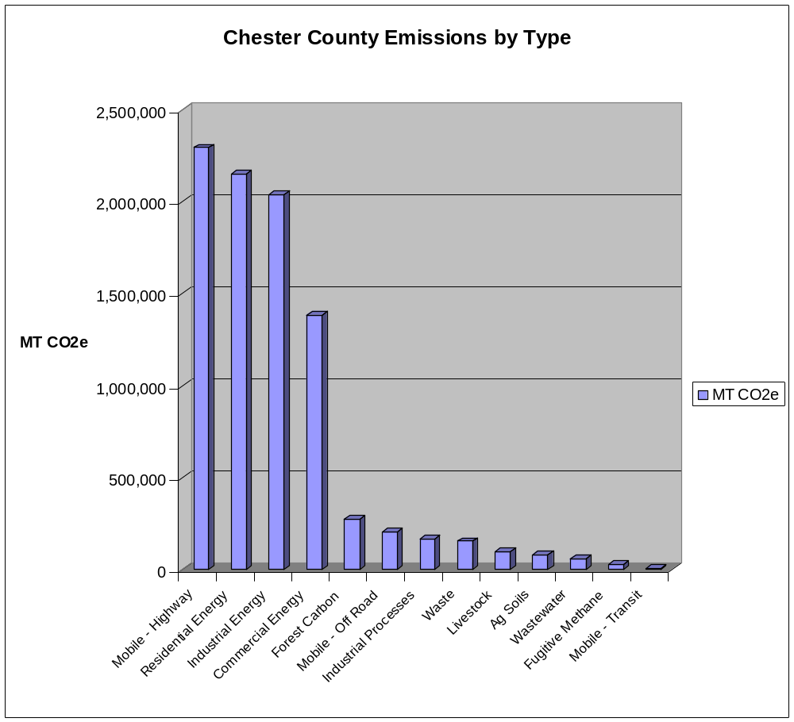
B. CHESTER COUNTY FACILITIES INVENTORY

Numerous County employees kindly provided assistance in completing the GHG inventory of County facilities. With their help energy utility invoices and fossil fuel records were used to estimate the greenhouse gas emissions that are listed in Table B-1.

The Carbon group was able to obtain 2005, 2006, and 2007 records for each of the facilities with one exception. Complete records for 2005 were not available for all of the District Courts.
Summary annual energy and fuel usage are provided in the table. 2005 totals are noted as being partial, pending further information for the District Court facilities. Figure B-1, 2, 3 shows the summary of emissions data in graphical formats and illustrates similar impacts from both direct combustion of fossil fuels and indirect emissions from the use of electricity.

Energy use will always vary from year to year because of the different factors that impact demand. Further analysis and use of the historical usage patterns will likely take place as part of ongoing efforts to understand and manage GHG emissions from County assets

 | 2005 |  | 2006 |  | 2007 |  | Avg 2006 and 2007
 | Energy | CO2e | Energy | CO2e | Energy | CO2e | Energy | CO2e
 | 10^6 BTU (LHV) | Metric Tonnes | 10^6 BTU (LHV) | Metric Tonnes | 10^6 BTU (LHV) | Metric Tonnes | 10^6 BTU (LHV) | Metric Tonnes
County Facilities | 100,237 | 6,400 | 112,943 | 7,240 | 115,560 | 7,471 | 114,252 | 7,356
District Courts | - | - | 24,417 | 1,513 | 19,187 | 1,183 | 21,802 | 1,348
Parks and Recreation | 8,268 | 591 | 8,207 | 581 | 8,332 | 588 | 8,270 | 585
Prison | 41,916 | 2,679 | 69,755 | 4,350 | 57,141 | 3,603 | 63,448 | 3,977
Pocopson Home | 61,558 | 3,897 | 58,904 | 3,768 | 31,737 | 2,075 | 45,321 | 2,622
Libraries | 17,083 | 1,073 | 16,637 | 1,047 | 17,397 | 1,093 | 17,017 | 1,070
Total Energy, 10^6 BTU | 229,062 |  | 290,863 |  | 249,354 |  | 270,109
Total CO2e, Metric Tonnes | (less Dist. Courts) | 14,640 |  | 18,499 |  | 16,013 |  | 17,256
Percentages of the Total
County Facilities | 43.80% | 43.70% | 38.80% | 39.10% | 43.60% | 46.70% | 42.30% | 42.60%
District courts | 0.00% | 0.00% | 8.40% | 8.20% | 7.70% | 7.40% | 8.10% | 7.80%
Parks and Recreation | 3.60% | 4.00% | 2.80% | 3.20% | 3.30% | 3.70% | 3.10% | 3.40%
Prison | 18.30% | 18.30% | 24.00% | 23.50% | 22.90% | 22.50% | 23.50% | 23.00%
Pocopson Home | 26.90% | 26.60% | 20.30% | 20.40% | 12.70% | 13.00% | 16.80% | 16.90%
Libraries | 7.50% | 7.30% | 5.70% | 5.70% | 7.00% | 6.80% | 6.30% | 6.20%

Figure B-1 Average 2006-2007 Greenhouse Gas Emissions from different County Government Operations
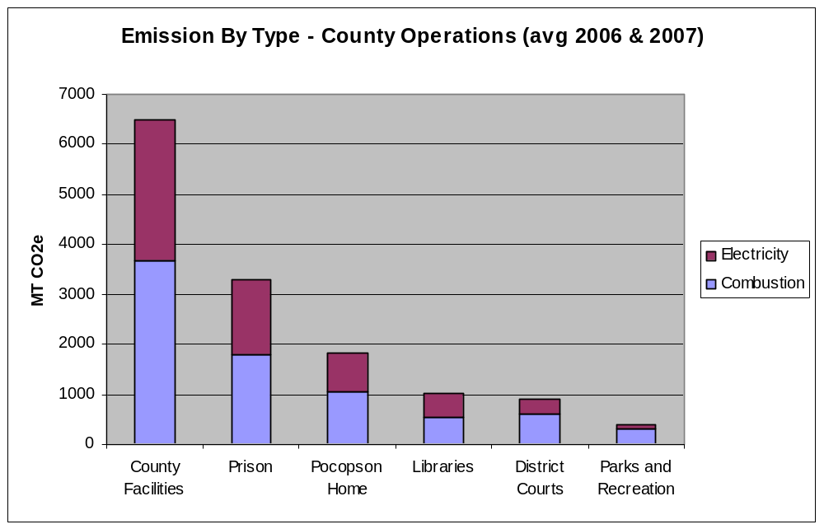

Figure B-2 Average 2006-2007 Greenhouse Gas Emissions from combined County Government Combustion and Electric Sources
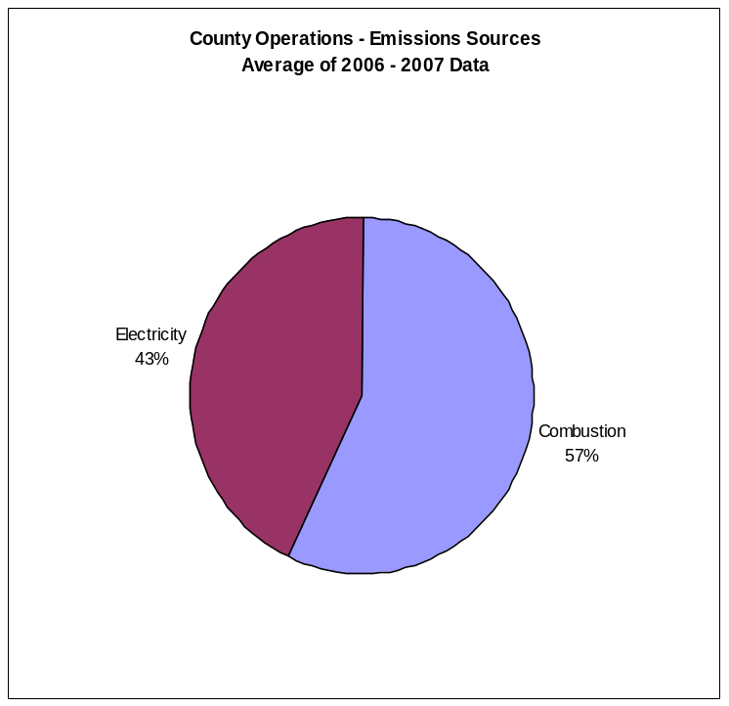

Figure B-3 Average 2006-2007 Greenhouse Gas Emissions from County Government Operations

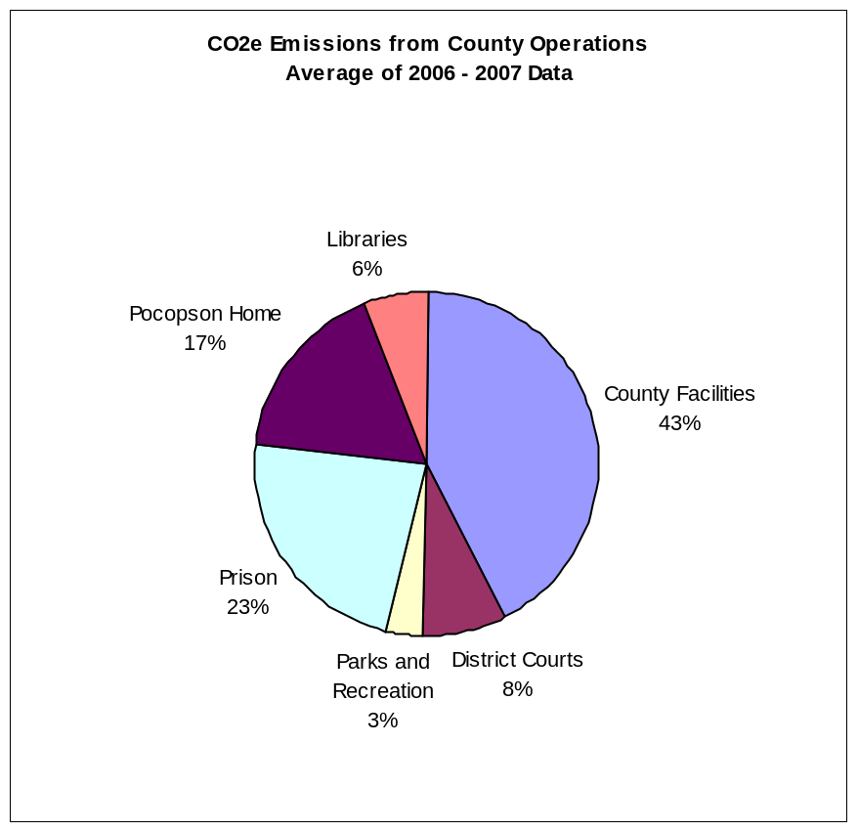

C. CARBON INVENTORY RECOMMENDATIONS

- Continue calculating an annual GHG Inventory
  - Commit to ongoing measurement, conforming to the Climate Registry's Local Government Operations Protocol or similar
  - Designate a County department responsible for managing the inventory process
  - Begin recording energy purchases by quantity consumed as well as price (data is now in several places)
  - Consider joining ICLEI (if necessary and useful) and start using the CACP GHG Inventory tool or similar based on need and cost effectiveness
  - Consider reporting an annual inventory to ICLEI and County residents

- Reducing County Operations GHG Footprint
  - Require each existing County building to do an annual assessment of their energy use, employing the USEPA ENERGY STAR Portfolio Manager program
  - Require all new County construction/revamps to be LEED certified
  - Establish a program to reduce transportation-related County emissions
  - Consider joining one or more USEPA voluntary programs (ENERGY STAR, Climate Leaders, Green Lights, etc)

- Set some GHG reduction goals for County Operations
  - Get at least one County building recognized by ENERGY STAR - The new Judicial Center is a likely candidate
  - Set a County Operations reduction goal (absolute or normalized), for example - 3% per year for 5 years - using 2006/7 average as a baseline
  - Create or add to someone's job the "sustainability coordinator" role, responsible for measuring and reporting progress towards these goals

Carbon Inventory Subcommittee Members

Rob Graff
Dianne Herrin
Tim Lutz
Tom O’Donnell
Don Verdiani

Appendix - B: Office of Sustainability

Defining Sustainability

The Office of Sustainability will define sustainability as…

Balancing the relationships between environmental stewardship, economic development, and social responsibility while meeting the needs of the present without compromising the ability of future generations of people and ecosystems to meet their own needs.

County Sustainability

Sustainability is not a problem, not something to be solved, but rather a vision of the future that provides us with a road map. The map helps to focus our attention on a set of values and ethical and moral principles…to guide our action. Sustainability in this instance is not an end point but a process.

Job Description for Chester County - Sustainability Coordinator
Title: Sustainability Coordinator
Department: Facilities Management
Job Code:
Level:
FLSA: Exempt

Occupational Summary:
The Sustainability Coordinator will develop, coordinate and administer programs and advise policies within the area of sustainability for Chester County.

Core/Principle Job Accountabilities:

A. ADMINISTRATIVE

Develop, plan, coordinate and implement activities related to sustainability for Chester County. These activities will include but not be limited to defining sustainability, goal setting, program(s) and their development, interaction and coordination with multiple organizations (e.g., County departments, County municipal organizations, citizens groups and citizens for the purposes of forwarding the institutionalizing the concept(s) of environmental sustainability. effort for the County. Both the manner in which these activities are organized and the nature of their content should be geared towards achieving buy-in and habit transformation from County management, employees, municipalities, citizens groups and citizens.

The Coordinator’s role would include oversight and direction general environmental, sustainable product procurement, waste elimination, toxicity reduction, energy and water improvement and environmental health and quality improvement in a leadership role for Chester County and its surrounding Communities.

This position will be responsible for tracking and benchmarking all environmental programs, coordination of environmental programs between County agencies and represents the organization’s environmental initiatives with both internal and external stakeholders. It will encourage and facilitate sustainability programs initiated by County management, employees, municipality organizations and community members. It will foster and coordinate new ideas and concepts for sustainability programming themes and identify materials and resources to supplement, expand or replace existing sustainability programming.

Specific Job Duties:

- Assist the Director of Facilities Management in defining goals, performance metrics and a long range plan for sustainability for Chester County. Monitor and evaluate program effectiveness, document performance trends, and recommend and implement modifications to improve program effectiveness.

- Represent Chester County’s sustainability programs to maintain liaison with groups, programs, offices and departments for Chester County to achieve sustainability objectives.

- Support the County’s continued emphasis on Greenhouse Gas Reduction Strategic Plan through the implementation of the approved recommendations while updating the task force recommendations on a regular basis.

- Research, identify, apply for and execute all sustainability related Federal and State grants available to the County and its partner organizations (Metropolitan Caucus of Counties, Local Municipalities, Green Counties, etc.).

- Represent Chester County’s sustainability programs to the public; attend professional meetings as appropriate; interface with external organizations to ensure cooperative efforts are enhanced and available resources are utilized.

- Direct the energy planning/purchasing/reporting effort for County buildings including historical tracking, projections of future requirements, recommending purchases size and types while participating in County direct partnering efforts to address with Dec. 31, 2010 deregulation.

- These requirements may necessitate the need to travel and meet regularly outside of business hours.

- Coordinate and/or participate in public relations activities to include preparing and supervising the production of a website, brochures, newsletters and other promotional materials and/or publications, preparing press releases, designing ads and fliers, and responding to inquiries; develop plans and schedules for release of publicity materials.

- Research and maintain working knowledge of best practices at peer institutions with regards to sustainability.

- Design and maintain a “clearinghouse” website for sustainability-related news for Chester County. (e.g., http://www.chesco.org/sustainability)

- Assist in the preparation of budgets and grant applications; monitor, verify and reconcile expenditure of budgeted funds as appropriate.

- Write job descriptions/profiles, recruit, interview, hire and manage employees to work on sustainability projects with well-defined deliverables.

- Advertise, solicit and screen applications for the grant funding to continue support of he Sustainability Office beyond the current grant funding opportunity.

- Oversee the execution of projects receiving grants. Publicize the results of granted projects. Perform other related duties incidental to the work described herein.

- Chairs Greenhouse Gas Reduction Task Force (GHGRTF or its succeeding group). Researches, directs analysis of, reviews data and advises GHGRTF relative to long and short range sustainability goals and projects. Provide quarterly reports.

- Serve as liaison between local sustainability groups or projects and administration and professional staff. Appropriately involves Media Relations, Government Relations, and community outreach in external group interactions. Works with Media Relations to develop a strategy for communicating organization’s commitment and progress toward sustainability to local community and nationally.

- Attends operations, construction, and other inter/and intra-department

- Participate on committees as Sustainability representative. Ensures collaboration and communication on intra and inter-departmental sustainability initiatives and reports on compliance with sustainability goals.

- Reviews, revises, recommends, and implements sustainable practices as appropriate for each site within the County and advice those agencies outside of the County. Establishes means of communicating best practices throughout the system through reports, meetings, educational events and website.

- Develops department website content, educational materials and a sustainability annual outcomes book and/or associated reports.

- Coordinates on-going communication of sustainability initiatives Chester County including through staff meetings, continuing education and other departmental initiatives.

- Consistently evaluates particular areas to strengthen partnerships, protocols, research, education, and marketing. Addresses ongoing sustainability needs.

- May be accountable for direction and evaluation of subordinate sustainability staff.

- Evaluates, recommends, engages and supervises consultants to assist in project development or implementation.

B. Technical

- Researches and recommends current sustainable business choices and develop plans for evaluation and implementation. Communicate effectively through verbal and written assessments.

- Analyzes and assesses current operating procedures, materials, and methods; anticipates and implements changes or modifications based on sustainability goals. Perform life cycle assessments and cost analyses of proposed modifications.

- Initiates and researches special studies and projects to enhance the long term viability of sustainability initiatives within different departments.

- Develops, oversees and approves marketing messages and outreach programs connected with sustainability.

- Monitors current evidence/based research on the environment and recommends design process changes. Recommends and describes design measures to become Chester County’s standard practice as new science is available.

- Oversees the creation and maintenance of a library of environmental construction products and practices that meet sustainability guidelines including life cycle cost information.

- Is responsible for start/up and implementation of new sustainability initiatives.

- Is responsible for marketing and branding of new sustainability programs. Works closely with Chester County’s administrative management to assure a consistent message and maximum positive exposure.

MINIMUM HIRING SPECIFICATIONS
EDUCATION & TRAINING

Work requires analytical, communications and organizational skills generally acquired through completion of a bachelor's degree program.

EXPERIENCE

Work requires experience in planning and program administration (environmental a plus) and knowledge of the community necessary to plan, coordinate and implement a variety of program activities and events across various intergovernmental agencies and public/private entities. Work requires excellent analytical, communication and organization skills; an ability to self-motivate, multi-task and to work in a fast-paced environment; to work under deadlines; and the ability to work closely with administrators from various Local, County, State and Federal government agencies, community groups, individual citizens and news media.

Commitment to understanding and valuing individual differences and ability to foster an environment of acceptance, fairness and mutual respect.

Must have outstanding communication and interpersonal skills. Must be able to communicate with various governmental agencies and community members at all levels in a respectful, supportive, positive, objective manner, keeping the issues at the forefront of the discussion. Demonstrated ability to work on problem solving as a process issue, not a personality issue.

Facilitation, change management and group process skills.

Superb presentation skills: verbal and written. Comfortable with public speaking, training and education. Experience in developing and presenting sustainable business concepts, training, and burgeoning technologies.

Extensive knowledge of local, regional and national emerging sustainable business strategies, life cycle costing, ROI analysis and other key sustainability tools and techniques.

Ability to analyze data, evaluate outcomes and recommend actions

Must be able function independently with minimal supervision.

Understanding of cost/benefit analysis in selection of sustainable business strategies. Knowledge of financial planning including budget development, consultant contract review and project budgeting.

Familiarity and understanding of Safety, Lean Management, and the U.S. Green Building Council’s Leadership in Energy & Environmental Design (LEED) standards, and basic environmental compliance for governmental agencies.

Ability to utilize a network of sustainable business resources

Strong computer skills: Word, Excel, & Power Point. Database familiarity useful.
Reporting Relationships:

Specific Qualifications: This position requires a college degree (BS) in business, natural resources, environmental studies, education or equivalent.

LEED Accredited Professional and plus

MBA or advanced degree preferred.

Annex I: Glossary

Aerosols: Solid or liquid particles suspended within the atmosphere (see "sulfate aerosols" and "black carbon aerosols").
Afforestation: Planting of new forests on lands that have not been recently forested.
Albedo: Refers to the ratio of light from the sun that is reflected by the Earth’s surface to the light received by it. Unreflected light is converted to infrared radiation (i.e., heat), which causes atmospheric warming (see “radiative forcing”). Thus, surfaces with a high albedo (e.g., snow and ice) generally contribute to cooling, whereas surfaces with a low albedo (e.g., forests) generally contribute to warming. Changes in land use that significantly alter the characteristics of land surfaces can therefore influence the climate through changes in albedo.
Alliance of Small Island States (AOSIS): A coalition of some 43 low-lying and small island countries, most of which are members of the G77, that are particularly vulnerable to the potential adverse consequences of climate change such as sea-level rise, coral bleaching, and increased frequency and intensity of tropical storms.
Allocation: Under an emissions trading scheme, permits to emit can initially either be given away for free, usually under a ‘grandfathering’ approach based on past emissions in a base year or an ‘updating’ approach based on the more recent emissions. The alternative is to auction permits in an initial market offering.
Ancillary Benefits: Complementary benefits of a climate policy including improvements in local air quality and reduced reliance of imported fossil fuels.
Annex A: A list in the Kyoto Protocol of the six greenhouse gases and the sources of emissions covered under the Kyoto Protocol. See also "Basket of Gases."
Annex B: A list in the Kyoto Protocol of 38 countries plus the European Community that agreed to QELRCs (emission targets), along with the QELRCs they accepted. The list is nearly identical to the Annex I Parties listed in the Convention except that it does not include Belarus or Turkey.
Annex I Parties: The 40 countries plus the European Economic Community listed in Annex I of the UNFCCC that agreed to try to limit their GHG emissions: Australia, Austria, Belarus, Belgium, Bulgaria, Canada, Croatia, Czech Republic, Denmark, European Economic Community, Estonia, Finland, France, Germany, Greece, Hungary, Iceland, Italy, Japan, Latvia, Liechtenstein, Lithuania, Luxembourg, Monaco, The Netherlands, New Zealand, Norway, Poland, Portugal, Romania, Russian Federation, Slovakia, Slovenia, Spain, Sweden, Switzerland, Turkey, Ukraine, United States.
Anthropogenic Emissions: Emissions of greenhouse gasses resulting from human activities.
Assigned Amount: In the Kyoto Protocol, the permitted emissions, in CO₂ equivalents, during a commitment period. It is calculated using the Quantified Emission Limitation and Reduction Commitment (QELRC), together with rules specifying how and what emissions are to be counted.
Base Year: Targets for reducing GHG emissions are often defined in relation to a base year. In the Kyoto Protocol, 1990 is the base year for most countries for the major GHGs; 1995 can be used as the base year for some of the minor GHGs.
Baselines: The baseline estimates of population, GDP, energy use and hence resultant greenhouse gas emissions without climate policies, determine how big a reduction is required, and also what the impacts of climate change without policy will be.
Basket of Gases: This refers to the group six of greenhouse gases regulated under the Kyoto Protocol. They are listed in Annex A of the Kyoto Protocol and include: carbon dioxide (CO₂), methane (CH₄), nitrous oxide (N₂O), hydrofluorocarbons (HFCs), perfluorocarbons (PFCs), and sulphur hexafluoride (SF₆).
Berlin Mandate: Decision of the Parties reached at the first session of the Conference of the Parties to the UNFCCC (COP-1) in 1995 in Berlin that the commitments made by Annex I countries were inadequate and thus needed to be strengthened.
Biodiversity: The variety of organisms found within a specified geographic region.
Black Carbon Aerosols: Particles of carbon in the atmosphere produced by inefficient combustion of fossil fuels or biomass. Black carbon aerosols absorb light from the sun, shading and cooling the Earth’s surface, but contribute to significant warming of the atmosphere (see “radiative forcing“).
Bryd-Hagel Resolution: In June 1997, anticipating the December 1997 meeting in Kyoto, Senator Robert C. Byrd (D-WV) introduced, with Sen. Chuck Hagel (R-NE) and 44 other cosponsors, a resolution stating that the impending Kyoto Protocol (or any subsequent international climate change agreement) should not - "(A) mandate new commitments to limit or reduce GHG emissions for the Annex I Parties [i.e. industrialized countries], unless the protocol or other agreement also mandates new specific scheduled commitments to limit or reduce GHG emissions for Developing Country Parties within the same compliance period, or (B) would result in serious harm to the economy of the United States..."
Bubble: An option in the Kyoto Protocol that allows a group of countries to meet their targets jointly by aggregating their total emissions. The member states of the European Union are utilizing this option.
Capital Stock: Existing investments in energy plant and equipment that may or may not be modified once installed.
Carbon Dioxide (CO₂): CO₂ is a colorless, odorless, non-poisonous gas that is a normal part of the ambient air. Of the six greenhouse gases normally targeted, CO₂ contributes the most to human-induced global warming. Human activities such as fossil fuel combustion and deforestation have increased atmospheric concentrations of CO₂ by approximately 30 percent since the industrial revolution. CO₂ is the standard used to determine the "global warming potentials" (GWPs) of other gases. CO₂ has been assigned a 100-year GWP of 1 (i.e., the warming effects over a 100-year time frame relative to other gases).
Carbon Dioxide Equivalent (CO₂e): Carbon Dioxide Equivalent (CO₂e). The emissions of a gas, by weight, multiplied by its "global warming potential."
Carbon Sinks: Processes that remove more carbon dioxide from the atmosphere than they release. Both the terrestrial biosphere and oceans can act as carbon sinks.
Carbon Taxes: A surcharge on the carbon content of oil, coal, and gas that discourages the use of fossil fuels and aims to reduce carbon dioxide emissions.
Certified Emissions Reduction (CER): Reductions of greenhouse gases achieved by a Clean Development Mechanism (CDM) project. A CER can be sold or counted toward Annex I countries’ emissions commitments. Reductions must be additional to any that would otherwise occur.
Chlorofluorocarbons (CFCs): CFCs are synthetic industrial gases composed of chlorine, fluorine, and carbon. They have been used as refrigerants, aerosol propellants, cleaning solvents and in the manufacture of plastic foam. There are no natural sources of CFCs. CFCs have an atmospheric lifetime of decades to centuries, and they have 100-year "global warming potentials" thousands of times that of CO₂, depending on the gas. In addition to being greenhouse gases, CFCs also contribute to ozone depletion in the stratosphere and are controlled under the Montreal Protocol.
Clean Development Mechanism (CDM): One of the three market mechanisms established by the Kyoto Protocol. The CDM is designed to promote sustainable development in developing countries and assist Annex I Parties in meeting their greenhouse gas emissions reduction commitments. It enables industrialized countries to invest in emission reduction projects in developing countries and to receive credits for reductions achieved.
Climate: The long-term average weather of a region including typical weather patterns, the frequency and intensity of storms, cold spells, and heat waves. Climate is not the same as weather.
Climate Change: Refers to changes in long-term trends in the average climate, such as changes in average temperatures. In IPCC usage, climate change refers to any change in climate over time, whether due to natural variability or as a result of human activity. In UNFCC usage, climate change refers to a change in climate that is attributable directly or indirectly to human activity that alters atmospheric composition.
Climate Sensitivity: The average global air surface temperature change resulting from a doubling of pre-industrial atmospheric CO₂ concentrations. The IPCC estimates climate sensitivity at 1.5-4.5ºC (2.7-8.1ºF).
Climate Variability: Refers to changes in patterns, such as precipitation patterns, in the weather and climate.
Commitment Period: The period under the Kyoto Protocol during which Annex I Parties' GHG emissions, averaged over the period, must be within their emission targets. The first commitment period runs from January 1, 2008 to December 31, 2012.
Conference of the Parties (COP): The supreme decision-making body comprised of the parties that have ratified the UN Framework Convention on Climate Change. It meets on an annual basis. As of February 2003, it is comprised of 188 countries.
Discounting: The process that reduces future costs and benefits to reflect the time value of money and the common preference of consumption now rather than later.
Early Crediting: A provision that allows crediting of emission reductions achieved prior to the start of a legally imposed emission control period. These credits can then be used to assist in achieving compliance once a legally imposed system begins.
Ecosystem: A community of organisms and its physical environment.
Emissions: The release of substances (e.g., greenhouse gases) into the atmosphere.
Emissions Cap: A mandated restraint in a scheduled timeframe that puts a “ceiling” on the total amount of anthropogenic greenhouse gas emissions that can be released into the atmosphere. This can be measured as gross emissions or as net emissions (emissions minus gases that are sequestered).
Emissions Reduction Unit (ERU): Emissions reductions generated by projects in Annex B countries that can be used by another Annex B country to help meet its commitments under the Kyoto Protocol. Reductions must be additional to those that would otherwise occur.
Emissions Trading: A market mechanism that allows emitters (countries, companies or facilities) to buy emissions from or sell emissions to other emitters. Emissions trading is expected to bring down the costs of meeting emission targets by allowing those who can achieve reductions less expensively to sell excess reductions (e.g. reductions in excess of those required under some regulation) to those for whom achieving reductions is more costly.
Energy Resources: The available supply and price of fossil and alternative resources will play a huge role in estimating how much a greenhouse gas constraint will cost. In the U.S. context, natural gas supply (and thus price) is particularly important, as it is expected to be a transition fuel to a lower carbon economy.
Enhanced Greenhouse Effect: The increase in the natural greenhouse effect resulting from increases in atmospheric concentrations of GHGs due to emissions from human activities.
Entry Into Force: The point at which international climate change agreements become binding. The United Nations Framework Convention on Climate Change (UNFCCC) has entered into force. In order for the Kyoto Protocol to do so as well, 55 Parties to the Convention must ratify (approve, accept, or accede to) the Protocol, including Annex I Parties accounting for 55 percent of that group's carbon dioxide emissions in 1990. As of June 2003, 110 countries had ratified the Protocol, representing 43.9 percent of Annex I emissions.
European Community: As a regional economic integration organization, the European Community can be and is a Party to the UNFCCC; however, it does not have a separate vote from its members (Austria, Belgium, Denmark, Finland, France, Germany, Greece, Ireland, Italy, Luxemburg, the Netherlands, Portugal, Spain, Sweden, and the United Kingdom).
Evapotranspiration: The process by which water re-enters the atmosphere through evaporation from the ground and transpiration by plants.
GDP: Gross Domestic Product, a measure of overall economic activity.
General Circulation Model (GCM): A computer model of the basic dynamics and physics of the components of the global climate system (including the atmosphere and oceans) and their interactions which can be used to simulate climate variability and change.
Global Warming: The progressive gradual rise of the Earth's average surface temperature thought to be caused in part by increased concentrations of GHGs in the atmosphere.
Global Warming Potential (GWP): A system of multipliers devised to enable warming effects of different gases to be compared. The cumulative warming effect, over a specified time period, of an emission of a mass unit of CO₂ is assigned the value of 1. Effects of emissions of a mass unit of non-CO₂ greenhouse gases are estimated as multiples. For example, over the next 100 years, a gram of methane (CH₄) in the atmosphere is currently estimated as having 23 times the warming effect as a gram of carbon dioxide; methane's 100-year GWP is thus 23. Estimates of GWP vary depending on the time-scale considered (e.g., 20-, 50-, or 100-year GWP), because the effects of some GHGs are more persistent than others.
Greenhouse Effect: The insulating effect of atmospheric greenhouse gases (e.g., water vapor, carbon dioxide, methane, etc.) that keeps the Earth's temperature about 60“F warmer than it would be otherwise.
Greenhouse Gas (GHG): Any gas that contributes to the "greenhouse effect."
Group of 77 and China, or G77/China: An international organization established in 1964 by 77 developing countries; membership has now increased to 133 countries. The group acts as a major negotiating bloc on some issues including climate change.
HGWP (High Global Warming Potential): Some industrially produced gases such as sulfur hexafluoride (SF₆), perfluorocarbons (PFCs), and hydrofluorocarbons (HFCs) have extremely high GWPs. Emissions of these gases have a much greater effect on global warming than an equal emission (by weight) of the naturally occurring gases. Most of these gases have GWPs of 1,300 - 23,900 times that of CO₂. These GWPs can be compared to the GWPs of CO₂, CH₄, and N₂O which are presently estimated to be 1, 23 and 296, respectively.
Hot Air: A situation in which emissions (of a country, sector, company or facility) are well below a target due to the target being above emissions that materialized under the normal course of events (i.e. without deliberate emission reduction efforts). Hot air can result from over-optimistic projections of growth. Emissions are often projected to grow roughly in proportion to GDP, and GDP is often projected to grow at historic rates. If a recession occurs and fuel use declines, emissions may be well below targets since targets are generally set in relation to emission projections. If emission trading is allowed, an emitter could sell the difference between actual emissions and emission targets. Such emissions are considered hot air because they do not represent reductions from what would have occurred in the normal course of events.
Hydrofluorocarbons (HFCs): HFCs are synthetic industrial gases, primarily used in refrigeration and semi-conductor manufacturing as commercial substitutes for chlorofluorocarbons (CFCs). There are no natural sources of HFCs. The atmospheric lifetime of HFCs is decades to centuries , and they have 100-year "global warming potentials" thousands of times that of CO₂, depending on the gas. HFCs are among the six greenhouse gases to be curbed under the Kyoto Protocol.
Incentive-based Regulation: A regulation that uses the economic behavior of firms and households to attain desired environmental goals. Incentive-based programs involve taxes on emissions or tradable emission permits. The primary strength of incentive-based regulation is the flexibility it provides the polluter to find the least costly way to reduce emissions.
Intergenerational Equity: The fairness of the distribution of the costs and benefits of a policy when costs and benefits are borne by different generations. In the case of a climate change policy the impacts of inaction in the present will be felt in future generations.
Intergovernmental Panel on Climate Change (IPCC): The IPCC was established in 1988 by the World Meteorological Organization and the UN Environment Programme. The IPCC is responsible for providing the scientific and technical foundation for the United Nations Framework Convention on Climate Change (UNFCC), primarily through the publication of periodic assessment reports (see "Second Assessment Report" and "Third Assessment Report").
Joint Implementation (JI): One of the three market mechanisms established by the Kyoto Protocol. Joint Implementation occurs when an Annex B country invests in an emissions reduction or sink enhancement project in another Annex B country to earn emission reduction units (ERUs).
Kyoto Mechanisms: The Kyoto Protocol creates three market-based mechanisms that have the potential to help countries reduce the cost of meeting their emissions reduction targets. These mechanisms are Joint Implementation (Article 6), the Clean Development Mechanisms (Article 17).
Kyoto Protocol: An international agreement adopted in December 1997 in Kyoto, Japan. The Protocol sets binding emission targets for developed countries that would reduce their emissions on average 5.2 percent below 1990 levels.
Land Use, Land-Use Change and Forestry (LULUCF): Land uses and land-use changes can act either as sinks or as emission sources. It is estimated that approximately one-fifth of global emissions result from LULUCF activities. The Kyoto Protocol allows Parties to receive emissions credit for certain LULUCF activities that reduce net emissions.
Market Benefits: Benefits of a climate policy that can be measured in terms of avoided market impacts such as changes in resource productivity (e.g., lower agricultural yields, scarcer water resources) and damages to human-built environment (e.g., coastal flooding due to sea-level rise).
Mauna Loa Record: The record of measurement of atmospheric CO₂ concentrations taken at Mauna Loa Observatory, Mauna Loa, Hawaii, since March 1958. This record shows the continuing increase in average annual atmospheric CO₂ concentrations.
Methane (CH₄): CH₄ is among the six greenhouse gases to be curbed under the Kyoto Protocol. Atmospheric CH₄ is produced by natural processes, but there are also substantial emissions from human activities such as landfills, livestock and livestock wastes, natural gas and petroleum systems, coalmines, rice fields, and wastewater treatment. CH₄ has a relatively short atmospheric lifetime of approximately 10 years, but its 100-year GWP is currently estimated to be approximately 23 times that of CO₂.
Microwave Sounding Units (MSU): Sensors carried aboard Earth orbiting satellites that have been used since 1979 to monitor tropospheric temperatures.
Montreal Protocol: (on Substances that Deplete the Ozone Layer) An international agreement that entered into force in January 1989 to phase out the use of ozone-depleting compounds such as methyl chloroform, carbon tetrachloride, and CFCs. CFCs are potent greenhouse gases which are not regulated by the Kyoto Protocol since they are covered by the Montreal Protocol.
National Action Plans: Plans submitted to the Conference of the Parties (COP) by all Parties outlining the steps that they have adopted to limit their anthropogenic GHG emissions. Countries must submit these plans as a condition of participating in the UN Framework Convention on Climate Change and, subsequently, must communicate their progress to the COP regularly.
Negative Feedback: A process that results in a reduction in the response of a system to an external influence. For example, increased plant productivity in response to global warming would be a negative feedback on warming, because the additional growth would act as a sink CO₂, reducing the atmospheric CO₂ concentration.
Nitrous Oxide (N₂O): N₂O is among the six greenhouse gases to be curbed under the Kyoto Protocol. N₂O is produced by natural processes, but there are also substantial emissions from human activities such as agriculture and fossil fuel combustion. The atmospheric lifetime of N₂O is approximately 100 years, and its 100-year GWP is currently estimated to be 296 times that of CO₂.
Non-Annex B Parties: Countries that are not listed in Annex B of the Kyoto Protocol.
Non-Annex I Parties: Countries that have ratified or acceded to the UNFCCC that are not listed in Annex I of the UNFCCC.
Non-Market Benefits: Benefits of a climate policy that can be measured in terms of avoided non-market impacts such as human-health impacts (e.g., increased incidence of tropical diseases) and damages to ecosystems (e.g., loss of biodiversity).
Non-Party: A state that has not ratified the UNFCCC. Non-parties may attend talks as observers.
Perfluorocarbons (PFCs): PFCs are among the six types of greenhouse gases to be curbed under the Kyoto Protocol. PFCs are synthetic industrial gases generated as a by-product of aluminum smelting and uranium enrichment. They also are used as substitutes for CFCs in the manufacture of semiconductors. There are no natural sources of PFCs. PFCs have atmospheric lifetimes of thousands to tens of thousands of years and 100-year GWPs thousands of times that of CO₂, depending on the gas.
Polluter Pays Principle (PPP): The principle that countries should in some way compensate others for the effects of pollution that they (or their citizens) generate or have generated.
Positive Feedback: A process that results in an amplification of the response of a system to an external influence. For example, increased atmospheric water vapor in response to global warming would be a positive feedback on warming, because water vapor is a GHG.
ppm or ppb: Abbreviations for “parts per million” and “parts per billion,” respectively - the units in which concentrations of greenhouse gases are commonly presented. For example, since the pre-industrial era, atmospheric concentrations of carbon dioxide have increased from 270 ppm to 370 ppm.
Quantified Emission Limitation and Reduction QELRC: Also known as QELRO (Quantified Emission Limitation and Reduction Objective): The quantified commitments for GHG emissions listed in Annex B of the Kyoto Protocol. QELRCs are specified in percentages relative to 1990 emissions.
Radiative Forcing: The term radiative forcing refers to changes in the energy balance of the earth-atmosphere system in response to a change in factors such as greenhouse gases, land-use change, or solar radiation. The climate system inherently attempts to balance incoming (e.g., light) and outgoing (e.g. heat) radiation. Positive radiative forcings increase the temperature of the lower atmosphere, which in turn increases temperatures at the Earth's surface. Negative radiative forcings cool the lower atmosphere. Radiative forcing is most commonly measured in units of watts per square meter (W/m2).
Radiosondes: Sensors carried aboard weather balloons that have been in continuous use since 1979 for the monitoring of tropospheric temperatures.
Ratification: After signing the UNFCCCCor the Kyoto Protocol, a country must ratify it, often with the approval of its parliament or other legislature. In the case of the Kyoto Protocol, a Party must deposit its instrument of ratification with the UN Secretary General in New York.
Reforestation: Replanting of forests on lands that have recently been harvested.
Regional Groups: The five regional groups meet privately to discuss issues and nominate bureau members and other officials. They are Africa, Asia, Central and Eastern Europe (CEE), Latin America and the Caribbean (GRULAC), and the Western Europe and Others Group (WEOG).
Renewable Energy: Energy obtained from sources such as geothermal, wind, photovoltaic, solar, and biomass.
Revenue Recycling: If permits are auctioned, this gives considerable sums of money to be recycled back into the economy, either through a lump sum payment of offsetting other taxes. If the existing taxes that are correspondingly reduced were very inefficient, this allows this allows the possibility of both environmental and economic benefits from the trading system, commonly called the 'double dividend.'
Second Assessment Report (SAR): The Second Assessment Report, prepared by the Intergovernmental Panel on Climate Change, reviewed the existing scientific literature on climate change. Finalized in 1995, it is comprised of three volumes: Science; Impacts, Adaptations and Mitigation; and Economic and Social Dimensions of Climate Change.
Secretariat of the UN Framework Convention: The United Nations staff assigned the responsibility of conducting the affairs of the UNFCCC. In 1996 the Secretariat moved from Geneva, Switzerland, to Bonn, Germany.
Sequestration: Opportunities to remove atmospheric CO₂, either through biological processes (e.g. plants and trees), or geological processes through storage of CO₂ in underground reservoirs.
Sinks: Any process, activity or mechanism that results in the net removal of greenhouse gases, aerosols, or precursors of greenhouse gases from the atmosphere.
Source: Any process or activity that results in the net release of greenhouse gases, aerosols, or precursors of greenhouse gases into the atmosphere.
SRES Scenarios: A suite of emissions scenarios developed by the Intergovernmental Panel on Climate Change in its Special Report on Emissions Scenarios (SRES). These scenarios were developed to explore a range of potential future greenhouse gas emissions pathways over the 21st century and their subsequent implications for global climate change.
Stratosphere: The region of the Earth's atmosphere 10-50 km above the surface of the planet.
Subsidiary Body for Implementation (SBI): A permanent body established by the UNFCCC that makes recommendations to the COP on policy and implementation issues. It is open to participation by all Parties and is composed of government representatives.
Subsidiary Body for Scientific & Tech. Advice: (SBSTA) A permanent body established by the UNFCCC that serves as a link between expert information sources such as the IPCC and the COP.
Substitution: The economic process of trading off inputs and consumption due to changes in prices arising from a constraint on greenhouse gas emissions. How the extremely flexible U.S. economy adapts to available substitutes and/or finds new methods of production under a greenhouse gas constraint will be critical in minimizing overall costs of reducing emissions.
Sulfate Aerosols: Sulfur-based particles derived from emissions of sulfur dioxide (SO₂) from the burning of fossil fuels (particularly coal). Sulfate aerosols reflect incoming light from the sun, shading and cooling the Earth’s surface (see “radiative forcing”) and thus offset some of the warming historically caused by greenhouse gases.
Sulfur Hexafluoride (SF₆): SF₆ is among the six types of greenhouse gases to be curbed under the Kyoto Protocol. SF₆ is a synthetic industrial gas largely used in heavy industry to insulate high-voltage equipment and to assist in the manufacturing of cable-cooling systems. There are no natural sources of SF₆. SF₆ has an atmospheric lifetime of 3,200 years. Its 100-year GWP is currently estimated to be 22,200 times that of CO₂.
Supplementarity: The Protocol does not allow Annex I parties to meet their emission targets entirely through use of emissions trading and the other Kyoto Mechanisms; use of the mechanisms must be supplemental to domestic actions to limit or reduce their emissions.
Targets and Timetables: Targets refer to the emission levels or emission rates set as goals for countries, sectors, companies, or facilities. When these goals are to be reached by specified years, the years at which goals are to be met are referred to as the timetables. In the Kyoto Protocol, a target is the percent reduction from the 1990 emissions baseline that the country has agreed to. On average, developed countries agreed to reduce emissions by 5.2% below 1990 emissions during the period 2008-2012, the first commitment period.
Technological Change: How much technological change will be additionally induced by climate policies is a crucial, but not well quantified, factor in assessing the costs of long-term mitigation of greenhouse gas emissions.
Thermal expansion: Expansion of a substance as a result of the addition of heat. In the context of climate change, thermal expansion of the world's oceans in response to global warming is considered the predominant driver of current and future sea-level rise.
Thermohaline Circulation (THC): A three-dimensional pattern of ocean circulation driven by wind, heat and salinity that is an important component of the ocean-atmosphere climate system. In the Atlantic, winds transport warm tropical surface water northward where it cools, becomes more dense, and sinks into the deep ocean, at which point it reverses direction and migrates back to the tropics, where it eventually warms and returns to the surface. This cycle or "conveyor belt" is a major mechanism for the global transport of heat, and thushas an important influence on the climate. Global warming is projected to increase sea-surface temperatures, which may slow the THC by reducing the sinking of cold water in the North Atlantic. In addition, ocean salinity also influences water density, and thus decreases in sea-surface salinity from the melting of ice caps and glaciers may also slow the THC.
Third Assessment Report (TAR): The most recent Assessment Report prepared by the Intergovernmental Panel on Climate Change, which reviewed the existing scientific literature on climate change, including new information acquired since the completion of the Second Assessment report (SAR). Finalized in 2001, it is comprised of three volumes: Science; Impacts and Adaptation; and Mitigation.
Trace Gas: A term used to refer to gases found in the Earth’s atmosphere other than nitrogen, oxygen, argon and water vapor. When this terminology is used, carbon dioxide, methane, and nitrous oxide are classified as trace gases. Although trace gases taken together make up less than one percent of the atmosphere, carbon dioxide, methane and nitrous oxide are important in the climate system. Water vapor also plays an important role in the climate system; its concentrations in the lower atmosphere vary considerably from essentially zero in cold dry air masses to perhaps 4 percent by volume in humid tropical air masses.
Troposphere: The region of the Earth's atmosphere 0-10 km above the planet's surface.
Umbrella Group: Negotiating group within the UNFCCC process comprising the United States, Canada, Japan, Australia, New Zealand, Norway, Iceland, Russia, and Ukraine.
UN Framework Convention on Climate Change: (UNFCCC) A treaty signed at the 1992 Earth Summit in Rio de Janeiro that calls for the “stabilization of greenhouse gas concentrations in the atmosphere at a level that would prevent dangerous anthropogenic interference with the climate system.” The treaty includes a non-binding call for developed countries to return their emissions to 1990 levels by the year 2000. The treaty took effect in March 1994 upon ratification by more than 50 countries. The United States was the first industrialized nation to ratify the Convention.
Uncertainty: Uncertainty is a prominent feature of the benefits and costs of climate change. Decision makers need to compare risk of premature or unnecessary actions with risk of failing to take actions that subsequently prove to be warranted. This is complicated by potential irreversibilities in climate impacts and long term investments.
Urban Heat Island (UHI): Refers to the tendency for urban areas to have warmer air temperatures than the surrounding rural landscape, due to the low albedo of streets, sidewalks, parking lots, and buildings. These surfaces absorb solar radiation during the day and release it at night, resulting in higher night temperatures.
Vector-borne disease: Disease that results from an infection transmitted to humans and other animals by blood-feeding anthropods, such as mosquitoes, ticks, and fleas. Examples of vector-borne diseases include Dengue fever, viral encephalitis, Lyme disease, and malaria.
Water Vapor (H₂O): Water vapor is the primary gas responsible for the greenhouse effect. It is believed that increases in temperature caused by anthropogenic emissions of greenhouse gases will increase the amount of water vapor in the atmosphere, resulting in additional warming (see "positive feedback").
Weather: Describes the short-term (i.e., hourly and daily) state of the atmosphere. Weather is not the same as climate.

LED: A Light Emitting Diode (LED) is an electronic light source. LEDs present many advantages over traditional light sources including lower energy consumption, longer lifetime, improved robustness, smaller size and faster switching

Annex II: Abbreviations

DVRPC: Delaware Valley Regional Planning Commission
PIER: California Energy Commission’s Public Interest Energy Research Program
CFL: compact fluorescent light bulb
LED: Light Emitting Diode

Annex III: Contributors to the report

Energy – CRI Subcommittee Members

- Audrey Zibelman
- Bill Clark
- Bill Risse
- Bruce Arnold
- Dan Orzech
- Dennis Crook
- Dr. Tim Lutz
- Drew McDowell
- George Braun
- Greg Cary
- Heath Eddy
- Heidi Kunsch
- Sally Silver
- Stephen Kirschner
- Suzanne Adams
- Tilo Stahl
- Jack Butler
- Jack Kane
- Joe Weidle
- John Bonan
- Keith Harrington
- Laura Cates
- Matthew Lillard
- Paul Spiegel
- Rhona Klein
- Robert Bryer
- Bob McKinstry
- Russell Rickert
- Tom Severino
- Bill Finch
- Vicky Will

Land Use & Transportation Sub-Committee Members

- Bob Bryer
- Mark Cassel
- Sally Cheyne
- Heath Eddy
- Patricia Horrocks
- Julia McGovern Lacy
- Doug MacBeth
- Michael McGee
- John Murphy
- David Ward
- Art Zadrozny

Carbon Inventory Team Members

- Rob Graff
- Dianne Herrin
- Tim Lutz
- Tom O’Donnell
- Don Verdiani

Communications & Outreach
Subcommittee members

- Tom O’Donnell, Victoria Webb - co-chairs
- Sarah Caspar
- Linda Hurlock
- Gerry Bricks
- Catharine Swan
- John Post
- Pat Horrocks
- Bob Byer
- Victoria Laubach
- Richard Whiteford
- Christine Knapp

Waste Management & Recycling
Subcommittee Members

- Robert A. Watts – Executive Director, Chester County Solid Waste Authority
- Nancy Fromnick – Chester County Recycling Coordinator
- Christine Knapp – Penn Future
- Rep. Barbara McIlvaine-Smith – State Representative
- John Post - 4CP
- Catharine Swan – Executive Director, Green Valleys Association.

AGRICULTURE AND WOODLAND
Subcommittee Members

- Bruce Arnold
- Thomas Bott
- Michael Bullard
- Joy Fritschle
- Hillary Krummrich
- Victoria Laubach
- Robert Lonsdorf
- Thomas O’Donnell
- Andrew Pitz
- Victoria Webb
- Gene Wilson
- Duncan Allison

A Light Emitting Diode (LED) is an electronic light source. LEDs present many advantages over traditional light sources including lower energy consumption, longer lifetime, improved robustness, smaller size and faster switching.
- Exelon will be retiring its coal operations at the Cromby station on May 31, 2011 and ceasing all operations at the station on or before May 31, 2012.
LEED is an internationally recognized certification system that measures how well a building or community performs across all the metrics that matter most: energy savings, water efficiency, CO₂ emissions reduction, improved indoor environmental quality, and stewardship of resources and sensitivity to their impacts. Developed by the U.S. Green Building Council (USGBC), LEED provides building owners and operators a concise framework for identifying and implementing practical and measurable green building design, construction, operations and maintenance solutions. ENERGY STAR is a joint program of the U.S. Environmental Protection Agency and the U.S. Department of Energy and helps consumers save money and protect the environment through energy efficient products and practices. According to the US EPA, results are already adding up. Americans, with the help of ENERGY STAR, saved enough energy in 2008 alone to avoid greenhouse gas emissions equivalent to those from 29 million cars — all while saving $19 billion on their utility bills.
As discussed below, there are complex tax rules relating to the types and ownership of facilities can be funded through tax exempt financing and the ownership of those facilities and equally complex rules regarding use of tax credits. Grant funds may also be restricted. Moreover, there are often restrictions on use of multiple incentives. For these reasons, different funds will be required, according to the source, recipient and use of the money.
The 40% tree cover goal is also recommended by national non-profit American Forests (for metropolitan areas east of the Mississippi. See http://www.americanforests.org/resources/urbanforests/treedeficit.php). Moreover, through his studies of many area watersheds, Dr. John Jackson of Stroud Water Research Center has concluded that approximately a 40% tree cover will sustain higher quality water designations in southeastern Pennsylvania (personal communication and unpublished data).

