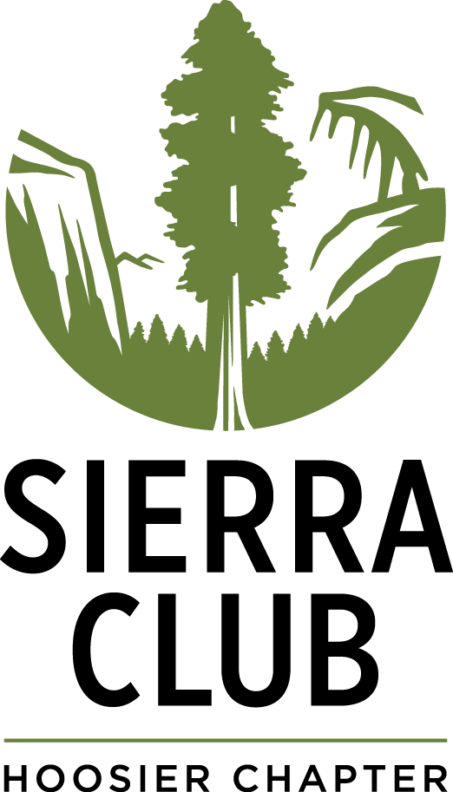
Sierra Club Hoosier Chapter
2018 Art Show – Entry Form

Environmental Justice in Indiana

Thank you for your interest in participating in our 2018 art show.

Artists are invited to submit art reflecting on the issues of environmental justice in our state. What challenges do we face here? What victories have we seen in our communities? Whose voices do we need to amplify? What questions would you like to answer - or pose - with your work?

Fill out this form and email it to rebecca.dien-johns@sierraclub.org or mail it to: Sierra Club Hoosier Chapter – 1100 W 42nd St., Suite 215, Indianapolis IN 46208. You can also use our online submission form

Use one form for each artwork submitted (two maximum). All fields required unless stated otherwise.

Participant

Name____________________________________________________________________

Phone Number ______________________ Email_________________________________

Title of Artwork ____________________________________________________________

Medium____________________________ Size__________________________________

Please indicate if your submission is for sale and if you would like to donate a percentage of sale proceeds to the Sierra Club Hoosier Chapter (minimum 50%). Only such works will be offered for-sale during exhibition. (Contributions and gifts to the Sierra Club Hoosier Chapter are not tax-deductible; they support our effective, citizen- based advocacy and lobbying efforts.)

[ ] This submission is not for sale
[ ] Artwork is for sale. If sold, I will donate ______% to the Sierra Club Hoosier Chapter.
Purchase price, if artwork for sale: $___________________________________________

Participant Statement (Please write no more than a paragraph about your work):

Participant Short Bio – Optional (Please write no more than a paragraph about yourself):

By entering this exhibition, I pledge that this artwork is an original composition. I understand it will be exhibited in a public venue. I understand that images of my work may be used for promoting Sierra Club Hoosier Chapter. I agree to abide by the Sierra Club Hoosier Chapter Environmental Justice in Indiana 2018 Art Show Rules & Regulations available at www.sierraclub.org/indiana/artshow

Participant’s Signature ______________________________________ Date _____________

All exhibitors are invited to a reception at the Indiana Interchurch Center (1100 W. 42nd St., Indianapolis, IN 46208) on Thursday 10 May 2018 at 6pm. More information will be provided upon entry submission.

