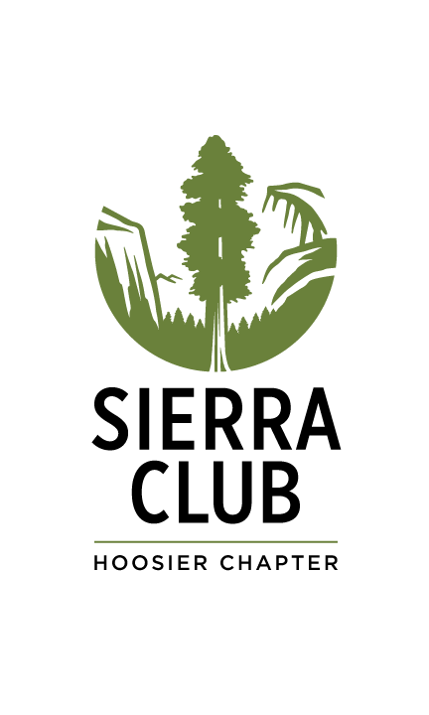
Sierra Club Hoosier Chapter
2019 Chapbook – Entry Form

Human/Nature

Thank you for your interest in submitting to our 2019 chapbook, Human/Nature.

How do we as humans interact with and impact nature, both positively and negatively?
How does the natural world affect us?
Can spending time in nature help us heal?
How has our relationship with the natural world changed?
Do we have a disconnect with nature, and has this been detrimental to our lives... and our planet?
Where do we go from here?

We invite writers to reflect on these questions and create poetry and prose in response. The deadline for submission is August 30, 2019. We will be publishing this chapbook to coincide with our art exhibition will run in October & November.

Please make sure you read the rules and regulations here before submitting your work.

Chapbook sales- We are working with a small local press to create aesthetically pleasing chapbooks at low cost. We plan on selling the chapbook at a small profit to raise money for our environmental work in Indiana. Each writer selected will be offered one copy of the chapbook at printing cost. Your work is still your own and if selected for the chapbook, you are still free to publish the work selected elsewhere. See Sierra Club Hoosier Chapter 2019 Chapbook Rules & Regulations here for further info.

Fill out this form and email it to rebecca.dien-johns@sierraclub.org or mail it to: Sierra Club Hoosier Chapter – 1100 W 42nd St., Suite 215, Indianapolis IN 46208. You can also use our online submission form

Use one form for each prose or poem submitted (two maximum). All fields required unless stated otherwise.

Participant

Name____________________________________________________________________

Phone Number ______________________ Email_________________________________

Title of Artwork ____________________________________________________________

Medium____________________________ Size__________________________________

Name of poem or prose

Please write or copy/paste your poem or prose here. If you prefer, you may send by email to rebecca.dien-johns@sierraclub.org or by mail to Sierra Club Hoosier Chapter, 1100 W. 42nd Street, Suite 215, Indianapolis, IN 46208. If you choose to send this way, please make sure you label it with the same name and title you're using on this form.

Participant Short Bio – (Please write no more than a paragraph about yourself):

By sending this form, I pledge that this writing is an original composition. I agree it can be published in the Human/Nature chapbook. I understand my work may be used for promoting Sierra Club Hoosier Chapter. I agree to abide by the Sierra Club Hoosier Chapter 2019 Chapbook Rules & Regulations available at: www.sierraclub.org/Indiana/chapbook

Participant’s Signature ______________________________________ Date _____________

There will be an opening reception for the Human/Nature art show and chapbook release in the evening of Thursday, October 10, 2019 which all chosen writers will be invited to attend. More information will be provided.

